Enforcing the zig-zag markings on the
pedestrian crossing outside Rumney Primary School

Active Travel at Rumney Primary School
Since 2019 Cardiff Council has had Active Travel Officers working in schools across Cardiff. They work with a school to create an Active Travel Plan, personalised for the school to help families and staff travel more actively, and support them in carrying out the actions. This is to respond to the climate emergency, create safe communities and reduce congestion and air pollution around schools.

Active Travel Officers have worked with Rumney Primary School to identify actions for their Active Travel Plan. These actions are based on the problems experienced by pupils at the school. For example, some of the problems facing pupils and their families are congestion outside the school gates and the lack of visibility when crossing at the pedestrian crossing due to parked cars.

Pedestrian crossing – Enforcing the zig-zag markings
As part of the school’s Active Travel Plan, the school are now working with the School Streets team in Cardiff Council to implement a CCTV enforcement camera on the zig-zag markings either side of the existing pedestrian crossing and the bus stop on Wentloog Road This will help to create a safer environment directly outside the school.

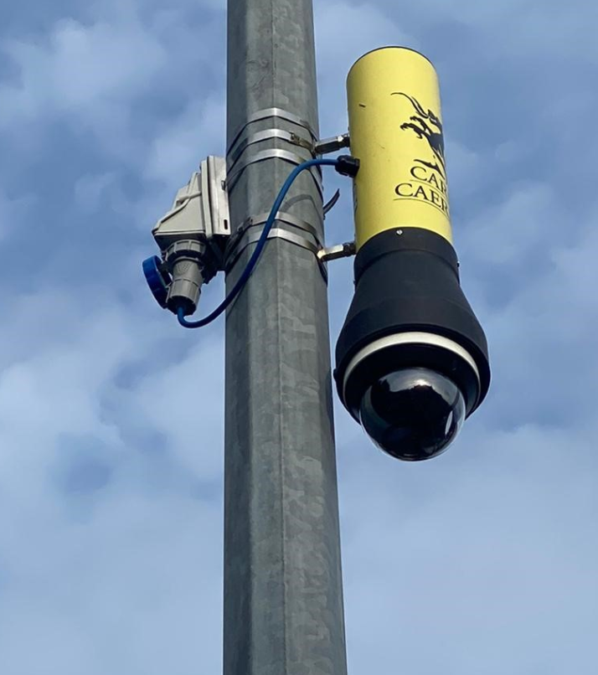
It is an offence to stop or park for any length of time, at any time, on these markings and you can now be issued with a Penalty Charge Notice (PCN) for doing so. Please be aware that the restriction is in force from the edge of the road to the centre, so no vehicles should stop on this stretch of road. For example, stopping in the middle of the road to let out a passenger would still lead to the issuing of a PCN.

Why is there camera enforcement?
Cameras are put in place around some restrictions where some enforcement such as a foot patrol is difficult, insensitive or impractical, or if compliance has not been achieved.

Penalty Charge Notices (PCN)
As the zig-zags will be enforced with CCTV the PCN will be sent by post. There will be a link in the letter to view the footage. The penalty for this contravention is £70, reduced to £35 if paid within 21 days. If a PCN is ignored, the penalty will increase and eventually Cardiff Council will register the debt with the County Court. There is an appeals process, and when considering the appeal, footage of the contravention will be reviewed, although PCNs are unlikely to be cancelled as stopping on zig zags at a pedestrian crossing can be very dangerous.

Zig zag markings either side of a pedestrian crossing are there to ensure safety for your children, the school and the wider community. We really hope the camera will ensure this space is kept clear at all times to make arriving and leaving school a safer place for everyone. For further information, please visit our website: www.keepingcardiffmoving.co.uk/schools. If you have any further questions then please email the school streets team: schoolstreets@cardiff.gov.uk

