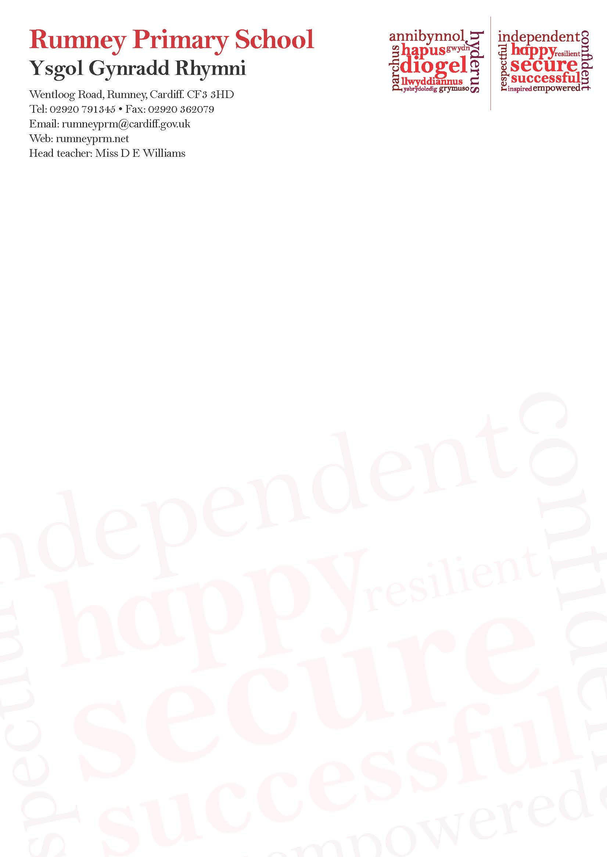

24th November 2020

Dear Parents/Carers

School has received an update from Welsh Government.

**Wearing of face coverings (primary)**

The Welsh Government has updated its guidance on the use of face coverings in schools.

**To reduce the risk of transmission amongst parents and relatives, please wear masks when visiting school, and at drop-off and collection areas. Maintaining clear social distance at the school gates will also reduce risk and set a good example to pupils.**

If you have a secondary school aged child, be aware that face coverings should now be worn by year 7 and above pupils in all areas outside the classroom and be worn on dedicated school transport for year 7 and up.

Please follow these guidelines and encourage your child to follow theirs too.

Along with regular hand washing/sanitising and social distancing, this will reduce the risk of spreading COVID-19 at school as far as possible.

They have been made stronger to keep you and your families as safe as possible. They are based on new advice from Welsh Government’s Technical Advisory Group, as we learn more about the way COVID-19 is transmitted.

Thank you for your help in doing all we can – together - to keep ourselves and others safe.

Stay safe and well.

Very best wishes.

**D Williams D Baker**

D E Williams D. Baker

Headteacher Chair of Governors