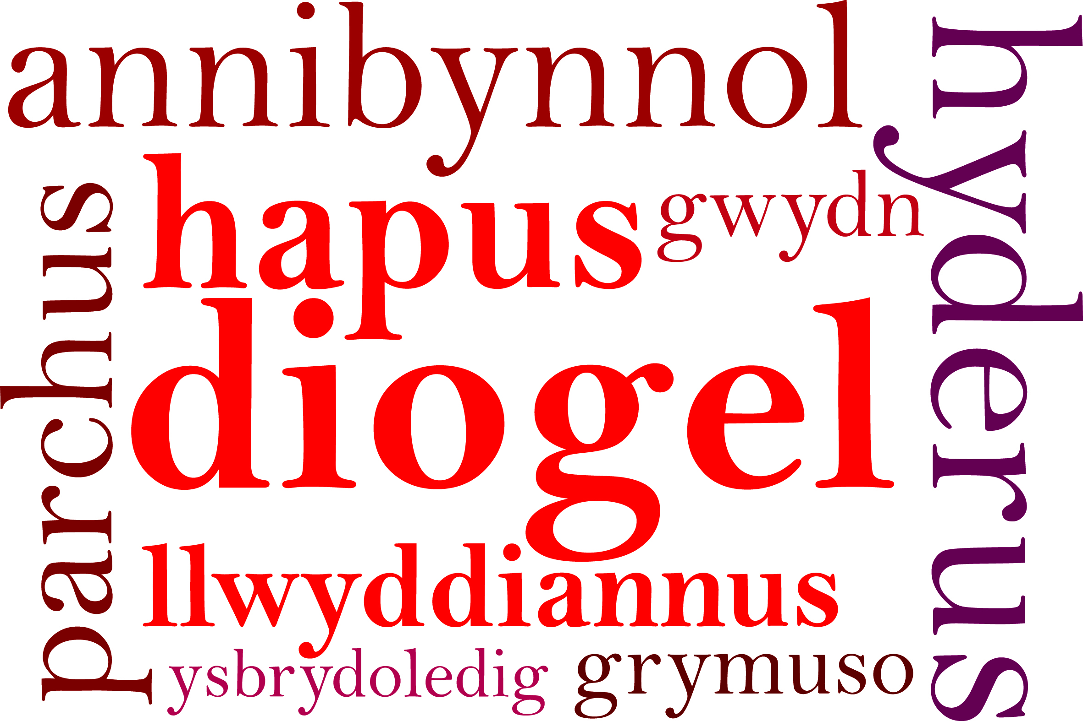
ParentPay
27th November 2020.
Dear Parents/Carers,
We are pleased to inform you that in conjunction with Cardiff Council the online payment system for school meals and other school activities has now been set up. You will need to activate your online account using the username and password that has already been sent home with your child. We can no longer accept cash or cheques as payment for your child’s school meal.
From Monday 30th November we are able to provide pupils with the option of school meals provided by Cardiff Council Catering Dept. At the moment they are offering a limited menu which consists of a jacket potato, pasta pot or sandwiches plus a desert. They also provide a bottle of water.
Due to the sudden school closure on Thursday 19th March we were unable to collect outstanding dinnermoney. We will therefore transfer outstanding debt or credit balance onto the ParentPay system. We are unable to provide school meals for pupils until all outstanding dinner money is paid.

For further information regarding ParentPay please visit www.parentpay.com.

Thank you for your continued support.

Yours sincerely,

Miss D.E. Williams
Headteacher

