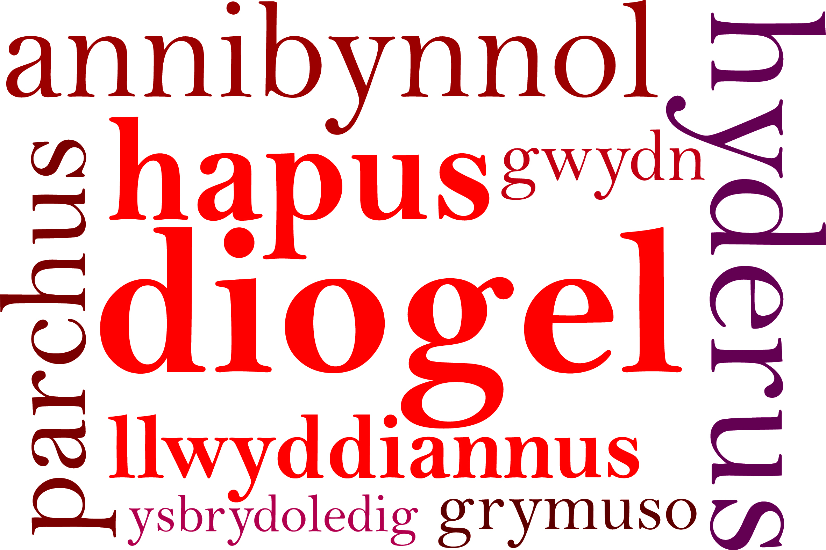
Headteacher's Update 2. October 2020

Dear Parents/Carers,

We are near the end of the first half term and what a busy one it has been! Everyone is ready for some time to rest and relax. We are all experiencing further challenges in the weeks ahead and the best way to keep us all safe and well is to follow what we are asked to do. We finish on Thursday 22nd October, for one week. School will reopen for all year groups on Monday 2nd November.

This Headteacher’s Update will hopefully provide some helpful information.

Mr Davies - Caretaker
“Happy Retirement Mr Davies from us all at Rumney Primary School”
I have shared with you in previous updates that Mr Davies was due to retire earlier in the year but as we faced the school closure he didn’t want to leave until he saw the children and staff return safely. We are really going to miss him. He has been at Rumney Primary School for 22 years! That is dedication and commitment. He has been a loyal and extremely hardworking caretaker and friend to us all. I am sure you would all join in with us to say,
“We are going to miss you! Thank you!”
and send him our very best wishes. Hopefully he will be able to go on the holidays he has planned very soon!
We are pleased to welcome Mr Oak who will be our new caretaker. You may have seen him working alongside Mr Davies this week.
“We all wish him the warmest of welcomes to our friendly and caring school. We are sure he will have many happy years looking after us and the building!”

Parents’ Consultation
We hope that you found the phone calls from school helpful and reassuring about how the children have settled into school. We hope there will be opportunities later in the school year to meet the staff but we will have to wait and see! At the moment I’m sure you would agree that keeping in touch is very important whether this is by phone or by email. Class teachers emails have already been sent but I have included them at the end of this update along with the details of the other ways school will keep you updated with what’s happening.
Mrs Proctor will be in touch with our Nursery parents/carers hopefully the week beginning the 16th November.

Merit Assembly
I am really pleased to be able to share that we have had some very special moments during our Merit assemblies. Whilst it has been different not being together in the hall we have all been together on screen! The children have been recognised for their superb efforts and achievements.

Harvest Festival
Our theme this year was exploring being grateful. In previous years you have been extremely generous by sending in donations of food items for the Food Bank. This year we haven’t been able to support them in the same way but we have taken time to say thank you for all that we have.

Breakfast Club
Thank you for the response to the questions related to Breakfast Club. After half term we hope to be able to provide an update on our plans. These are very much at the early stage.

Lunchtime
At the start of next term children will need to continue to bring packed lunches. We hope to have Parent Pay up and running very soon. Until we have the resources in place we are not able to reintroduce catering. Further information will be sent out when we can confirm the details. Parent Pay will continue with direct payments for families in receipt of Free School Meals during the holidays. You may have heard that in Wales this will continue for all school holidays up to and including the Easter holiday.
We have been given information from Rumney Forum about a food service they will be offering. Please see the information at the end of my update.

Start and finish times
We are extremely grateful to you for your patience and understanding with the staggered times at the start and end of the day. Thank you! There are a couple of points we need your continued support with:
- keep to the times for the different year groups and avoid coming onto school site earlier than necessary
- stay on site with your child until it is time for your child to go into school
- one adult only to collect the children from school- we know secondary age pupils,Y9 onwards, are not at school immediately after half-term. We ask that they do not come onto the school site.
- At the end of the day please make sure children stay with their adult and not go on the equipment or run around on the playgrounds.
- no football before school
We have been fortunate that the weather hasn’t been too wet or too cold...yet! I’m not sure this will be the same next half term. Whatever the weather we need everyone to keep to our organisation for dropping off and picking up.

Social distancing remains an important factor for everyone's safety. The restrictions coming into place from Friday 23rd October means we need all adults and children to follow the school procedures in place. Please consider this and leave the school site promptly. Certain areas are becoming congested and we all have a responsibility to prevent this happening.

Active Outdoors
The children will continue to access the outdoors as much as possible. We hope to be outside for break times and dinner times. Please ensure the children have coats with hoods.

Dates for Your Diary
INSET Days:
Friday 23rd October
Friday 27th November
Monday the 8th February
Monday 19th and Tuesday 20th July
Please :
- Tell us of any changes of contact details
- Encourage independent skills in being able to do coats up and laces
- Keep school informed of any need to self isolate
- if anyone has a problem accessing the electronic communications from school please contact the school office by phone

Finally I wanted to thank you all for the continued support you are giving to your children and the whole school community. By working together we will achieve the best for everyone. I want to recognise the amazing care and dedication that all staff have shown during these challenging and busy times.

I hope you all have a great half term week - keeping safe and well!

Very best wishes,

Miss D E Williams
Headteacher

Keeping in Touch

RUMNEY PRIMARY SCHOOL
Tel No 029 20791345
Email: rumneyprm@cardiff.gov.uk
Website: rumneyprm.net
Twitter @rumneyprm
Schoop I.D : 10411

Class Teacher emails are attached

Class | Class Teacher | email
Little Saplings  Nursery | Mrs Proctor | jproctor@rumneyprm.net
Little Pumpkins | Miss Baldwin | dbaldwin@rumneyprm.net
Willows | Mrs McNally | kmcnally@rumneyprm.net
Cherry | Mrs Lewis | slewis@rumneyprm.net
Apples | Mr Fryer  Mrs Moore | dfryer@rumneyprm.net  gmoore@rumneyprm.net
Holly | Mrs Dash | jdash@rumneyprm.net
Little Acorns | Miss Jones | sjones@rumneyprm.net
Cherry Blossom | Mrs Heycock  Mrs Lloyd | cheycock@rumneyprm.net  dlloyd@rumneyprm.net
Chestnut Trees | Mrs Rogers | rrogers@rumneyprm.net
Cedar Trees | Mrs Oelmann | joelmann@rumneyprm.net
Maple Trees | Mrs Williams | jwilliams@rumneyprm.net
Palm Trees | Mrs Jones  Mrs Margetts | kjones@rumneyprm.net  kmargetts@rumneyprm.net
Hazel Trees | Mrs Howells | rhowells@rumneyprm.net
The Oaks | Miss Nicholls | dnicholls@rumneyprm.net
The Redwoods | Mr Carne | mcarne@rumneyprm.net
ALNCO | Mrs Kilpatrick | jkilpatrick@rumneyprm.net

Rumney Forum Lunchbox
Brachdy House
Healthy Half Term Lunches Provided for £1.30 to families that receive free school meals
Grab Bag will contain Sandwich, Crisps, Piece of Fruit and a drink
Monday 26th-Friday 30th October 2020
From 10am until 12:30pm
To reserve a grab bag please text
Lunchbox x (number of Grab Bags) with your name to 07922546933
E.g: Lunchbox x 2
For Further Information please contact kath@rumneyforum.org.uk or visit our Rumney Forum FB page
Volunteers would be welcomed

