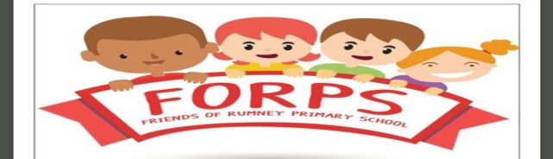

FREE PRE-lOVED RUMNEY PRIMARY SCHOOL UNIFORM AVAILABLE AT RUMNEY FORUM (OLD LIBRARY BRACHDY ROAD)
IN LINE WITH THE NEW POLICIES FOR COVID 19 FORPS ARE NOW AVAILABLE THROUGHOUT THE SUMMER HOLIDAYS TO PROVIDE SCHOOL ITEMS, WE CAN TAKE REQUESTS THROUGH EMAIL (RUMNEYPRIMARYPTA@HOTMAIL.COM) OR ON OUR FACE BOOK/PM, TO ARRANGE COLLECTION AND DROP OFF AS WE STILL APPRECIATE DONATIONS OF ANY ITEMS SUCH AS BAGS, PE KIT, FOOTWEAR, ETC.
WE ARE OFFERING A SERVICE WHEREBY PRE LOVED ITEMS CAN BE PASSED ON TO PARENTS/CARERS AT NO COST. WE HAVE A VARIETY OF ITEMS AVAILABLE IN EXCELLENT CONDITION.

