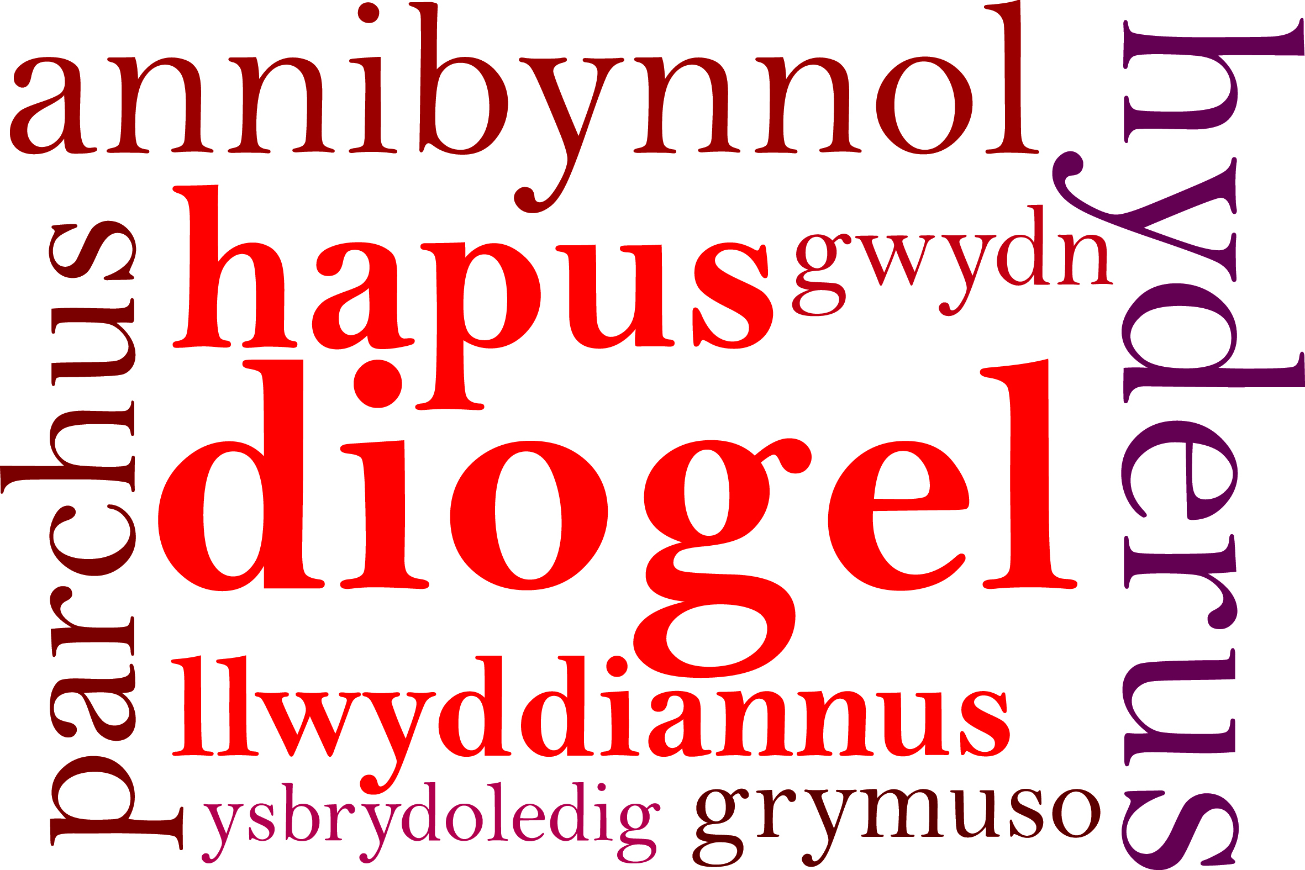
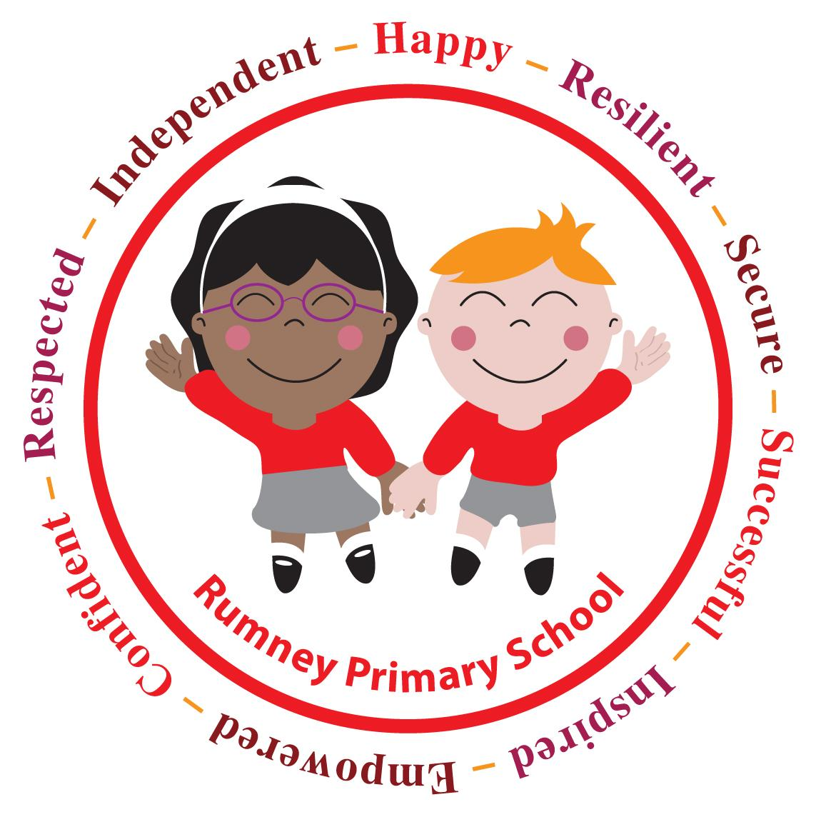
Headteacher's Update 1. September 2020

Dear Parents/Carers,

Welcome Back and Welcome to our new families joining us!

First of all, from myself, all school staff and the governing body thank you for the tremendous support we have received in following the new procedures and plans in place to keep our children, staff and wider school community safe and well. Without this the past 12 days would not have run smoothly and calmly.

Every morning has started with such a fabulous “good morning” with so many families. I’ve watched the children coming back to school running, laughing, eager to be back and looking the best in their uniform! The days couldn’t have started any better for me. During the day hearing the children across school having fun and enjoying being in school has made school feel like school again. The end of the day has been very similar and given me the opportunity to talk through some school details with families and catch up about the past six months! They all seem to have grown so much.

The children have adapted well to the many changes and are once again making great friendships and renewing their enthusiasm for school.

Attached to my Headteacher Update 1. Is some very helpful guidance for you. We know that children and household members may become unwell in the coming months with all sorts of colds, sickness etc. this might help you.

Keeping in touch
Clearly the level of communication between school and home has been vital and this continues to be the case. We all know about the new measures that are in place and school needs you to keep in contact and up to date with all communication from school. At the end of this HT Update you will find the details of the ways school will be keeping in touch.

There may be times that you need to be in contact with the class teacher. To help the lines of communication please could you email the class teachers directly using their school emails. These can be found at the end of this HT Update.

The next regular Headteacher Update will be on 22nd October. Going forward the HT Updates will be available electronically on the last Thursday before each half term. You will be able to access the updates on the social media communication platforms we are using.

School Uniform
Thank you for ensuring the children are ready for school. All uniform can be purchased via YC Sports. This includes the PE kit. We are encouraging all children to wear dark shorts, black/navy, and a t-shirt in their house colour. These can all be purchased from YC Sports along with bags. Please can we remind all parents/carers that appropriate clothing should be worn for PE and crop tops/belly tops are not to be worn for PE.

We are trying to reduce any items in lost property. All items of clothing, water bottles,particularly shop bought bottles, lunch boxes and small snack boxes all need to be labelled with your child’s name to avoid any lost property. School can not keep these items in school.

Breakfast Club
At the moment we are not able to give any indication about when Breakfast Club will start. School is continuing to consider what needs to be in place to continue to keep children and staff safe and well.

Lunchtime
We know that there will be no catering on site at lunchtime until after 5th October. During this time all children will need to continue to bring packed lunches.

Staff need your help. The children need you to pack a spoon if they need it, think about the packaging to help the children to develop their independent skills.

Start and finish times
We are extremely grateful to you for your patience and understanding with the staggered times at the start and end of the day. Thank you! There are a couple of points we need your continued support with:
- Please stay on site with your child until it is time for your child to go into school
- At the end of the day we need to make sure children stay with their adult and not go on the equipment or run around on the playgrounds.
- No football before school

Active Outdoors
We have been so lucky that the weather has been dry, warm and even hot! We are aiming to be outdoors as much as possible this term so please make sure the children have a coat with a hood (when the weather changes).

IT
Starting this half term the children will be learning how to access and use Google Classroom for home/school learning. All children who have a School ChromeBook on loan will be asked to bring them into school regularly for lessons from now on. Class teachers will give you more information in time.

Date for Your Diary
INSET Day Friday 23rd October
Further Inset Day dates will be available soon.

Please :
- any changes of contact details
- keep school informed of any need to self isolate
- note this is the final paper based communication you will receive from school
- if anyone has a problem accessing the electronic communications from school please contact the school office by phone

Finally I hope you all have a lovely weekend keeping safe and well!

Very best wishes,

Miss D E Williams
Headteacher

Keeping in Touch

RUMNEY PRIMARY SCHOOL
Tel No 029 20791345
Email: rumneyprm@cardiff.gov.uk
Website: rumneyprm.net
Twitter @rumneyprm
Schoop I.D : 10411

Class | Class Teacher | email
Little Saplings  Nursery | Mrs Proctor | jproctor@rumneyprm.net
Little Pumpkins | Miss Baldwin | dbaldwin@rumneyprm.net
Willows | Mrs McNally | kmcnally@rumneyprm.net
Cherry | Mrs Lewis | slewis@rumneyprm.net
Apples | Mr Fryer  Mrs Moore | dfryer@rumneyprm.net  gmoore@rumneyprm.net
Holly | Mrs Dash | jdash@rumneyprm.net
Little Acorns | Miss Jones | sjones@rumneyprm.net
Cherry Blossom | Mrs Heycock  Mrs Lloyd | cheycock@rumneyprm.net  dlloyd@rumneyprm.net
Chestnut Trees | Mrs Rogers | rrogers@rumneyprm.net
Cedar Trees | Mrs Oelmann | joelmann@rumneyprm.net
Maple Trees | Mrs Williams | jwilliams@rumneyprm.net
Palm Trees | Mrs Jones  Mrs Margetts | kjones@rumneyprm.net  kmargetts@rumneyprm.net
Hazel Trees | Mrs Howells | rhowells@rumneyprm.net
The Oaks | Miss Nicholls | dnicholls@rumneyprm.net
The Redwoods | Mr Carne | mcarne@rumneyprm.net
ALNCO | Mrs Kilpatrick | jkilpatrick@rumneyprm.net

