Rumney Primary School Year 1 - Home Learning Summer Term 2 Week 6
Day 1 | Literacy  It’s back to school for some of you this week and we are looking forward to seeing you. Sometimes it does feel a little scary to go back somewhere after a long time away. Listen to this rap story called ‘The Lion Inside’ about a mouse who overcomes his fears.  https://www.youtube.com/watch?v=O7D2nASjCwU  Challenge-Have a go at learning the first part of the rap and listening to the rhyming words.Maybe you could write some of them down. | Maths  We are now in the month of July. it is the 7th month of the year. Can you remember the order of the months?  Recite them to your grown up or maybe write them down.  Now check your answers-:  Challenge- Try doing this quiz to improve your knowledge of how many days in each month.  https://uk.ixl.com/math/year-1/read-a-calendar | Creative  Jim Field drew the pictures in the story, he is called an illustrator. Have a look at the pictures he has drawn on his website-:  https://www.jimfield.me/  Challenge- Now have a go at drawing your own cover for the ‘ Lion Inside’ story. Remember to think about the different sizes of the animals and their different features-: The lion’s mane, the mouse’s whiskers etc  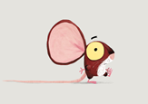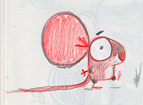
Day 2 | Literacy  You can listen to the story being read today-:  https://www.youtube.com/watch?v=GlfDD3gYZ_0  Look at the pictures of the lion and the mouse. Can you describe them? Think of all those super adjectives!  Challenge- Using your key words write some sentences about the lion and the mouse. | Maths  Can you write out the names of the months of the year and on each separate piece of paper write out how many days they have eg January -31  February- usually 28  March - 31  Challenge -Can you sort out the months into those with 30 and 31 days? You could use hoops/ big circles to sort the month labels and the number of days in that month | Creative  Watch this clip to remind us of facial expressions-:  https://www.bbc.co.uk/bitesize/clips/zfjn47h  Look at the different facial expressions of the lion and the mouse throughout the story.  Can you copy these expressions and describe them to your grown up ?  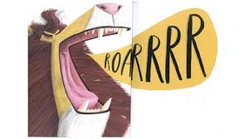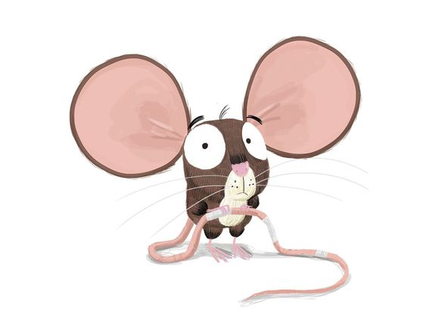  Challenge- Video yourself making these expressions and ask a friend if they can guess what you are doing/feeling?
Day 3 | Literacy  There are lots of rhyming words in the story- gold/old  rock/o’clock  toes/nose  saw/roar  Challenge- Can you write a list of words to rhyme with ‘mouse’, ‘rock’ ? You could even write them on a mouse template-  https://www.template.net/design-templates/animal-templates/mouse-template  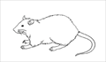 | Maths TTRockstars 10 mins  Symmetry  https://www.bbc.co.uk/bitesize/clips/ztpyr82  Do you remember we did some work on symmetry drawing decorations on Christmas trees? A butterfly can be symmetrical too- it shows that both sides are the same  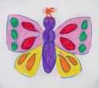  Challenge- Finish this symmetrical pattern-:  https://;www.twinkl.co.uk/resource/t-t-10468-butterfly-pattern-symmetry-worksheet  You could add some extra spots too but remember to make them symmetrical! | PSHE  The mouse was scared in the story but we can do things to overcome our fears. We can remind ourselves that we are all good at something and we may be scared or struggle at first but we will get there!  Challenge-Write some lists of what you are good at to keep that positive mindset.  You could even write all the things you are good at on some balloons if your grown up can help you and you will feel proud when you see all the things you can do!
Day 4 | Literacy  Write a rap about yourself, writing all the things you are good at from yesterday afternoon’s activities. Can you think of any rhyming words to include eg cool/school, friend/end.  Challenge- Perform it for your grown ups and video it and we would love to see it too on Twitter. You can DM it to us too! | Maths TTRockstars 10 mins  Symmetry  Try matching these symmetrical patterns to practice what you learnt yesterday  https://www.topmarks.co.uk/symmetry/symmetry-matching  Challenge- Use a mirror with your grown up to find a symmetry in anything you can see in your home/garden/park. Draw what you can see. | Creative/ Music  Listen to ‘The Lion Inside’ rap and use a musical instrument you have made or even rice in a plastic bottle-: https://www.activityvillage.co.uk/homemade-instruments-rainmaker) and shake to the rhythm of the story.  Challenge-Perform your own rap with musical instruments. Make a video and practice your IT skills and send it a family member or friend who does not live in your house.  .
Day 5 | Literacy  We have enjoyed seeing some of you at school this week and some of you will be looking forward to returning next week or in September. Tell your grown ups what you have enjoyed or what you are looking forward to, e.g seeing your friends  Challenge -Write some of the things you are looking forward to in the months to follow. Can you fill a jar with post-its of exciting times ahead? | Maths  Play TTRockstars 10 minutes  Revision- Number names-:  Start at this level and see if you can go higher-:  https://uk.ixl.com/math/year-1/convert-from-digits-to-words-up-to-20  https://uk.ixl.com/math/year-1/write-digits-given-words-up-to-20  Challenge-Write your number names out and label your soft toys, lego pieces by placing them in number name order. You could write the number digits too! | PSHE / Creative  You are very special and we have been so lucky to have you in our class in Year 1. You are unique with your own features.  Look in a mirror and draw what you see- this is called your reflection.  Challenge- Write all your special qualities on this special template-:  https://www.twinkl.co.uk/resource/t-c-7167-things-i-like-about-me-self-esteem-worksheet  