Dear Families,
When we closed school on the 19th March I never thought we would be welcoming the children back in July, three weeks before the end of the summer term! But we are so pleased that we can finally open our doors to the children to ‘Check in, Check Up and Prepare’.
Whilst the school has been closed to our school community we have provided supervision for keyworker children from other schools too. We are incredibly proud of the way our pupils from RPS have coped with the changes. They have adapted to the new normal and are well used to the routines to keep themselves and others safe and well. Well done to them all!
We are aware that sadly some of our families and staff have experienced some difficult times. Our thoughts are with them. We also know that some families are unable to return to school at the moment. Please be reassured that school will be doing as much as we can to stay connected, keeping relationships going and for all the children to feel part of what is happening at school including finding out their teachers for September. The KS2 class teachers are going to be in touch to arrange a Google Meet and FP teachers will be posting messages to the children. For those children involved in Google Meet sessions with their teachers, please can you read the Home School Agreement for all live online sessions at the end of this Headteacher Update.
You will also see attached Classes for 2020-2021

Restart- things to know
A map of the school site was sent out previously but can be found on the school website and twitter site showing the entrances and exits
Teachers have shared photos and video clips of the classrooms.
The one way system must be followed
Signs are displayed to show entrances, the one way system and keeping 2 m distance
Staggered arrival times and departure times have been shared
No adults other than school based staff will be able to enter the building
Avoid coming to the main office, please phone or email any information you need to share
Children need to bring a filled water bottle
If the children need a snack it must be an individually wrapped
Children do not need to wear school uniform

Social distancing and regular hand washing must be maintained at all times

Nursery and Reception

Miss Baldwin, Mrs McNally and Mrs Proctor have exciting plans to be in touch with families and make sure that all the children know we are looking forward to welcoming them to our school very soon.
End of Year Reports
Before the end of term all pupils will receive their report. They will be available from 13th July onwards. Arrangements are in place for the reports to go home with the children or be collected from school on given days and times . If your child is not returning to school this term you will hear from us when you can come and collect their report. Some children will be given their HWB passwords and Google Classroom account information with their reports. Please keep these safe for future use.

Other goodbyes
We have members of our school community leaving too.
It is with great sadness that at the end of this term Mrs Budd will be retiring from Rumney Primary School. Mrs Budd has given so much care and dedication to our school community over the past 18 years. Mrs Budd is looking forward to enjoying spending more time with her family and her hobbies and I’m sure you will join with me in sharing our very best wishes for lots of happy times ahead. Thank you Mrs Budd for everything you have done. We will miss you !
Miss Clark, Miss Riella, Mrs Turner and Miss Jones will also be leaving us. We are very grateful for the care and support they have given to our children and school. We send them very best wishes for their time ahead.
We will miss you!

Year 6
For our Y6 pupil moving to Y7 we have plans in place to celebrate their time at Rumney Primary School. The end of Y6 won’t be the same as other years but nevertheless there will be opportunities to share memories and say some farewells.
Classes for 2020-2021
2019-2020 |  | 2020-2021
YEAR GROUP | CURRENT TEACHER  2019-2020 | YEAR GROUP | NEW TEACHER  2020-2021
NURSERY  Mrs Proctor  Saplings |  | REC | Miss Baldwin  Little Pumpkins
 |  | REC | Mrs McNally  Willows
REC | Miss Baldwin  Little Pumpkins | YR 1 | Mrs Lewis  Cherries
REC | Mrs McNally  Willows | YR 1 | Mr Fryer & Mrs Moore  Apples
YR 1 | Mrs Lewis  Cherries | YR 2 | Mrs Dash  Holly Trees
YR 1 | Mrs Dash & Mrs Moore  Apples | YR 2 | Miss Jones  Little Acorns
YR 2 | Mr Fryer  Holly Trees | YR 3 | Mrs Heycock & Mrs Lloyd  Cherry Blossoms
YR 2 | Miss Jones  Little Acorns | YR 3 | Mrs Rogers  Chestnuts
YR 3 | Mrs Rogers  Chestnuts | YR 4 | Mrs Oelmann  Cedars
YR 3 | Mrs Williams  Cherry Blossoms | YR 4 | Mrs Williams  Maples
YR 4 | Mrs Oelmann  Cedars | YR 5 | Mrs Howells  Hazels
YR 4 | Mrs Jones & Mrs Margetts  Maples | YR 5 | Mrs Jones & Mrs Margetts  Palms
YR 5 | Mrs Howells  Hazels | YR 6 | Miss Nicholls  The Oaks
YR 5 | Mrs Heycock & Mrs Lloyd  Palms | YR 6 | Mr Carne  The Redwoods
How can I help my child with returning back to school ?
You may find this information helpful in talking to your child

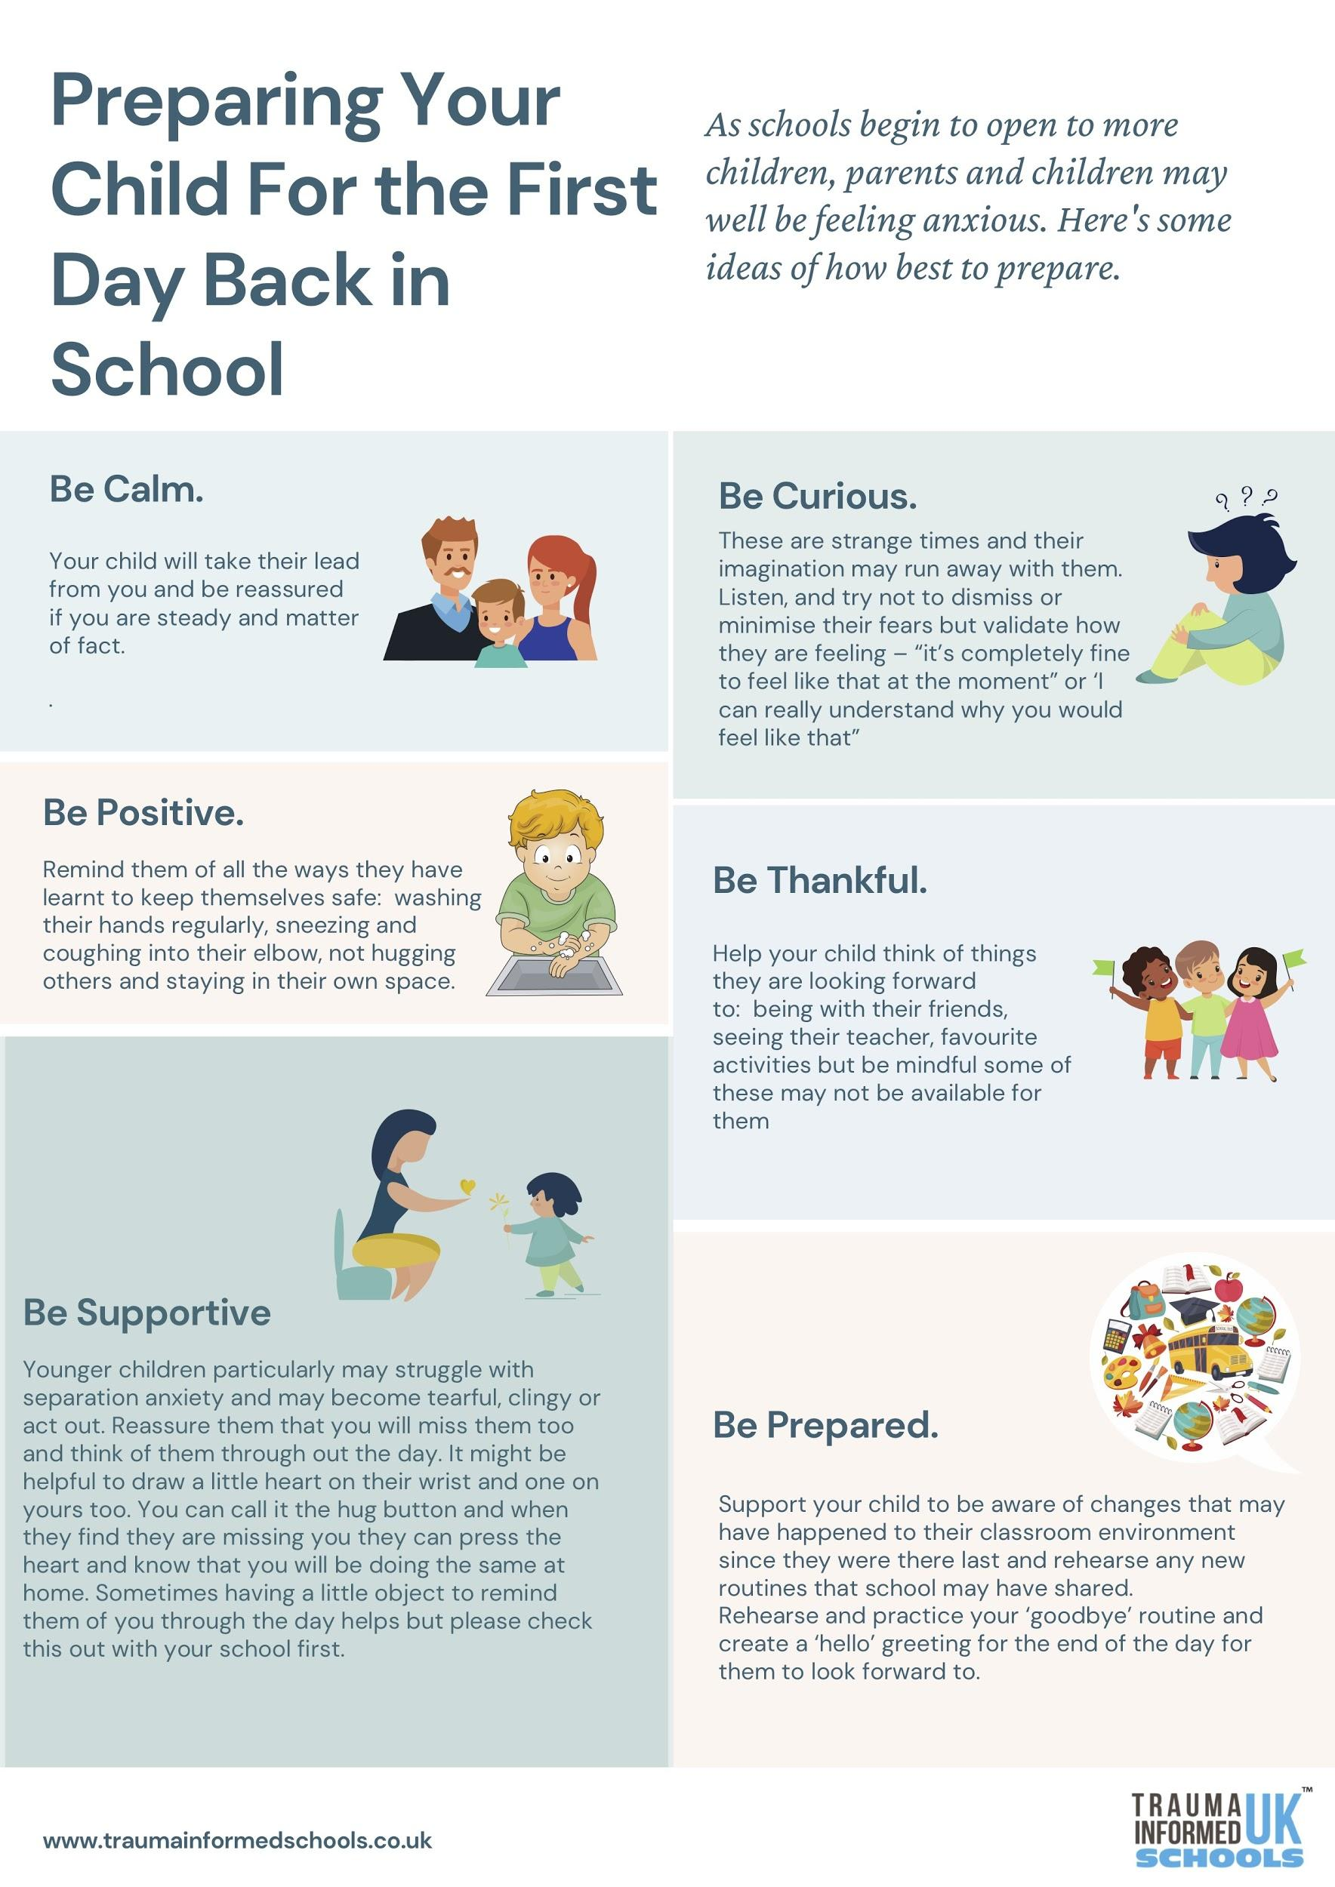
Agreement between Home and School for Live On-line Sessions
Teachers agree to:
Discuss expectations with the learners at the beginning of every session
Notify the SLT, learners and parents/carers of any scheduled sessions, cancelled sessions or changes in arrangements
Ensure they keep themselves up to date with all relevant policies and procedures, including on-line safety, safeguarding and data protection policies
Prevent any 1:1 situation at the end of the session

Learners agree to:
Be punctual for all sessions
Have any prepared materials to hand
Make sure they have laptops ready and are logged in
Show respect for everyone in the online classroom
Dress appropriately for all classes, thinking about respect for others
Ensure the log in location is appropriate. It needs to be in a public place in the home and carer/ parent present
Seek to contribute in a positive way and not be disruptive at any time
Not share images of the class

Parents & carers to:
Be present for the whole session
Support the learner in following the agreed code of conduct

There will be a further Headteacher Update before the end of term and hopefully share the latest information in relation to the new term.
In the meantime stay safe and take care. Thank you for your continued support
Best wishes
Miss D Williams
Headteacher

