Rumney Primary School Year 1 - Home Learning May 11 - 15th
Day 1 | Literacy  Read/Watch the tale Jack and the Beanstalk.  https://www.youtube.com/watch?v=W5rxfLRgXRE&t=44s  Keep pausing the story and talk about what has happened so far and make predictions about what you think is going to happen.  Challenge - Practise reading and spelling your keywords. | Maths TTRockstars 10 mins  Number  Practise some simple addition within 10/20 or beyond if needed. e.g. 7 + 5 =  remember to put the big number in your head and count on using your fingers. Or you may want to find 7 objects and place them in a group and add 5 more and count them all together. A numberline may also be used to help.  Challenge – Write out 10 number addition sentences. | Investigation  Have a look at the video of the life cycle of a green bean plant  https://www.youtube.com/watch?v=w77zPAtVTuI  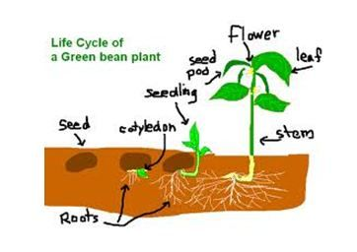  Challenge - Talk about the changes you can see taking place to the bean.
Day 2 | Literacy  Have a go at telling the story Jack and the Beanstalk in your own words. What happened in the beginning, middle and ending? Which part was your favourite and why? Oracy task only today.  Challenge - Maybe you could ring a grandparent or friend and entertain them with the story. | Maths TTRockstars 10 mins  Measure  Pick some leaves/strands of grass/weeds and place them into order of size.  Challenge – Can you measure the leaves using lego blocks placed together? Extend this if ready by using a ruler and looking at how many centimetres (cm) with lots of help. | Investigation  Re-watch the bean growth video to remind yourself of how the bean changes.  Divide paper into 4 sections however you choose.  Draw the first 2 of 4 pictures to show how the bean changes over time  Challenge - Can you label your pictures using a pencil and ruler?
Day 3 | Literacy  Practise reading and writing your keywords. This could be in chalks out the garden or using coloured felt tips.  Challenge - Play key word snap or pairs using your homemade keyword cards. | Maths TTRockstars 10 mins  Subtraction  Think of a number between 6 and 20 - roll a dice and take away that number. You may be able to use your fingers and count backwards or you may need the help of a number line to jump your finger backwards.  Challenge - Create some subtractions stories. If I have 12 sweets and my sister takes 4 how many sweets are left? | Investigation  Looking back at yesterday’s challenge. Can you draw the final two pictures to show how the bean has grown and has sprouted stems and leaves.  Challenge - Can you record yourself talking through the changes that happen to the bean?
Day 4 | Literacy  Create a word bank of all of the names and objects in the story Jack and the Beanstalk e.g. golden hen, beanstalk, Jack, Giant etc  Challenge - Ask your grown up to pretend to be a character from the story and ‘hot seat’ them by asking them lots of questions. E.g Jack- What did you think you would find at the top of the beanstalk? | Maths TTRockstars 10 mins  Odd/Even  Write out number cards to 1 - 20 and get your grown up to hide them around the room. When you find the card decide if it’s an even or odd number and sort them into two piles.  Challenge - Order the numbers and chant  (use higher numbers if your child needs extending) | PE  Choose your favourite Yoga programme from Cosmic Kids www.youtube.com/user/cosmickidsyoga  Have a lovely stretchy, calm afternoon. Namaste!  Relaxing Challenge - Now you are all relaxed time to cosy up with a favourite book to read together.
Day 5 | Literacy  Have a little go at writing the story Jack and the Beanstalk in your own words. Or maybe you would prefer to write a sentence or two explaining your favourite part.  Challenge - Can you remember to use a capital letter for names in the story? | Maths TTRockstars 10 mins  Patterns  Can you make your own patterns using coloured pencils?  red yellow red yellow  red red red yellow yellow red red red etc  Challenge - Be creative and use objects around home/garden  book leaf leaf book leaf leaf | Investigation  If you have soil available why not have a go at planting your own tomato seeds it looks very simple. Watch this link which will show you how. If this isn't possible, slice open a tomato and have a look at the seeds together and talk about how they can create another tomato.  https://www.youtube.com/watch?v=s0w4SDj3sjs  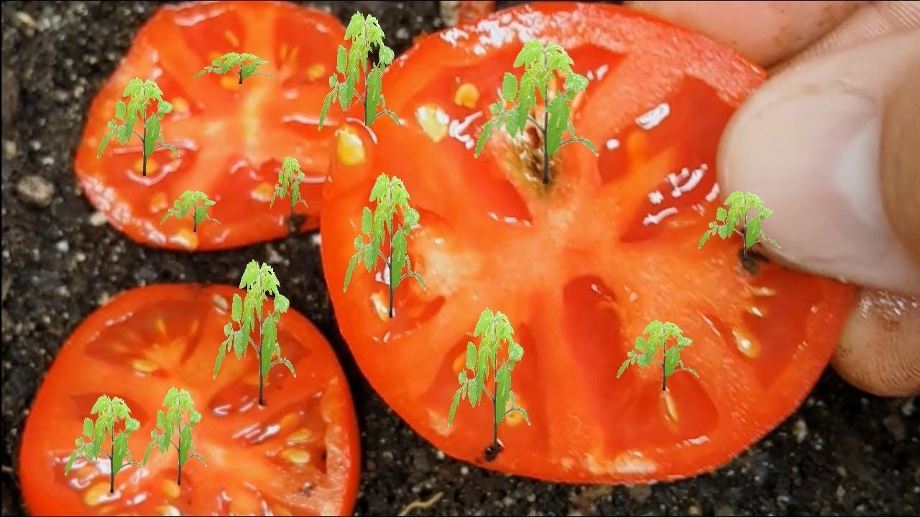  Challenge- Plant your tomatoes and watch them grow with all fingers crossed!!

