Rumney Primary School Year 4 Home Learning Week 8
Monday 1st - Friday 5th June
Day 1 | Literacy  Spelling  Practice your new words using your spelling menu.  Handwriting  In your assignments you will find a short biography of David Walliams. Copy it out in your very best handwriting, thinking about keeping your tall letters tall and all of your letters on the line.  We’d love to see a photo of your beautiful handwriting - you can turn it in using the assignment. | Maths TTRockstars 10 mins  Maths War!  You will need:  2 players, a dice, 10 counters, pen and paper. (The counters could be made out of paper.)  How to play:  - Each player starts with 5 counters.  - Player One shakes the dice twice, and writes down the two numbers that they roll. Now player One multiplies those 2 numbers together and writes down the answer.  - Player Two shakes the dice twice, and writes down the 2 numbers that they roll. Now player Two multiplies those two numbers together and writes down the answer.  - Whose answer is the highest? The player with the higher answer takes a counter off the other player.  - Repeat until one player has all the counters - they are the winner of Maths War! | Challenge  Summer of Sport Event 1  Sprint  Can you find somewhere where you can sprint over roughly 60 metres?  Things to practise during the week:  Practise starting quickly as soon as your helper shouts “Go”.  Push off as hard as you can from your starting point.  Practise moving your arms “hip to lip”, keeping your elbows bent.  Try jogging on the spot and moving your arms “hip to lip” whilst you do so.  Try and practise 3 sprints every day, ready for your actual Sprint on Thursday or Friday. How fast can you cover the distance? Make sure to send us a photo or video of yourself in action via Google Classroom or Twitter, so we can award you 5 house Points for entering!
Day 2 | Literacy  Spelling  Practice your new words using your spelling menu.  The World’s Worst Teachers - Reading Attack  The World’s Worst Teachers is a very funny book by David Walliams. Today, we would like you to watch a reading of one of the chapters in the book - Miss Seethe’s Detention Rampage. You can find it here:  https://www.youtube.com/watch?v=1PDI3NLapC0  Now make a few quick notes about the story, using a Reading Attack grid, just like we’ve done in class. What did you like about the text? What didn’t you like? What was interesting about the text? Can you draw a quick sketch or find an appropriate image of something from the text? There is a Reading Attack Grid you can fill in on Google Doc in Classroom Assignments. | Maths TTRockstars 10 mins  Times Tables - Which ones do you know?  On the google slide presentation, have a go at filling in all of the times tables that you know. You will find the 2x, 5x, 10x, 3x, and 4x to have a go at.  Can you work out the ones you’re not sure of?  Highlight the ones you didn’t know - this will be useful for you tomorrow.  If you want to stretch yourself, have a go at the Extra Challenge - some very tricky Times Tables to try including 6x, 8x, 7x, 9x and 11x! | Challenge  Summer of Sport Event 2  Standing Long Jump  Make a start line.  Stand with your feet about shoulder-width apart, just behind the line. Bend your knees and jump as far forward as you can.  Things to practise during the week:  Bending your knees and dipping slightly just before you take off.  Using your arms to pull you through the air.  Bending your knees when you land to soften the impact.  Practise doing squats on the spot to help with your landing.  Start by doing short jumps to help with your landing.  On Thursday or Friday, do your 3 actual Long Jumps - which was your longest? Make sure to send us a photo or video of yourself in action via Google Classroom or Twitter, so we can award you 5 house Points for entering!
Day 3 | Literacy  Spelling  Practice your spellings using your spelling menu.  World’s Worst Teachers - Character Drawing  Draw a picture to show what Miss Seethe looks like! Write 5 adjectives around her to show what kind of person she is, and any other information you can remember about her.  You can turn in a photo of your work in your Classroom Assignments. | Maths TTRockstars 10 mins  Times Tables Target Game  Think of the Times Table that gave you the most trouble yesterday.  Write the answers to that times table out on separate pieces of paper. Spread them out on the floor or on a wall (check if that’s okay first!). You may want to use blu-tac to keep them still.  Ask someone in your house to call out the times tables facts you have chosen in any order. Each time they call one out, you hit the right answer.  You could do this with your hand, a ball, a nerf gun or even stomp the right one with your foot if the answers are stuck down on the floor!  Here’s how one family played this game:  https://youtu.be/orcYQ11wTpQ  We can’t wait to see how you decide to play! | Challenge  Nature Scanner  Cut a rectangular hole in a piece of paper or card. Ask grown up to help you if this is a bit tricky! This is your Nature Scanner.  Place your Nature Scanner over a patch of grass, a plant or gently over some flowers.  Look through the hole. What can you see? Spend some time looking really carefully.  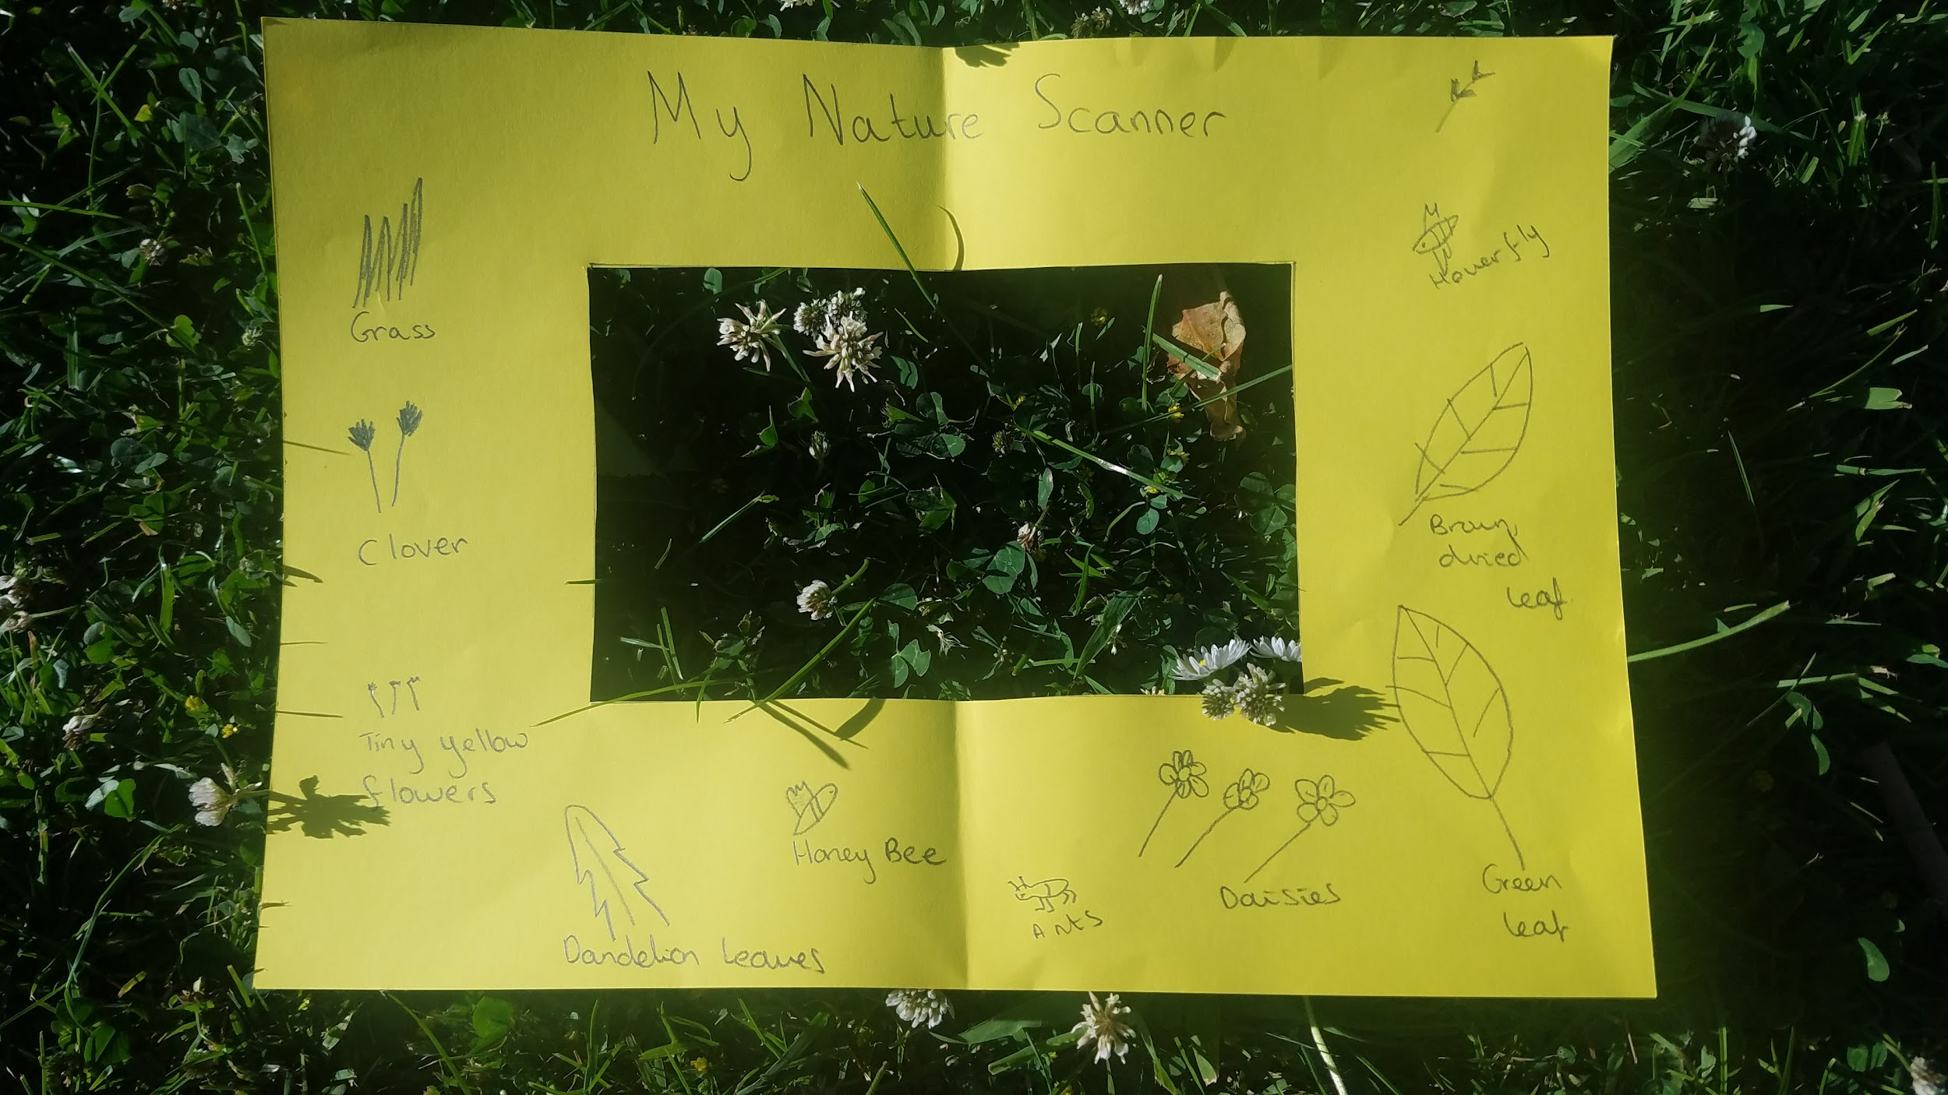  Around the edge of the hole in your scanner draw and label all the things you find. You might like to try more than one place! Don’t forget to share your finished Nature Scanners with us!
Day 4 | Literacy  Spelling  Practice your spelling using your spelling menu.  World Worst’s Teachers - create your own character. Imagine your own World’s Worst Teacher! What will your World’s Worst teacher be like? Too talkative? Too mean? Too loud? Too quiet? Too busy? Too lazy? Too strong?What would they be called? What would they look like? What would they sound like? What would people think of them?  Fill in the Google Doc in Classroom Assignments, or write answers to the questions above to tell us all about your World’s Worst Teacher. | Maths TTRockstars 10 mins  Teacher’s Times Tables  Use your times tables knowledge to answer a range of word problems all about your teachers! They are in a google doc in your assignments. You can type your answers in the doc. | Challenge  Butterfly Life Cycle  This Saturday is Butterfly Awareness Day! The idea of the day is to make sure everyone realises how amazing Butterflies are and how important it is to look after them and their habitats.  We’re sure you know that Butterflies start their lives as Caterpillars - watch this video to find out more!  https://www.youtube.com/watch?v=3kZD6rlSLUw  Now create your own diagram to show the different stages in the life of a Butterfly. It’s up to you how you set it out! You could do this on paper or on a Google Slide. Don’t forget to share your diagrams with us!
Day 5 | Spelling  5 minute spelling test  World’s Worst Teachers - write the opening of your own chapter  Write the opening of your own chapter about the terrible teacher that you created yesterday. If you’d like to, you could even write a whole chapter about them. I dread to think what might happen! Why not do this on a Google Doc or Google Slide - that makes it very easy to turn in! | Maths TTRockstars 10 mins  Times Tables Outdoors  Collect some objects outside, perhaps in your garden or when you go for a walk. You will need quite a lot - maybe 20 or so! Look for little things.  Can you use the objects you have collected to make some Times Tables Facts?  For example:  You could arrange 10 pine cones in 2 rows of 5 to show 2 x 5 =10  or  you could arrange 18 stones in 3 rows of 6 to show 3 x 6 = 18  or  you could arrange 12 leaves in 3 rows of 4 to show 3 x 4 = 12  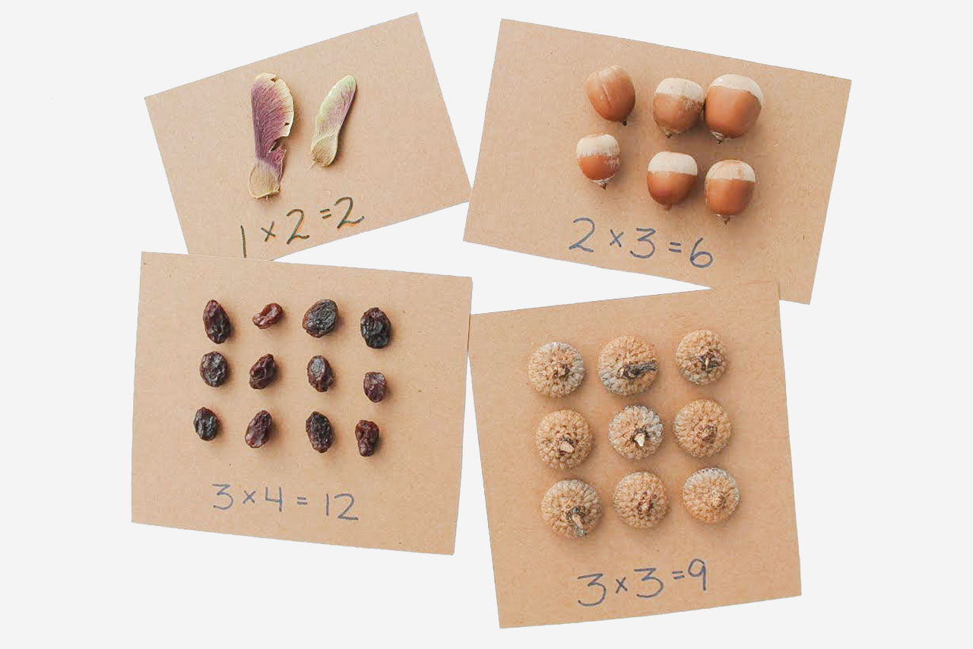  Don’t forget to share what you do with us! | Challenge  Balancing Butterfly  This is a great STEM Challenge!  Draw or print off a simple butterfly.  If you draw one, remember to make sure that it is symmetrical!  Fix a small weight underneath each wing, near the front of the butterfly - something like a paperclip or a small coin.  Can you get your butterfly to balance on a pencil tip? How about your fingertip? Where else can it balance? Do you have to make any changes to make it balance in other places? Make sure you send us a photo of your balancing butterfly!  