Rumney Primary School Year 4 Home Learning Week 10 ( 15th - 19th June)
Day 1 | 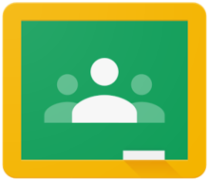  Literacy  Spellings  1. 10 mins using your spelling menu.  2. Can you write your spellings in ‘Alphabetical Order’  There is a sheet you CAN type your spellings straight onto in your google classroom to make it easier for you to ‘turn in’ your work | Maths TTRockstars 10 mins  Counting on and back in different steps  Can you recognise the number pattern?  Is it going forwards or backwards?  Find the next 4 numbers in the pattern?  You CAN type onto the maths sheet to turn it in | Challenge  Virtual Sports Day Activities - Welly Boot Throwing  Tips  - Try to keep your welly boot close to the side of your head with your elbow bent throughout the back and forward movement.  - Practice with some lighter objects like a pair of socks to get your technique right.  - Have a go with both hands to test our which side is stronger.  How to prepare  -Before throwing , get used to pushing your welly boot up and down over your head to get a feel for the movement  -Squats will help with your lower body strength and balance  -Try some forward and sideways lunges to get used to transferring your body weight backwards and forwards  -Tuck jumps will make you explosive and powerful to get maximum distance on your throw
Day 2 | Literacy  Fact File on a Famous Person  There are lots of famous people  in the world, pop stars, sports stars, actors / actresses, social media stars and so on……  You must all have a favourite famous person, or someone you think is really good at what they do.  We would like you to create 2 mini fact files on any famous person of your choice. Your 2 fact files must include:-  - A picture of them  - Their name and age  - Where they live  - What they are famous for  - A before they were famous fact  - 1 interesting / strange / funny random fact about them  There is an example in your google classroom  You CAN type straight onto it adding your own fact file underneath to ‘turn in’ | Maths TTRockstars 10 mins  Place Value  Have a go at the place value sheets in your google classroom, there’s lots of different style questions for you to have a go at to show your understanding.  You DON’T need to print this off to complete it you can write your answers on a piece of paper and send us the picture or you can type your answers on a google doc and ‘turn it in’ As long as you number your answers we will be able to see if you’ve got them right. | Challenge  Virtual Sports Day Activities - Superstrong Challenge  Tips  - Try to move your opposite arm and opposite leg at the same time to stay balanced  - Keep your back flat, there should be a straight line from your hips right through to your head  - Pretend you are carrying a bucket of water on your back and try not to spill any  How to prepare  - Start by practising your plank exercises to get your core strong  - Add in some push ups to build strength in your chest and shoulders  - Mountain climbers will help keep those hips loose and work on your endurance
Day 3 | Literacy  Creative Writing  Read the passage about the flying saucer.  Can you finish off the story explaining what happens?  How can you make the ending exciting?  Can you use lots of adjectives in your writing to make it exciting to read?  You CAN type straight onto the sheet to ‘turn it in’ | Maths TTRockstars 10 mins  Adding Money Challenge  Every letter of the alphabet is worth 1p eg a = 1p, b = 2p, c=3p and so on.  (there is a grid in google classroom to help you)  Now write a simple shopping list and work out the cost of each item by adding together the values of the letters eg  b r e a d  b= 2p, r=18p, e=5p, a=1p, d=4p  2p+18p+5p+1p+4p=30p  Which was your cheapest item?  What was the most expensive?  You CAN type straight onto the sheet to ‘turn it in’ | Challenge  STEM Challenge - How strong is a piece of paper?  We would like you to test the strength of paper by folding it in differently shaped columns, a triangle, a circle and a square and piling books on top. This is very similar to how columns are used to support buildings and other structures.  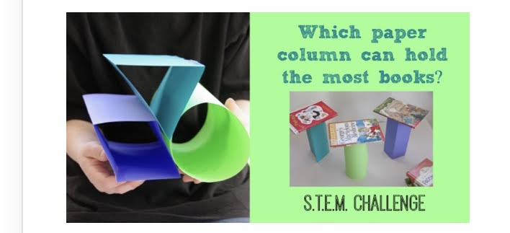  Instructions  - Use 3 pieces of ordinary paper  - Fold each piece of paper into the 3 shapes and secure with tape  - Stand the paper columns up on its end  - Make your prediction  - Add a book to each column one at a time  - How many books can you pile on top of each shape without them collapsing?  There is a ‘science’ style sheet in your google classroom which you CAN type straight onto. Have a look at it BEFORE you begin the experiment
Day 4 | Literacy  Better words for ‘said’ and ‘went’  Look at the sentences, can you improve them by using more interesting words for said and went  Remember there are 2 sheets in your google classroom and you CAN type on them to ‘turn it in’ | Maths TTRockstars 10 mins  Simple Subtraction  Great practice to keep your subtractions skills up to scratch  Extra challenge - time yourself to see how quickly you can complete them!  You DON’T need to print this off to complete it you can write your answers on a piece of paper and send us the picture or you can type your answers on a google doc and ‘turn it in’ As long as you number your answers we will be able to see if you’ve got them right. | Challenge  Blind Taste Testing  You might need some help with this one - ask an adult or older sibling to prepare a few little bowls of different foods from your cupboard (try and make them a mixture of salty sweet bitter and sour if you can)  Blind fold yourself - NO PEEKING!  Can you identify the food you’re tasting without looking?  Make a list of what foods you could identify and those you couldn’t  Can you sort all the foods you test into the 5 categories sweet, bitter, salty and sour?  Fill in the table on your google classroom you CAN type straight onto it
Day 5 | Literacy  Using the correct Tense  Look at the sentences , can you choose the correct past tense and future tense words so the sentences make sense?  Remember there are 2 sheets in your google classroom and you CAN type on them to ‘turn it in’ | Maths TTRockstars 10 mins  Big Maths  Double 2d numbers  Remember:-  - Partition the number  - double both sides  - add them back together  36  partition 30 6  double 60 12  add 60+12  72  You DON’T need to print this off to complete it you can write your answers on a piece of paper and send us the picture or you can type your answers on a google doc and ‘turn it in’ As long as you number your answers we will be able to see if you’ve got them right. | Challenge  Mindfulness challenge cards  A peaceful way to end the week! - There are lots of mindfulness challenge cards to choose from and you can use these whenever you want a little bit of thinking / relaxing time. Encourage your family to take part too.  There is nothing to hand in but any pictures are always welcome.

