Rumney Primary School Year 1 - Home Learning Summer Term 2 Week 4
Day 1 | Literacy  Your mission for today is to create your own obstacle course, ideally outside, but it can be indoors if you need it to be. Think carefully about what household objects you could use e.g. skipping rope as a tightrope, food tins as cones, sheets to crawl under.. anything goes!  How will you know which way to go? How will you know where to start/finish? Using paper and pens carefully draw a plan and label it.  Challenge-  Make some  signs/instructions for your obstacle course so that the other people in your family know how to have a go too! | Maths  Hit the Button (Number bonds to 20)  https://www.topmarks.co.uk/maths-games/hit-the-button  Today we are going to look at comparing numbers using the symbol > for greater than and < for less than.  Watch the video from Twinkl: https://www.youtube.com/watch?v=fd-Uw-uRGFE  Have a go at putting the correct symbol in between these numbers:  45 75  21 25  38 64  25 21  42 65  Your adult can challenge you to do some even bigger numbers if needed. | Finals Week  Rumney Primary Summer of Sport!  Thank you all for all your super efforts with our Summer of Sports! We are so proud of you all. Will you earn 50 points in your final week? Let’s go for it!  The instructions for the final activities are here:  https://healthy-kidz.com/week-4-marathon-challenge-create-your-own-obstacle-course/  As usual, send in your scores every day and tweet your photos and videos. We will end our Summer of Sports with a picnic celebration on Friday. Yum!
Day 2 | Literacy  Today we are going to research a Welsh sporting hero and then write a short biography about them. A biography contains information about a person’s life.  Some examples of a sporting hero are Tanni Grey Thompson, Gareth Bale, or Sam Warburton.  There is a biography template here:  https://www.twinkl.co.uk/resource/t2-e-1262-mini-biography-writing-frame  Keyword revision | Maths Ordering numbers to 100 https://www.topmarks.co.uk/ordering-and-sequencing/coconut-ordering  Roll two dice to make a 2-digit  Number. Do the same again to make another 2-digit number.  Compare the numbers using the symbol > for greater than and < for less than.  Repeat 5 times.  Play TT Rockstars for 10 minutes | Welsh  Sports/Chwaraeon  Draw and label the sports in Welsh.  Reidio beic - riding a bike  Chwarae tenis - playing tennis  Chwarae rygbi - playing rugby  Dawnsio - dancing  Rhedeg - running  Chwarae Pêl-Droed- playing football  Physical -  Marathon challenge and obstacle course.
Day 3 | Literacy/PSE  Write a menu for your celebration picnic. Include pictures of each food. Make sure you include lots of delicious, healthy foods! What will you include?  Can you put the foods onto a shopping list?  Keyword revision | Maths TTRockstars 10 mins  Word problems. Read each challenge card carefully with your adult and work out the answer.  https://www.twinkl.co.uk/resource/t-n-2545155-year-1-sports-day-maths-differentiated-challenge-cards  Challenge -  Can you write your own word problems? | Creative-  Talk to your adult about the different clothes worn in sports. Design some clothes for your favourite sport. It could be a new football strip, leotard for gymnastics or athletics kit. Label any special features.  Physical -  Marathon challenge and obstacle course.
Day 4 | Literacy  We are team players in Year 1, but what makes a good team player? Think about some of the skills that you might need, e.g. being a good listener, being patient etc.  Complete the online quiz with your adult.  https://www.educationquizzes.com/ks1/personal-social-and-health-education/working-together/  Can you write a set of instructions on how to be a good team player? Remember when writing instructions we need to include some bossy verbs and to number each instruction.  Challenge -  Go on Oxford owls – explore all the stories and find one you would like to read (use your school book band to find the correct level). Complete the activities at the end. | Maths TTRockstars 10 mins  Addition and Subtraction  Make number fact families using bonds to 20 + - and =. You can draw some pictures to accompany each sum.  e.g.  14+6=20  6+14=20  20-6=14  20-14=6  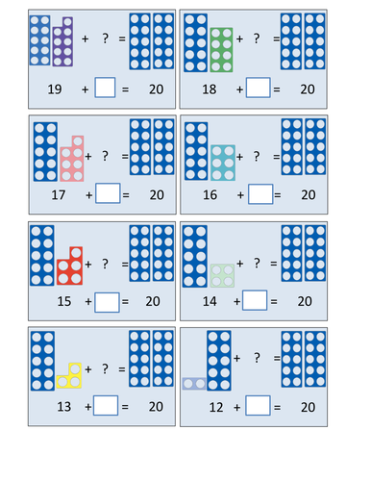  Play TTRockstars 10 minutes | Welsh  Practise the Welsh words for Sports that you learnt on Tuesday.  Act out the sport and ask 'wyt ti'n hoffi ......?' Your partner can answer 'ydw' or 'nag ydw'. Swap roles.  Have a go at some Welsh games.  https://www.learn-welsh.net/welshgames  Or watch some Welsh kids tv https://cyw.cymru/en/  Physical -  Marathon challenge and obstacle course.
Day 5 | Literacy  Write an acrostic poem with a sports theme. You can choose the word to go down the side.  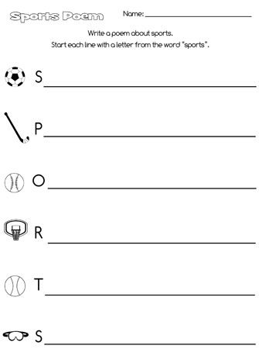  Challenge -  Go on Oxford owls – explore all the stories and find one you would like to read (use your school book band to find the correct level). Complete the activities at the end. | Maths  Repeating patterns. Have a go at making your own repeating patterns of 3 or more shapes. There’s an example below:  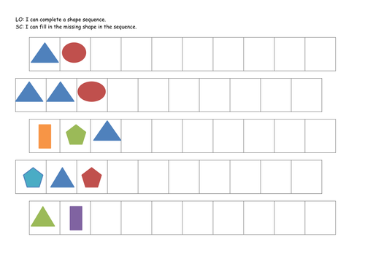  Play TTRockstars 10 minutes | Physical -  It’s party time! Perform your  Marathon challenge and obstacle course to the very best of your ability. Your family can cheer you on! Don’t forget to wear your house colours if you can. Celebrate all your super sporting achievements over the last four weeks.  Tweet your distance and time to your teachers. Don’t forget to send any pictures and videos so we can share with your friends!

