Rumney Primary School Y3 Home Learning - week beginning 18/5/20
Day 1 | Maths activities  Telling the time. Last week we started work on telling the time. This week we are going to look at analogue and digital time. You will still be at different stages when it comes to telling the time so your adult will help you to decide if you are ready to move on to this week’s work or if you need to continue practising what we did last week. If you need to stay on what we did last week then click on the links on last week’s planner. Remember it’s not a race and the goal is to confidently be able to tell the time.  Look at the clips below to start your learning  Once you have watched the bbc bitesize clip complete the activity - matching analogue time to digital time.  https://www.bbc.co.uk/bitesize/topics/zkfycdm/articles/zcrmqty  https://www.youtube.com/watch?v=ENOYemdWU08  https://www.topmarks.co.uk/Search.aspx?q=digital%20clock  Use the interactive digital clock to practise telling the time. Ask somebody to give you a time and then you show it on the digital clock. | Literacy activities  Spelling patterns & Key words  This week's spelling patterns are posted on Google Classroom ‘Classwork’ for you to practice using LOOK, COVER, WRITE & CHECK. Remember to carry on practising your Key Words as well.  Quiz Kidz  During lockdown many people have been keeping themselves busy by holding family quiz nights. Quizzes are good fun and help to keep your mind active. They also help you learn new things.  Have a go at this ‘Thank you’ quiz on CBBC.  https://www.bbc.co.uk/cbbc/quizzes/bp-thank-you-quiz | ALL ABOUT ME  Please continue to ‘turn in’ your Who & what is important to you task as we are still missing some.  Mrs Rogers  https://classroom.google.com/u/0/c/NjAwOTA3NTY3NTha/a/OTMyNTc0MjYyOTFa/details  Mrs Williams  https://classroom.google.com/u/0/c/NjAwOTE4MTg5MzBa/a/NzkyNDAxMzE3ODJa/details  Thank you  CHELSEA FLOWER SHOW  On Monday 18th May, the Chelsea Flower Show begins in London. This year, because of lockdown, people will not be able to visit the fantastic gardens but will have to look at them on TV or online.  Look at this newsround article  https://www.bbc.co.uk/newsround/48354702  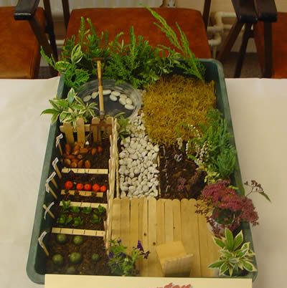  Shoe box garden - task  Ask an adult to help you collect a range of materials from the garden - eg. pebbles, soil, twigs, flowers, leaves etc.  Use your workbook to draw and plan out your showbox garden. Consider a pond, a bridge, a swing, a play area etc.  Build your garden and then take some close up photos.  Can you post your photos on Y3 Twitter page for us all to enjoy a Year 3 Rumney Flower Show?  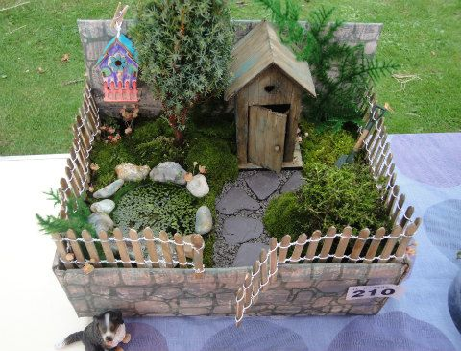
Day 2 | Telling the time  If you are ready to move on click the links for today’s practise games if not keep working on the work from day 1.  Look at the game telling the time and match the analogue times with the digital times  https://mathsframe.co.uk/en/resources/resource/117/telling-the-time-in-words  Follow the link to play the games. Choose the right level for you.  https://www.helpfulgames.com/subjects/mathematics/digital-clock.html#  Look in your google classroom for the Match the Time worksheet. | Reading task - Close up pictures  Have a go at the Picture Quiz on Google Classroom. Look carefully at the close up photos and guess what the object is. Show your family the pictures - can they beat your score?
Day 3 | Telling the time  To recap look at the links again. Decide what stage you are on and play the games for that stage.  It’s time to practice your skills now. Choose from the Digital Time worksheets on Google Classroom.  Remember to become an expert at telling the time you have to practice. So tell the time whenever you can! Also remember to choose the correct level for you. 1 star is the easiest, 2 stars middle and 3 stars is the hardest. | Would you rather?  Look at the Would you rather? Powerpoint on Google Classroom. Think about the questions - what would you rather?  Use the Would you rather activity sheet to answer the questions in your workbook.  Now ask your family the same questions. Do they give the same answers as you?
Day 4 | Chestnuts vs Cherry Blossoms - Battle of the Bands Round 3  Last week’s battle was a great success. A huge well done to the winning class (see Twitter Y3 page)  Another battle has been scheduled between our two classes on TT Rockstars. The class with the biggest score will win the Battle of the Bands and become this week’s champions!  Log on to your TT Rockstar account and click on Tournaments. The battle will begin 9.00am on Thursday 21st May and will end on Friday 22nd May. It is our last battle before half term so let’s make it a good one!  Good Luck! May the best class win!  https://ttrockstars.com/ | General Knowledge Quiz  Organise a family quiz where you are the quiz master. Use the General Knowledge quiz sheet on Google Classroom to quiz your family. They will need to write the answers down on paper. Count up the scores after each round and then find the total.  Have fun!  Extension task:  If you have some spare time, you might want to write some quiz questions about your family. They are always good fun!  eg. What colour is Nan’s front door?  What is Mum’s favourite drink?  What was our first ever pet called?  How many times have we been to McDonalds?
Day 5 | Chestnuts vs Cherry Blossoms - Battle of the Bands Round 3  Keep going everyone! May the best team win! | My Diary  Look back at your week and write about what you have been doing. Think about:  How have you been kind to someone this week?  What activities have you enjoyed doing?  Have you made or created anything this week?  Have you seen anyone whilst out walking?  Why not send us some pictures of you having fun outdoors on Twitter or Google Classroom?

