Rumney Primary School Y3 Home Learning - week beginning 11/5/20
Day 1 | Maths activities  Telling the time  When it comes to telling the time you will all be at different stages. It doesn’t matter where you are with telling the time but you will have to work out the best place for you to start. Ask your grown up to help you decide.  Look at the clips below to start your learning  https://www.bbc.co.uk/bitesize/topics/zkfycdm/articles/zcrmqty  https://www.bbc.co.uk/bitesize/topics/zhk82hv/articles/zcmdwxs  This game has different levels. Decide where you need to start. Don’t move onto the next level until you completely understand. The place to start is O’clock and Half past. Remember it doesn’t matter what stage you are on. What is important is that you learn how to tell the time confidently. Concentrate on section 1-3  https://mathsframe.co.uk/en/resources/resource/117/telling-the-time-in-words | Literacy activities  Spelling patterns & Key words  This week's spelling patterns are posted on Google Classroom ‘Classwork’ for you to practice using LOOK, COVER, WRITE & CHECK. Remember to carry on practising your Key Words as well.  Who is Banksy?  A secretive artist called Banksy has posted a piece of artwork on a corridor wall in a hospital in Southampton. It shows a little boy playing with his superhero toys and the toy he likes the best is a superhero nurse!  Read and watch these clips to find out more;  https://www.bbc.co.uk/newsround/52561722  https://www.bbc.co.uk/news/entertainment-arts-52556544 | HOLD STILL - PHOTOGRAPHY PROJECT  The Duchess of Cambridge is encouraging children to take a photo of ‘life in lockdown’. Look at this article for more information:  https://www.bbc.co.uk/newsround/52545189  Ask an adult to use their phone or your tablet to take a photo of something special whilst your family are in lockdown.  Upload your photo to the National Portrait Gallery website https://www.npg.org.uk/hold-still/  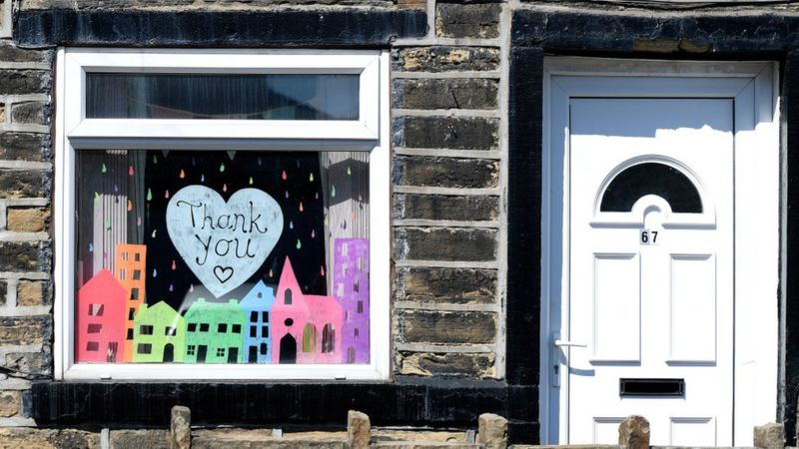  BANKSY  Use black and grey pencils to create your own piece of art based on Banksy’s style. Look on Google for some images of Banksy’s work.  Don’t draw on the wall though! Use white paper. Can you pin up your work secretly for someone in your family to find? Ssssh - don’t tell anyone!  ALL ABOUT ME  Please ‘turn in’ your Who & what is important to you task as we are still missing some.  Mrs Rogers  https://classroom.google.com/u/0/c/NjAwOTA3NTY3NTha/a/OTMyNTc0MjYyOTFa/details  Mrs Williams  https://classroom.google.com/u/0/c/NjAwOTE4MTg5MzBa/a/NzkyNDAxMzE3ODJa/details  Thank you
Day 2 | Telling the time  If you are ready to move on to 5 minute intervals then listen to the catchy song in the link below.  https://www.youtube.com/watch?v=jGtBYUQKF4M  Go back to yesterday’s game and click on section 4  If you still need more practise with O’clock, Half past, Quarter past and Quarter to then stick to games 1-3 | Reading comprehension - Google Classroom  Who is Banksy? Reading comprehension- read about this secretive artist and make some notes about him in your work book.
Day 3 | Telling the time  To recap look at the links again. Decide what stage you are on and play the games for that stage.  It’s time to practice your skills now. Choose from the worksheets on Google Classroom and write your answers in your workbook.  Remember to become an expert at telling the time you have to practice. So tell the time whenever you can!  o’clock, half past, quarter past/to  5 minute intervals | Banksy Fact File  Use the notes you have made to create a Fact File about Banksy. Use sub headings, titles, pictures and relevant information & facts to organise your work.  This can be done in your work book or you can create a Google Doc or Google Slide and ‘turn in’ your work to me on Google Classroom. It’s up to you!
Day 4 | Chestnuts vs Cherry Blossoms - Battle of the Bands Round 2  Last week’s battle was a great success. A huge well done to the winning class (see Twitter Y3 page)  Another battle has been scheduled between our two classes on TT Rockstars. The class with the biggest score will win the Battle of the Bands and become this week’s champions!  Log on to your TT Rockstar account and click on Tournaments. The battle will begin 9.00am on Thursday 14th May and will end on Friday 15th May.  Good Luck! May the best class win!  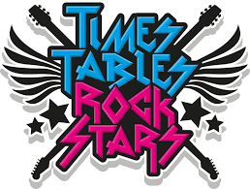  https://ttrockstars.com/ | Banksy Fact File  Use the notes you have made to create a Fact File about Banksy. Use sub headings, titles, pictures and relevant information & facts to organise your work.  This can be done in your work book or you can create a Google Doc or Google Slide and ‘turn in’ your work to me on Google Classroom. It’s up to you
Day 5 | Chestnuts vs Cherry Blossoms - Battle of the Bands Round 2  Keep going everyone! May the best team win! | My Diary  Look back at your week and write about what you have been doing. Think about:  What activities have you enjoyed doing?  What happens on ‘Clap for carers’ on your street?  Did you celebrate VE day?  Who have you spoken to this week?  Why not send us some pictures of you having fun outdoors on Twitter or Google Classroom?

