Rumney Primary School Y3 Home Learning - week beginning 4/5/20
Day 1 | Maths activities  Chestnuts vs Cherry Blossoms - Battle of the Bands  A battle has been scheduled between our two Year 3 classes on TT Rockstars. The class with the biggest score will win the Battle of the Bands!  Log on to your TT Rockstar account and click on Tournaments. The battle will begin 9.00am on Monday 4th May and will end on Thursday 7th May.  Good Luck! May the best class win!  https://ttrockstars.com/ | Literacy activities  Spelling patterns & Key words  This week's spelling patterns are posted on Google Classroom ‘Classwork’ for you to practice using LOOK, COVER, WRITE & CHECK. Remember to carry on practising your Key Words as well.  VE Day  On Friday 7th May it is the 75th anniversary of VE day. Watch the clips below to find out all about VE day and why it is celebrated.  https://www.bbc.co.uk/teach/class-clips-video/history-ks2-ve-day/z7xtmfr  https://www.bbc.co.uk/newsround/48201749  In your book write some sentences about what you saw in the video clips and any facts you heard about VE day.  Why do you think it is important that we still celebrate and remember this today? | VE day celebrations  World War 2:  On the 8th May 1945 the German Nazis surrendered and victory in Europe was declared.  Sadly millions had died, but the millions who had been saved were able to celebrate the end of a six year world war and the VE Day (Victory in Europe) parties went on for quite some time!  VE day song  https://www.bbc.co.uk/cbbc/watch/horrible-histories-songs-ve-day-song  Union Jack flag collage  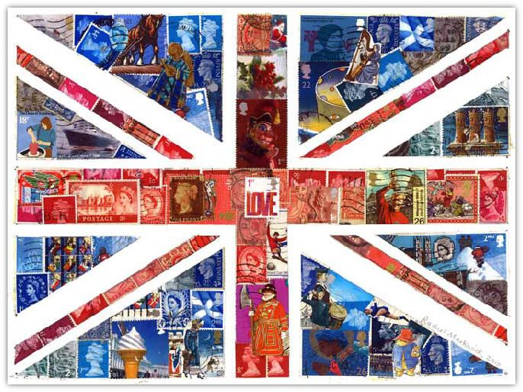  Ask an adult for some old magazines or leaflets. Rip out any red, white and blue items from the magazine. Glue them down onto paper in the formation of the Union Jack Flag. Fill in any gaps with red, white and blue paper or coloured pencils.
Day 2 | WW2 shopping  Collect items from your kitchen and set up a WW2 grocery shop. Make some price labels for each item. You can choose the prices - 2 digit numbers or 3 digit numbers.  Ask your family to come to the shop and buy items. Add the items together and find the total. Write these sums in your workbook.  eg. potato 65p + tin of peas 23p = 88p  eg. dishcloth £1.22 + wooden spoon £1.35 = £2.57  Can you work out how to give change from £1.00 or £2.00? | Reading comprehension  Google Classroom: VE Day reading comprehension- read about WW2 and VE Day and answer the questions in your work book. Use a full sentence for each answer.
Day 3 | Times table Challenge - We know you’ve been practising TT Rockstar times tables. Use your times table knowledge to have a go at this game!  https://www.topmarks.co.uk/maths-games/hit-the-button | VE Day  It’s time to get creative! Use the internet to research the celebrations and the parties that were held on VE Day. You can also look at the clips from the beginning of the week to help you.  Choose from the 2 activities below.  Activity 1  Create an Information poster all about VE day. Think about adding pictures such as flags and bunting to make your poster stand out.  Activity 2  Plan your own family VE day party. What food will you eat? What games will you play? What songs will you sing? Remember to include things that they would have had back in 1945.
Day 4 | Cooking and Rationing during WW1 and WW2  Watch this clip to find out about what people used to eat in wartime. Food was in very short supply and people had to be careful not to waste any food.  https://www.bbc.co.uk/bitesize/clips/zwrkwmn  Maths & Literacy: Read and follow this recipe for a delicious Wartime Carrot Cake. It uses carrots to sweeten instead of sugar.  https://www.nationaltrust.org.uk/croome/recipes/wartime-carrot-cake
Day 5 | BANK HOLIDAY  VE DAY CELEBRATIONS | BANK HOLIDAY  VE DAY CELEBRATIONS

