Rumney Primary School Year 4 Home Learning Week 6
Monday 11th - Friday 15th May
Day 1 | Literacy  New Spellings delivered.  Practice your new words using your spelling menu.  May 11th Fair Trade Day  Did you know that today (May 11th) is Fair Trade Day?  Look at these film clips from YouTube on FAIR TRADE.  https://youtu.be/JoIZWd2q2Ec  https://youtu.be/VeUGvhINwHw  https://youtu.be/75xjgRoFLWs  - Write some sentences explaining what FAIR TRADE means.  - Write a list of some of the foods that are FAIR TRADE  - Say why you think it is important to buy Fair Trade goods where possible.  - Draw the FAIR TRADE symbol.  You could do this work on paper or turn it in using Google Docs. | Maths TTRockstars 10 mins  Fair Trade Maths Challenge  Have a look on the website of the supermarket where your family does their shopping.  - List the products that they sell that are FAIR TRADE  - Write the price of these FAIR TRADE foods  - NEXT, write the price of the same foods but NOT fair trade  - Look at the difference in prices - is the Fair Trade product cheaper or more expensive?  - Work out what the difference is in price (HINT: you will need to do take-away sums!)  There’s a worksheet in google classroom with a table to help you to do this children or you could just complete the work in your books from school | Fair Trade Artists Challenge ...  Design a poster encouraging people to buy Fair Trade goods from their local supermarkets.  Include a catchy slogan (in bubble writing if possible) to persuade people that supporting farmers in other countries by buying Fair Trade is a great idea  EG.  - Let’s Play Fair, Buy Fair Trade!  - Fair Trade is Fairer for Everyone!  You could add drawings of Fair Trade products OR cut out pictures of Fair Trade products and stick them on your poster.  Make sure you include the FAIR TRADE symbol you saw this morning on the Youtube clips.  You can do this poster in your books, on a large piece of paper or create a google doc that has pictures in it of Fair Trade products you found on Google images.
Day 2 | Literacy  Spelling  Practice your spellings using your spelling menu.  Fair Trade Recipe Writing  Can you remember the foods that are FAIR TRADE from yesterday?  - Choose any of the foods and include them now as you try to write your own recipe.  - You might want to use a recipe you’ve found or that you know, just making your own little changes to it.  - If you can, take a photo of your work and upload it to show us how you did. | Maths TTRockstars 10 mins  Division Problems  - Have a go at these worded Division problems. Do as many as you can.  - Ask an adult to help you read them if you’re not sure.  - They start off easy but get a bit more challenging.  There is a worksheet children in google classroom but put the answers in your books or put them into a google doc to upload | POETs, RAPPERs, MUSICIANs FAIR TRADE Challenge...  Can you create a poem, rap or song about FAIR TRADE?  Go on - Have a go!  You could even take photos or make a short clip of you reading, rapping or singing your creation.  Good Luck!
Day 3 | Literacy  Spelling  Practice your spelling using your spelling menu.  Year 4 So Far Questionnaire…  We’d love to know what you think of your time in Year 4 so far, what you’ve taken part in, and what activities you’ve enjoyed. Go to Google Classroom to find a questionaire for you to fill in all about Year 4 so far. Although it’s on two pages, most of the questions only need a yes or no answer, so it shouldn’t take too long! | Maths TTRockstars 10 mins  Time Problems - Time for some work on time children!  Remember we did this a little while ago? Well here’s a bit of time practice.  Have a good time doing this time sheet in google classroom!  Write the answers in your books or put them into a google doc to upload | 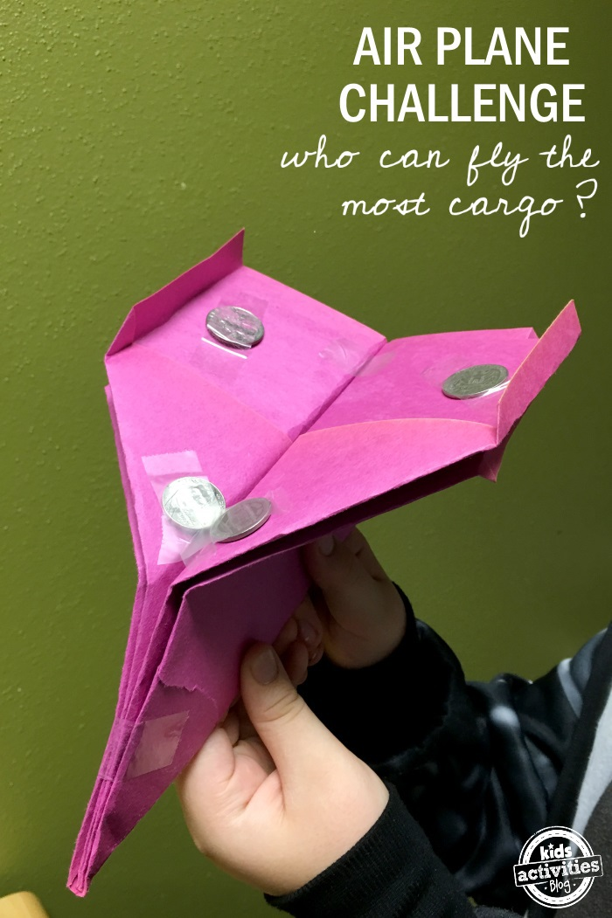  STEM Challenge!  Can you make a paper areoplane that will glide at least 3 metres AND carry a cargo of some mini figures or some coins? You will probably have to make a few different designs until you find one that works - be patient! We’d love to see photos or videos of your paper areoplanes in action - you could post them on your Class Stream or on the Year 4 Twitter feed.
Day 4 | Literacy  Spelling  Practice your spelling using your spelling menu.  WORLD BEE DAY -  World Bee Day is coming up children! Perhaps now more than ever we need to bee (!) doing all we can to look after our bees and make sure there are still plenty of them around for the future.  Draw a bee in the middle of your page (you could always download a picture, or cut a picture out if you’d rather not draw your own).  Can you write as many adjectives and similes as you can to describe bees and how they move? Try using alliteration ….  EXAMPLE:  - moving like large, furry, stripy bullets  - as stripy as humbug sweets  - their stripes are as yellow as dandelions and as brown as chocolate  - buzzy brown bumbling bees  See how many you can do either in your books or on a google doc if you wish | Maths TTRockstars 10 mins  Stunning Symmetry  Collect 10 - 12 objects from around your home or garden that are symmetrical.  EITHER ...  Take a photo or photos of them, using wool or string to show the line/s of symmetry  OR ...  Draw pictures of them in your book, using a ruler to get a straight line to show where the line/s of symmetry are.  REMEMBER  - For an object to be symmetrical it must be exactly the same on both sides of the line of symmetry.  - Sometimes there can be more than one line of symmetry. | Symmetry Challenge  Create a picture of something that is symmetrical.  - It can be a symmetrical pattern or it can be a creature made up or real that is symmetrical.  - You can use whatever you have to hand to create your picture.  - You could even build a model that is symmetrical either from recycled items or from Lego.  - Be as creative as you like and have fun!  - If you can, upload a photo of your symmetrical creation for us to admire.
Day  5 | Spelling  5 minute spelling test  World Bee Day - Did you know that on 20th May is World Bee Day?  World Bee Day Quiz  See if you can find the answers to some or all of these questions about bees!  - How many different kinds of bee do we have in Britain?  - How do bees make honey?  - How can you make your garden more bee friendly?  - What is one of the problems our bees are facing at the moment?  World Bee Day Research - Can you find out anything about Bees/World Bee Day?  https://www.seewhatgrows.org/how-to-celebrate-world-bee-day/  Ask your adults, look on the internet or in books for some information.  EITHER put your facts onto a Google Slide so you can turn it in.  OR  Draw a picture showing how our gardens can be made more bee friendly. Draw in the things that attract bees.  Label your picture.  Can you choose ONE thing that you could do in your garden to make it more bee friendly? | MATHS - TTRockstars 10 mins  BEE MATHS!  Did you know that some bees are as long as 1.5 cm?  Can you find and draw or photograph 10 objects in and around your house & garden that are 1.5 cm or smaller?  Remember children ….  - you may well need to use mm to measure the objects you find  - there are 10 mm in 1cm  Have a go, try to bee (!) as accurate as you can!!  FUN FRIDAY EXTRA….  How many BEE jokes can you find to share with us on stream?  BEE as funny as you’d like!! | World Bee Day Cooks Challenge -  Can you find a recipe that uses honey as one of its ingredients?  - If possible follow the recipe with your adults and make the dish.  - Have a look at what the recipe needs you to do. Is there cooking involved or can some recipes using honey be made without using the cooker?  - Can you make a list of ingredients you would need to make the recipe?  - Can you work out how much it would cost to buy the ingredients to make the recipe?  - Take photos to upload or in your books draw a picture of yourselves & your adults making your recipe that uses honey. Include some sentences explaining what you did.  Quick Question  Were you surprised at how many recipes have honey as one of their ingredients?

