Rumney Primary School Home Learning - Monday 6th July (Week 13)
This week we will be reading and completing tasks based on the book ‘Superworm!’
Literacy | - Watch this clip to find the book ‘Superworm!’ https://youtu.be/7Jnk3XApKBg  - Ask an adult to read this poem to you. https://www.yumpu.com/en/image/facebook/24160782.jpg Can you answer these questions? 1) What season are worms the fattest? 2) What animal likes to eat the worms? 3) When the boy was very young, where did he put a worm? 4) Who thinks the little boy ate a worm?  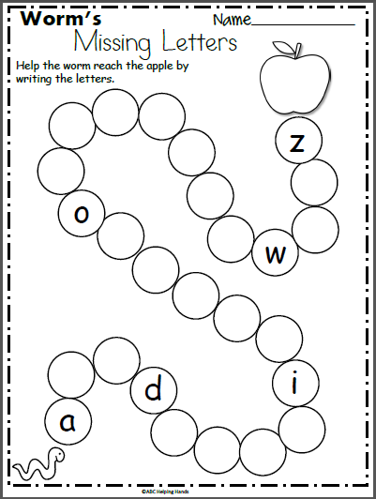  - Watch this clip about worms. https://youtu.be/7O40A-6Jmt4 Talk about and then write down your favourite facts about worms. Think about how to spell your keywords and sound out unknown words using your letters and sounds.  - Can you read these sentences with your key words? You do not need to print them out but can read them from the screen! https://www.twinkl.com/resource/t-t-252808-minibeasts-simple-sentence-cards  - Sometimes worms forget the letters of the alphabet! I told them you were really good at remembering the letters and could help! Are you up for the challenge? Watch this video to help remind you https://www.youtube.com/watch?v=hKakY4OQthA Try and write letters on a hungry worm.
Maths | 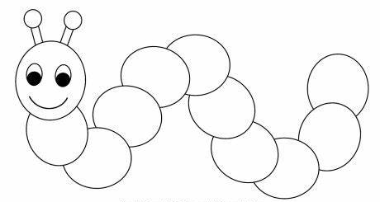  - Oh no!! The worm’s body parts are usually numbered but now they have rubbed off. Ask your adult to help you draw a worm with a number to 20 in the middle. Fill in the missing numbers.  - Can you order numbers to 20? https://www.topmarks.co.uk/ordering-and-sequencing/caterpillar-ordering  - Use objects or your fingers to find the answers. https://uk.ixl.com/math/reception/complete-the-addition-sentence-sums-up-to-10  - The worm was ‘Super Long’. Can you find the objects that are longer and shorter? https://uk.ixl.com/math/reception/long-and-short  Continue to  - form numbers correctly - using number formation rhymes  - Play ‘post it maths’ (see last week). Using the number to 20 cover the answer with the ‘post it’ question.
ICT | - Find and type the numbers using a keyboard. https://uk.ixl.com/math/reception/add-doubles-sums-up-to-10  - Explore the outside. Where do you think you might find a worm? Where do they like to live? Can you take a photo of a worm? You could ask your adult to show us on Twitter…. don’t forget to tell us what you called it!!  Continue to  - Practice your tens and untis https://www.splashlearn.com/math-skills/first-grade/place-value/numbers-up-to-20
General | 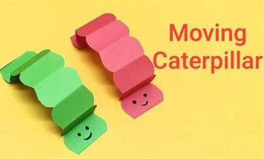  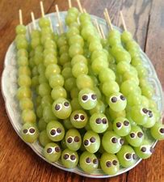  - Who will win the paper worm race? Watch this video on how to make and race your own paper worm! https://youtu.be/IxEhFgJ-Bjk  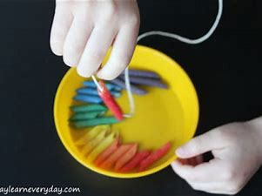  - I don’t normally eat worms…. but these grape worms look tasty!! Can you make your own fruit worms as a healthy snack?  - Can you use your funky fingers to make your own wiggly worm by threading pasta or cereal onto sting? Can you colour the pasta in to make different patterns?  - Listen to and sing along to the song Wiggly Woo! Can you join in the actions too? https://www.youtube.com/watch?v=vdWsez-CD5o
Superworm https://youtu.be/7Jnk3XApKBg
Worm poem https://www.yumpu.com/en/image/facebook/24160782.jpg
Video about worms https://youtu.be/7O40A-6Jmt4
Mini beast reading https://www.twinkl.com/resource/t-t-252808-minibeasts-simple-sentence-cards
Alphabet song https://www.youtube.com/watch?v=hKakY4OQthA
Caterpillar ordering https://www.topmarks.co.uk/ordering-and-sequencing/caterpillar-ordering
Adding https://uk.ixl.com/math/reception/complete-the-addition-sentence-sums-up-to-10
Long and short https://uk.ixl.com/math/reception/long-and-short
Make a worm https://youtu.be/IxEhFgJ-Bjk
Sing along to Wiggly Woo https://www.youtube.com/watch?v=vdWsez-CD5o

