Rumney Primary School Year 1 - Home Learning
If you have any queries and wish to contact us then please email us directly. We are here to support your child, their learning and yourselves so your child’s learning can be at its best. Parents/carers of children with IEPs will be emailed directly and support and guidance in relation to their targets will be given.
Mrs Lewis - Cherries - slewis@rumneyprm.net
Mr Fryer/Mrs Moore - Apples - dfryer@rumneyprm.net gmoore@rumneyprm.net
Please note;
- Parents should access the year group Twitter page for information and school updates. Throughout the week we post further activities to support your child’s learning. You can also communicate with us via Direct Messages on Twitter.
- We ask that parents ‘post’ pictures/messages on @RumneyPrmYearOne Twitter page to show engagement in home learning.
- Contact will be made with families who are not engaging with home learning so guidance and support can be offered.
Day 1 | Literacy- Writing  We are going to have a go at writing some of our own New Year’s resolutions.  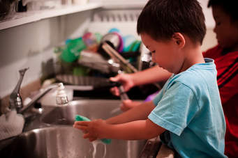  Is there anything that you would like to do/try? Maybe you would like to learn to draw better or try new fruits you have never eaten.  Could you be more helpful in any way? How could you help your grown ups around the house?  Challenge  Write out your New Year promises | Maths-Ordering/ Number  It’s the beginning of January- the first month of the year.  Do you remember the months of the year?Here is a little song to help.  https://www.youtube.com/watch?v=Fe9bnYRzFvk  Can you write how many days there are in each month?  Challenge  Which month has the most number of letters in it? Is it January or September?  Which number has the least number of letters -is it March or June? | KUW  if you are out and about on your daily walk or even in your home and garden.  Can you find  5 things that have a scent (a special smell)  5 things that are red  5 things that start with a ‘ch’ sound  5 different shaped leaves  Challenge  Could you find something that you could use to make a gift for someone?
Day 2 | Literacy-Speaking/|Listening  Listen to the story of ‘The snail and the whale by Julia Donaldson,  https://www.bbc.co.uk/iplayer/episode/m000cslw/the-snail-and-the-whale  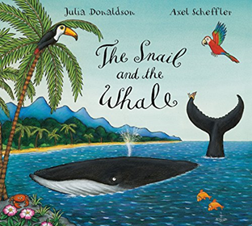  Challenge  Can you tell your grown up the rhyming words you can hear? flock/ rock, caves/waves.  You could make a list of them and find other words to rhyme too. | Maths- Measuring  Have you got cuddly toy animals at home? or you could use lego pieces, cardboard boxes etc. Have a go at putting them in order of size from the smallest to the biggest. 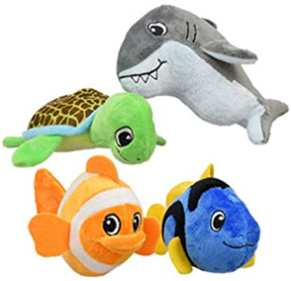  Challenge  If you have got a measuring tape or ruler then you can measure their height in centimetres. What size is the smallest? What size is the biggest? | Cutting Skills  Ask your grown up to help you draw around your hands. Think of all the things you can do with your hands. you might need to cut out two pairs or more and you can write on each hand one of your special skills-; drawing, writing cutting  They can help you count in 5s too.  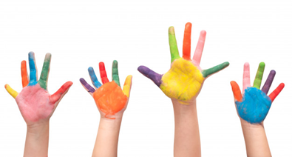  Challenge  Can you add finger nail patterns to your hand templates?
Day 3 | Literacy-Reading/Handwriting  Can you find out which animals live in the sea? Remember our ‘Big Blue’ topic and the sea creatures in the books we looked at?  Have a go at writing their names or other sea animals you can think of.  Practise making sure that your ‘curly caterpillar’ lower case letters are the same size and your tall letters reach the top of your lines.  Challenge  Can you put your sea creatures in alphabetical order?  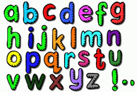 | Maths- Sequencing  Draw a snail or use a template-:  http://clipart-library.com/snail-template.html  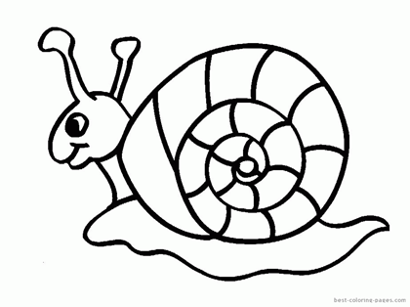  Use 3 different colours and give your snail different coloured spots on its shell. remember the pattern red, blue, green and then start with red again  Challenge  Can you draw your own animal and create a different sequence using 4 colours of your choice | PE  It's time for Cosmic Yoga and a sea adventure.  https://www.youtube.com/watch?v=LhYtcadR9nw&t=729s  Challenge  How long can you stand in this pose by holding out your arms to balance? You could set a timer to find out how long you can balance for and challenge the people in your house too.  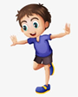

Day 4 | Literacy -Read and write your keywords  Write out your keywords twice using different coloured felt pens/crayons/paints and have a little game of snap or pairs or both!  Challenge  Can you make a sentence with the keywords you have written and using ‘snail’ and ‘whale’ too. remember your capital letters at the beginning of your sentence and a full stop at the end. | Maths- Number  Count to 100 in 10s. Take 100 steps during your daily exercise - what can you see around you?  Challenge  Count in 5s to 100 too.  Write out the numbers, cut them up and put them back in order | Music  Listen to the humpback whales sing and and draw your own picture of a whale taking you on a special adventure.  https://www.youtube.com/watch?v=CRnBghGOUnM  Challenge  Look at a world map or globe of all the different seas and oceans. Can you name two of them?
Day 5 | Literacy -Oracy  Time to think up your own story - imagine the whale could take you on an adventure. What part of the whale would you hold onto? Where would you go? Who would you meet?  Challenge  Ring a friend or family member and tell them your own lovely story about the day you went on an adventure with a whale. | Maths- Number  Can you draw your own number line to 20 or beyond. If you have chalks maybe you could chalk outside your numbers to 20 and beyond. Remind yourself of 1 more and 1 less. Which way do you move your finger or jump?  Playing hopscotch will also help with learning ‘counting on’ with your numbers or you can add a variation on the original game -:  https://www.parents.com/fun/activities/hopscotch/  Challenge  Try 2 more and 2 less. | Art  Time to get messy!  Can you create your own snail patterns using coloured pencils and pens/glue and glitter or maybe you could make slime with flour and water to make slimy snail trails.  Challenge  Use up all that Christmas wrapping and cardboard by decorating a snail shape or sweet tub lid with coloured squares. You could have curly patterns or zig zags- or how about choosing your own patterns!  