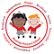Rumney Primary School Year 1 - Home Learning
We look forward to seeing the children in both Apples and Cherry class back in school on
Tuesday 23rd February 2021
Our new topic will be ‘To Infinity and Beyond’ and we will be learning about Space and the planets.
Your child has also been allocated a new Collins ebook which will be accessible on Monday 22nd February.
As always, if there are any queries please contact your child’s class teacher.

Mrs Lewis - Cherries - slewis@rumneyprm.net
Mr Fryer/Mrs Moore - Apples - dfryer@rumneyprm.net gmoore@rumneyprm.net
Day 1 | Literacy- Writing  We are going to be learning about Space this half term.You could start thinking about what you would take to space if you were an astronaut,  Draw pictures of things you could take to Space and leave there in a Time Capsule or you may like to make one and bury one in your garden. click on the link below to give you ideas-:  https://www.youtube.com/watch?v=UkkGAtRMmJs  It could be your favourite food, some photos, a family tree of your family members and a map of where you live.  Challenge  Label the different objects you would put in your time capsule | Maths- Counting backwards  Imagine a rocket is being counted down before blast off. Practice counting back from 3) and beyond by playing the game below. click on the link below  https://www.topmarks.co.uk/learning-to-count/blast-off  Challenge  Write your numbers backwards from 50  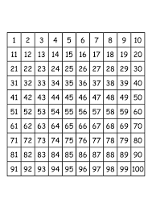 | D/T  Time to make your Time Capsule  Make a capsule using a cardboard tube or find a box and fill it with some items you have or can make.  Challenge  Find the objects you would like to place inside your capsule.  You could draw a tree like this picture to make your family tree with pictures of your close family members,  