Rumney Primary School Home Learning - Monday 22nd June (Week 11)
This week we will be reading and completing tasks based on ‘Only One You!’
Literacy | - Listen to the story ‘Only One You!’ https://youtu.be/vu9capmEY5I  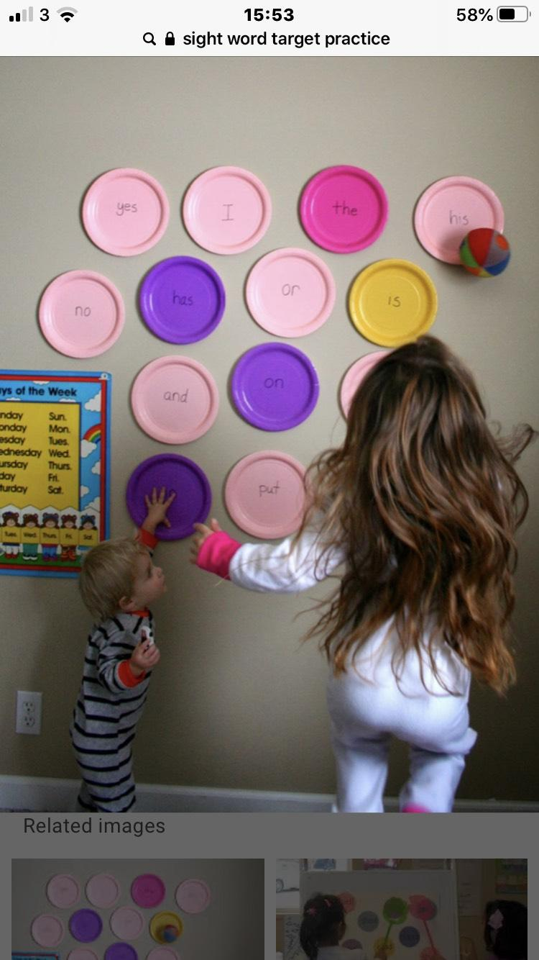  - “Know when to speak, know when to listen!” Play a game of ‘Draw my Picture’. Tell your partner what they need to draw to make your pictures look the same. This will help your child to speak and listen and also to learn shapes, colours and positional language. eg Draw a small red triangle, under the triangle draw a …  - “Make wishes on the stars in the nighttime sky!” Wrap up nice and warm and with an adult take a blanket outside and lie down (I’d choose a nice evening!!) What are your wishes and dreams?  - Write sentences using keywords eg. My wish for me is to … My wish for my mum/ dad/ nan is …  - Think of ingenious and fun ways to learn your keywords this week. Perhaps try a little target practice?  Continue to  - Read and talk about different story books. Can you spot any of your keywords in your book?  - Listen to the letters and sounds songs https://www.dailymotion.com/video/x2wpdvv
Maths | - Partition your numbers to 30 (or 50 if you can) see pic  - Use your free twinkl account to look at these worksheets (you do not need to print them out but talk about the tens and units and create some of your own) https://www.twinkl.co.uk/resource/t-n-1346-tens-and-units-worksheet  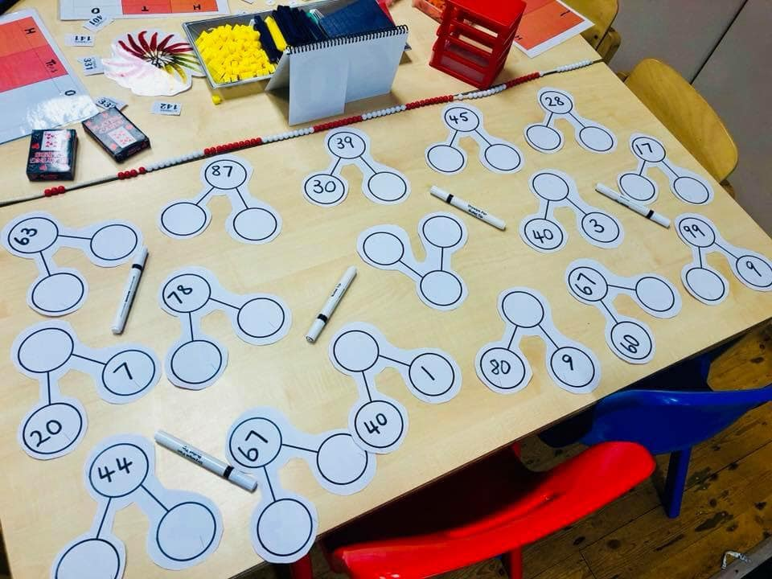  - In school we use tens and units. At home you probably don’t have any. BUT you might be able to create edible ones. You could use carrot sticks for tens and peas for units (or for a treat chocolate fingers and chocolate buttons). What numbers can you create… and then eat?!  Continue to  - form numbers correctly - using number formation rhymes  - use arrow cards all the way up to 30 (or 50 if you can!) Can you make the number that your adult says? Can you add one more to that number? Can you take away from that number?
ICT | - “Appreciate art. It’s all around you!” Have a go at creating your own masterpiece with this online game https://www.bbc.co.uk/cbbc/games/cbbc-picture-maker  Continue to  - Use you Carol Vordeman account https://www.themathsfactor.com  - Practice your tens and untis https://www.splashlearn.com/math-skills/first-grade/place-value/numbers-up-to-20
General | - “Look for the beauty wherever you are!” Take a moment and find the beauty; playing in the garden, out on a walk  - “Set aside some quiet time to relax and reflect!” Join yoga kids https://www.youtube.com/watch?v=LhYtcadR9nw  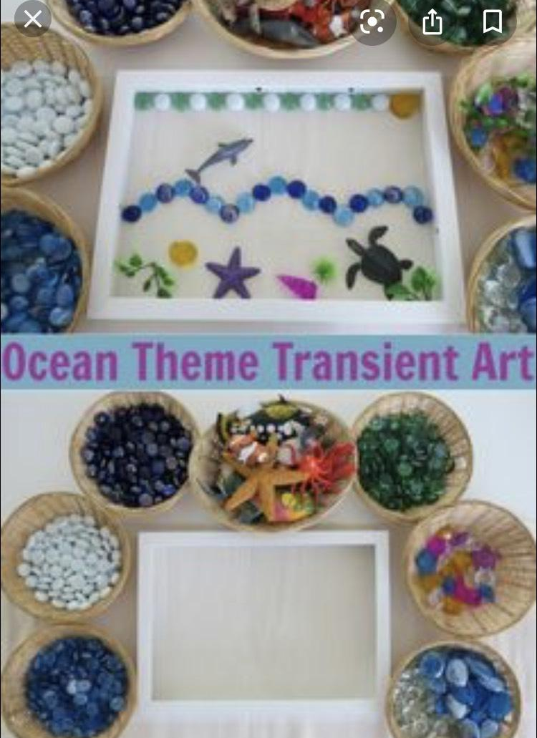  - “Appreciate art. It’s all around you!” Use an empty photo frame or make one out of cardboard. Use a selection of different objects and create your own piece of art which can be ever changing eg. shells, pebbles, sand or pasta shapes, rice, cereal or ribbons, buttons, fabric etc.  - Look out for your new sports day challenge on Twitter this week and don’t forget that Rumney Sports Days always end with a family picnic. It would be lovely to celebrate our sporting achievements over the last few weeks in a picnic on Friday (it may be a carpet picnic looking at the forecast!)

