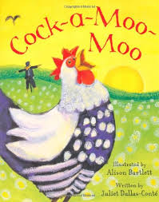
Rumney Primary School Nursery Home Learning 2 - 11.1.21
Spring Term Topic - ‘Down on the Farm’
*Literacy | - Listen to and watch the video of ‘Cock-a-Moo-Moo’ by Juliet Dallas-Conte read by Mrs. Proctor  - Sing ‘Old MacDonald had a Farm’ and add a different animal each time - how many animals can you remember?  - Play ‘Guess the Farm Animal’ by listening carefully to the animal sounds- how many did you guess correctly?  - Practise writing your first name. Use the alphabet sheet below to remember where to start each of the letters.  - Play ‘Kim’s game’ by putting a selection of 10 objects (or farm animals/toy animals) on a tray. Have time to look and remember them. Cover them with a tea towel/cloth and see how many you can remember. Now close your eyes and ask your grown-up to remove one or two of the objects. Remove the cloth - which object is missing?
*Maths | - Find up to 10 objects around the house, roll dice and count the objects to match the number.  - Recognise numbers to 10 and then 20 https://www.pexels.com/search/farm  - Practise writing numbers to 5 and then 10 using the number formation rhymes (below) as a prompt.  - How many animals can you count in the ‘Cock-aMoo-Moo’ story?  - Use your number skills to draw caterpillars
ICT based  (tablet/  computer) | - www.topmarks.co.uk website - set to ‘early years’ games in the drop down bar  - https://www.bbc.co.uk/teach/school-radio/nursery-rhymes-songs-index/zhwdgwx A huge selection of Nursery rhymes and songs to sing along to and learn  - See if you can draw a lamb with Squigglet - Get Squiggling
General | - Follow us on Twitter (Twitter Account: @RumneyprmNurse1) for regular updates and learning jobs  - Look out for any messages sent out via the Schoop app (Schoop ID: 10411)  - Play turn-taking games with a family member - discuss feelings, e.g. winning, coming last, improving, trying your best  - Help to lay the table at meal times - setting out the cutlery, glasses etc. (with supervision)  - Helping to tidy up at the end of an activity just like in Nursery. How many things can you put away by the time your grown-up counts to 10?  - Can you move like a farm animal? See if your grown-up can guess the animal!

Any words in blue writing have a hyperlink so click on them to take you to the resources.
*Please note that videos will be posted on Twitter weekly to support Maths and Literacy.

Home Learning Expectations;
We would expect your child to complete one activity daily from all of the above boxes e.g. a literacy task, a maths task, an ICT based task and a general task.
Keep the activities short and fun to engage your child. The most important thing is to spend time with your child and talk about the activities.
If you have any queries and wish to contact your child’s class teacher then please email directly.
Mrs. Proctor - jproctor@rumneyprm.net
Please note;
- Parents should access the year group Twitter page and Schoop for information and school updates
- If possible, we ask that parents post at least one picture/message/email a week to show/outline how children have been engaging in home learning
- Parents are encouraged to contact the class teacher for guidance and support if they are having difficulties accessing the home learning information

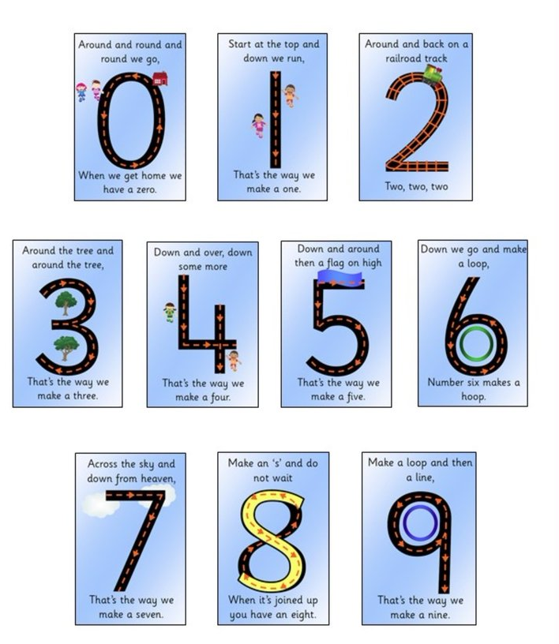
Number Formation Rhymes

