Rumney Primary School Home Learning Days 21-25
If you have any queries and wish to contact us then please email us directly. We are here to support your child, their learning and yourselves so your child’s learning can be at its best. Parents/carers of children with IEPs will be emailed directly and support and guidance in relation to their targets will be given.
Miss Jones - Little Acorns - sjones@rumneyprm.net
Mrs Dash - Holly Trees - jdash@rumneyprm.net
We are here for you to support you however we can. Please keep in touch via Twitter so we can share in your child’s learning. Please note:
- Parents should access the year group Twitter page for information and school updates. Throughout the week we will post further activities to support your child’s learning. You can also communicate with us via Direct Messages on Twitter.
- We ask that parents ‘post’ pictures/messages on @RumneyPrmYearTwo Twitter page to show engagement in home learning.
- Contact will be made with families who are not engaging with home learning so guidance and support can be offered.
Mighty  Monday  10/15 minutes today  https://www.doorwayonline.org.uk/activities/text-type/text-type.html  Let’s get our typing up to speed. Really focus on using the correct fingers to hit the spoken keys. | https://www.youtube.com/watch?v=dvPuhLC9GjU  Make a list of how you can help birds in the winter.  Name 3 things that birds need could make a nest out of?  What things can we do to give birds in our gardens a helping hand? | Literacy Phonics/Spelling task –  Watch the er video:  https://youtu.be/Taa3ANEyN_Y  This week we are focusing on the digraph er  Remember to flick your fingers to get the sound you need and form your letters correctly. The er is one flick but you must write the 2 letters together. er should be the same size. Tall letters are b d f h k l t These should be written taller than the rest of your letters.  er  her, fern, kerb, germ, perch, every, tower, power  Challenge words (these are tricky!) flower, sister, summer, winter, finger, father, other, mother, brother, another, together, altogether, weather, computer  Click on link below for online reading/spelling practise:  username rumney  password Rumney21  https://www.phonicsplay.co.uk/resources/phase/2/picnic-on-pluto  Phase 3 er real words/not real words  https://www.ictgames.com/phonicsPop/ Choose oi, oa, er, ee Press GO | Maths  Hit the Button x2 x5  Today we are going to look at counting tally charts. A complete tally looks like this  We count this as 5. In class we count 4 and number 5 closes the gate.  Any loose lines we count in 1s e.g.  This tally represents 8  (5 and 3)  Come and do some tallying with me before you complete today's activity.  https://www.loom.com/share/1756dfb1b9c44b0dba988cfd687c3443  Today’s first activity  https://docs.google.com/document/d/1KcMQMySUIUThfyTdo3iQVAfkBeKui7CRnPr3GUkKFFs/edit?usp=sharing  Your next activity is to create a tally chart for these birds I saw in my garden today  https://docs.google.com/document/d/11PTJONh8ZO50TEfNXBmaac22cp1QOGFVUOAlRN4-tUY/edit?usp=sharing  KEEP THIS FOR TOMORROW | Puzzle  St Dwynwen's Day  Watch our video. Let’s share the story of St Dwynwen, the Welsh Patron Saint of Love  Follow the instructions to make a love bird for someone you care about.  https://www.gluedtomycraftsblog.com/2019/01/valentine-love-note-bird.html  Include one of these Welsh words/phrases in your note:  Caru ti - love you  Dydd Santes Dwynwen Hapus - Happy St Dwynwen’s Day  Cwtch - hug  Arbennig - special | PE  Cardiff Games - 1 MinuteChallenge  Squats  https://youtu.be/ripcNTmFbdg  Clowning around  You will need a dice and a ball. Roll your dice and have a go at the suggested action:  1- Roll the ball up and down your body whilst sitting  2- Roll the ball up and down your body whilst standing up  3- Pass the ball from hand to hand x4  4- Roll the ball through your legs x3  5- Move the ball through your legs x3  6- Move the ball around 1 leg x3  Top tip- if you don’t have a dice at home there are virtual dice on the Internet. Why not have a go at making up your own action?
Thoughtful Tuesday  10 minutes today  https://www.doorwayonline.org.uk/activities/text-type/text-type.html  Let’s get our typing up to speed. Really focus on using the correct fingers to hit the spoken keys. | https://www.youtube.com/watch?v=0N7FGPeykfE  Can you explain what the word migrate means? You may need to rewind and listen again.  Can you explain what hibernation is?  What happens to an Arctic foxes coat in the Winter?  Can you explain what camouflage means?  What is special about a Ptarmigans legs and feet?  Can you work out why none of these animals would eat a penguin? 🤔 | Literacy  Warm up with Geraldine the Giraffe  https://www.youtube.com/watch?v=WaxZN4BZjgc&t=10s  Sentence construction  Get someone to test you on your words from yesterday. Write a sentence with that word in. Remember to use a capital letter to start EVERY sentence and end it with a full stop.  Practise your spelling words in a different way every day this week.  Choose from the following activities  In school we use a range of kinesthetic learning opportunities for spelling as well as Look, Say, Trace, Cover, Write & Check when practising our key words.  https://docs.google.com/document/d/1HmojpOA0g_avkw97k9UFd4Etg0djg8D8wJ_Ri53wsdw/edit?usp=sharing  Play the buried treasure phonics game. How many coins will you collect?  https://www.phonicsplay.co.uk/resources/phase/2/buried-treasure  https://youtu.be/KK8_kUg3454 Have a look at what Geraldine the giraffe has found today.  Test your phonic knowledge by getting the alien to his spaceship  https://www.phonicsbloom.com/uk/game/alien-escape-full?phase=3&src_url=/uk/game/list/phonics-games-phase-3 | Pictograms  A pictogram is a chart that uses pictures to represent data. Pictograms use columns of pictures to show the numbers involved.  Watch the video with me  https://www.bbc.co.uk/bitesize/clips/zg4d2hv  This shows us first how we use 1 picture for 1 count and the next how we used 1 picture for 2 counts.  Come and watch your activity with me before you complete today’s activity  You need your tally chart from yesterday.  Now choose a symbol to represent 1 bird. The idea has to be simple.  Bird’s foot, beak, worm  Draw this symbol on 30 squares of paper  Draw your axis lines  At the bottom write the labels  robin, chaffinch, blackbird, blutit - underneath write  Types of bird  On the axis line going up write the numbers 1-10  (top tip - line up 10 of your squares on top of each other and write your numbers alongside these)Turn your page and write next to your numbers Amount of birds  Now use your tally chart to correctly fill in your pictogram.  Don't stick your squares down.  KEEP ALL OF THIS FOR TOMORROW | Puzzle  Comparing and contrasting a British birds and an Antarctic bird - double bubble  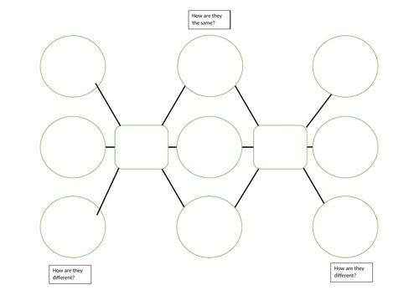  We are going to use a double bubble map to compare and contrast a chosen British bird and an Antarctic bird. Focus on a Robin (British bird) and an Albatross (Antarctic bird).  Use your independent research skills and jot down information that you find from videos, books and factfiles. Can you identify some things which the birds have in common? Can you identify some differences? We will model how to display your facts by using a double bubble map. See Loom video. | PE  Cardiff Games - 1 Minute Challenge  Star Jumps  https://youtu.be/pbZKufNbm5g  Baby Shark Challenge  https://youtu.be/LmaIiYTYQiw
Welsh  Wednesday  10 minutes today  https://www.doorwayonline.org.uk/activities/text-type/text-type.html  Let’s get our typing up to speed. Really focus on using the correct fingers to hit the spoken keys. | No act of kindness, no matter how small, is ever wasted.  https://youtu.be/DSqLseTDbNQ  Why was the man lucky that he wasn’t on his own when he saw the bird?  What were the dangers for the injured bird? What could have happened to him if he’d been left?  Do you think it was a good idea to do what the man did?  Why was it important to make the bird eat and drink?  What do you think happened to this bird? | Literacy  Using verbs and adverbs  Watch the introduction video.  Verbs are doing words, adverbs add detail to the verb. They explain how, where or when.  For example. I walked to the shop quickly.  The bird sang loudly.  Write an interesting sentence to describe what is happening in each photograph or video. Use a verb and an adverb in each sentence.  Challenge - can you extend your sentences by using one of your cool conjunctions? | Maths Loom activity  Today you are going to turn your pictogram into a bar graph. This is going to be simple. Make sure all your symbols are all in the correct place. Now turn them all over. Now you should have a blank square replacing your picture. You have now made your bar chart.  Now you are going to use it to answer the following questions.  https://docs.google.com/document/d/1iYwJ7n21xONW4kLNQd7-Vma6a4X7VutPPNJpcSbcCEQ/edit?usp=sharing | Puzzle  Comparing and contrasting  Continue to research your chosen birds.  Focus on researching these three areas:  Habitat - where do they live? What do their homes look like? What is their environment like? What is the temperature where they live?  Appearance - what do they look like? Do they have any interesting features?  Diet - what do they eat? Do you think that where each bird lives impacts upon their diet?  Did you notice any similarities or any differences? Keep your super research safe for tomorrow! | PE  Cardiff Games - 1 Minute Challenge  Sofa Wall Catches  https://youtu.be/HsZmaCUi9Oc  Sock challenge  This activity will help to develop your core strength. Be warned it is tricky! Get your grown up to record you. How many quarter turns can you complete in 20 seconds? Challenge yourself to beat your time!  https://youtu.be/c9lm8Y7koqE
Thankful  Thursday  10 minutes today  https://www.doorwayonline.org.uk/activities/text-type/text-type.html  Let’s get our typing up to speed. Really focus on using the correct fingers to hit the spoken keys. | https://youtu.be/VkQMpOjZ5mY  Do you think you would like to look after a wild bird like this?  Where in your house would you keep it for it to be safe?  Why do you think the bird liked being up high? | Here is a link to the Big Schools Winterwatch  LIVE LESSON THURSDAY 11 o’clock  You can email your names to  live.lessons@bbc.co.uk to let them know that you will be watching.  https://www.bbc.co.uk/teach/live-lessons/big-schools-winterwatch-live-lesson/zv8vn9q  This is a link to the work in the live lesson for you to have a look at before the lesson starts.  http://teach.files.bbci.co.uk/livelessons/BigSchoolsWinterwatch-ActivitySheet_v7-compressed.pdf  You don’t need to print this out. You’ve drawn incredible penguins.Now use this link to help you draw a robin. Watch it first, then watch and draw and pause as you go along.  https://www.youtube.com/watch?v=D1QkdrWOOt0&feature=youtu.be  Maths Practise your 2 x table using Hit the Button |  | Presenting our information  Copy the table below (we will put a larger version on the Twitter page!) Add your own information. Presenting information in a table is a super skill and helps you access facts and figures quickly.  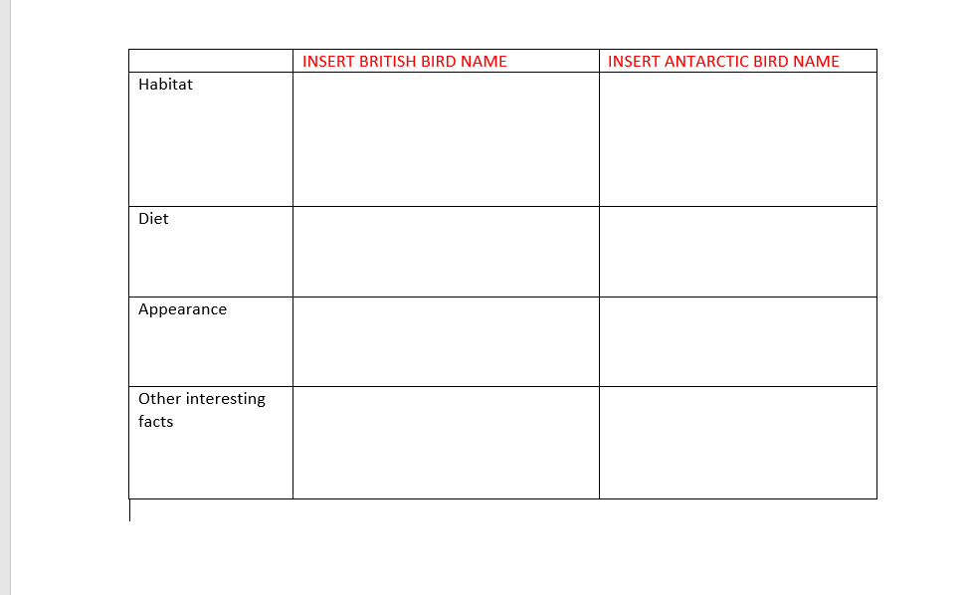 | PE  Popping Pirates  This is a super fun game that we play in school to develop our balance and coordination. How many items of treasure can you balance on your partner?  https://www.youtube.com/watch?v=SuyJjmwEDQA&feature=youtu.bew
Friendship Friday  10 minutes  today  https://www.doorwayonline.org.uk/activities/text-type/text-type.html  Let’s get our typing up to speed. Really focus on using the correct fingers to hit the spoken keys. | https://youtu.be/WZDzgE1S3xw  Why do you think the bird wasn’t released into the wild straight away?  Look at a map or a globe and first find the UK. Then find Africa.  Look at the distance the bird will travel. Isn’t that amazing?  How do you think the man felt when the bird flew away? | Literacy  Questions are sentences that we use when we want to find out information?  How…? Can …? Why….? Would…?  The bird rescuer has agreed to answer some of your questions.  Think carefully about 2 or 3 questions and email them to myself in Little Acorns JonesS959@hwbcymru.net  and Holly Trees  DashJ9@hwbcymru.net  using your Hwb emails.  Your grown up can help you but see if you can do the steps yourself. We know some of you can already 👏🏻👏🏻👏🏻 | Maths TT Rockstars or  Hit the Button Times Table x2 for at least 10 mins.  Reasoning Egg activity.  I will share the puzzle with you. You can pause me and have a go. Then we will work through it together on screen. | Teachers in the freezer! 🥶  A group of British teachers went on an Antarctic adventure.  Watch carefully and answer the following questions in full sentences.  https://www.youtube.com/watch/pJdykZRFuqs  1. How many thousand  miles did they travel?  2. Why did they go to Antarctica?  3. How cold can it get in Antarctica?  4. Why is it tricky to tell the time?  5. How do people get around?  6. Why did the teachers need to eat lots of sweets?  7. How did they keep their bodies warm? | PE  Street Dance class  Get your groove on with Turbo’s dance class.  https://www.youtube.com/watch?v=agezOTZ1RZ8
Mindfulness  & Brain Break Activities to build into your routine | Penguin Dance with Jack Hartmann  https://www.youtube.com/watch?v=uf0uKmKwnKs&list=PLDRDbe1SEBVd22PPBbDpy91UUo_rCYJoB&index=8&t=0s | Pedro the Penguin - An Antarctica Adventure https://www.youtube.com/watch?v=jSZvMHlw9vs | Lose yourself in Antarctica  https://www.youtube.com/watch?v=t57DPnH06V0 Can you see the Aurora Australis and the millions of stars in the Milky Way? How does this make you feel? Look carefully.  What else can you see?  The temperature here can be -70°C. I can’t even begin to imagine how cold that feels! | Do the Yeti dance with Smallfoot  https://www.youtube.com/watch?v=T9T5fJDy_ig | Go Noodle - Trolls dance ‘Can’t Stop the Feeling’  https://www.youtube.com/watch?v=KhfkYzUwYFk

