Rumney Primary School Home Learning Days 11-15
If you have any queries and wish to contact us then please email us directly. We are here to support your child, their learning and yourselves so your child’s learning can be at its best. Parents/carers of children with IEPs will be emailed directly and support and guidance in relation to their targets will be given.
Miss Jones - Little Acorns - sjones@rumneyprm.net
Mrs Dash - Holly Trees - jdash@rumneyprm.net
We are here for you to support you however we can. Please keep in touch via Twitter so we can share in your child’s learning. Please note:
- Parents should access the year group Twitter page for information and school updates. Throughout the week we will post further activities to support your child’s learning. You can also communicate with us via Direct Messages on Twitter.
- We ask that parents ‘post’ pictures/messages on @RumneyPrmYearTwo Twitter page to show engagement in home learning.
- Contact will be made with families who are not engaging with home learning so guidance and support can be offered.
Mighty  Monday  10 minutes today  https://www.doorwayonline.org.uk/activities/text-type/text-type.html  Let’s get our typing up to speed. Really focus on using the correct fingers to hit the spoken keys. | Storytime - watch and listen to the story then answer the questions.  Arnie the Doughnut  https://www.youtube.com/watch?v=6E67n1vZZjQ  Can you recall the sequence steps that it took to make Arnie?  What escape route would you have taken if you were Arnie?  Make a list of things that you would do with Arnie.  How do you think Arnie felt when he was walking away from Mr Bing? How do you think Mr Bing felt?  Talk to your grown up about how Arnie’s feelings changed throughout the story.  Draw your own amazing doughnut. | Literacy Phonics/Spelling task –  Watch the video:  https://www.youtube.com/watch?v=Z-0wWdE-Ezg  This week we are focusing on the digraph oi  Remember to flick your fingers to get the sound you need and form your letters correctly. The oi is one flick but you must write the 2 letters together. oi should be the same size. Tall letters are  b d f h k l t These should be written taller than the rest of your letters.  oi  oil, boil, coil, foil, soil,coin, oink  Challenge words (these are tricky!)  spoil, joint, point, pointy, choice, voice,noise, noisy,  Can you add ed to any of these words to make more words?  Click on link below for online reading/spelling practise:  username rumney  password Rumney21  https://www.phonicsplay.co.uk/resources/phase/5/dragons-den  Phase 3 oi real words/not real words  https://www.ictgames.com/phonicsPop/ Choose oi, oa, ee, igh Press GO | Maths TTRockstars or Hit the Button x 2 10 mins Watch the video first  https://www.loom.com/share/e05691930e0140c0a2f9f1950cc44986  Arrays  Can you remember what an array is? Today you are going to make arrays to match these calculations in our 2 x table  This array shows  3 lots of 2 2 + 2 + 2 or 2 lots of 3 3 + 3  Part 1 Draw these arrays and use them to work out the following calculations. Write the repeated addition sum underneath. See below. You could also make the arrays with lego, cereal, beads, buttons - anything that you can move and count. Try to get in the habit of organising your sets neatly.  6 x 2 = 4 x 2 = 2 x 2 =  10 x 2 = 8 x 2 = 11 x 2 =  9 x 2 = 12 x 2 = 7 x 2 =  Part 2 Can you write the other multiplication fact and repeated addition?  E.g.  6 x 2 = 2 x 6 =  2+2+2+2+2+2= 6 +6 = | Puzzle  Report writing - create a circle map  This week we are going to research one of Antarctica’s most famous creatures, the penguin! We will spend the week gathering information in different ways before writing a report on Friday. We need you to become ‘Nature Detectives’ and use books, videos, and Internet factfiles to compile lots of facts. There are lots of different types of penguins in Antarctica, one of the most common is the ‘Emperor Penguin’ and this might be a good one to research. We will post lots of videos and links to help you on our Twitter page.  Today we are going to use a circle map to display what we already know. Write the word Penguin neatly in the middle of your A4 page and ask your grown up to draw a circle around it. You then need to draw a big circle the size of your page. You will write all of your  information inside this. Here is an example:  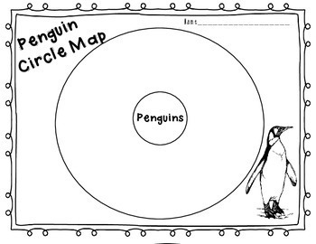  It would be helpful to have your circle map ready before you start your research so that you can quickly jot information down.
Thoughtful Tuesday  10 minutes today  https://www.doorwayonline.org.uk/activities/text-type/text-type.html  Let’s get our typing up to speed. Really focus on using the correct fingers to hit the spoken keys. | https://www.youtube.com/watch?v=Gg1OQbIaAE4  What advice would you give Pip-Pip if he told you he was scared?  How do you think Mum felt when Pip-Pip jumped into the water for the first time?  Talk about something that you have not been sure about but then been proud when you have had a go? | Literacy Sentence construction  Get someone to test you on your words from yesterday. Write a sentence with that word in. Remember to use a capital letter to start EVERY sentence and end it with a full stop.  Practise your spelling words in a different way every day this week.  Choose from the following activities  In school we use a range of kinesthetic learning opportunities for spelling as well as Look, Say, Trace, Cover, Write & Check when practising our key words.  https://docs.google.com/document/d/1HmojpOA0g_avkw97k9UFd4Etg0djg8D8wJ_Ri53wsdw/edit?usp=sharing | Maths Loom activity  Let’s use all of our learning to work out these answers to these money problems.  We are going to work with 2ps. You might have some in a money jar or you might want to make 12 of your own by cutting out circles and writing 2p on them. All cutting is good cutting! We do need to practise.  We are going to answer these questions?  How many 2p coins will I need to make …  10p 20p 14p 16p 24p 60p 2p 18p 22p 30p 6p  Challenge  Can you draw some purses 👛 or a piggy bank and draw in these amounts  12p 18p 8p 4p 22p 14p | Penguin facts  Write some sentences using your facts. Use the openers below:  OPENERS:  It’s interesting that…  Did you know…  An interesting fact about…  Many…  It’s surprising that…  Usually…  Keep your sentences safe for tomorrow’s learning.
Welsh  Wednesday  10 minutes today  https://www.doorwayonline.org.uk/activities/text-type/text-type.html  Let’s get our typing up to speed. Really focus on using the correct fingers to hit the spoken keys. |  | Literacy Labelling a diagram  Today we are going to learn how to label a diagram correctly  First we need a drawing of a penguin. We are writing a report so we will need a good diagram to feature in it.  Click on the link to show you how to draw an Emperor Penguin. Follow the explanation after watching the whole video first.  https://www.youtube.com/watch/Y1APW_4J8dw  Diagrams need to be well presented.  Labels should be sitting on the line and should always be horizontal (not at all wonky angles). Use a ruler or straight edge to draw a line from the body part to where you will write the label. Label these parts  beak, body, brood pouch, ear patch, eyes, flipper like wing, head, neck, tail, webbed feet.  When you have finished colour your diagram in using the correct colours. Look carefully at photos of Emperor Penguins to see the colours you need.  Keep this to include in your report. | Now we have worked with 2p and 5p, we are going to use our coin recognition to sort coins.  Have a look if you have any coins in a money box. Tip them out and first we are going to sort them. If you haven’t got any coins look at the coins on the internet and make 5 of each type. You’ll already have 2ps and will need them for tomorrow.  Sort them using the following criteria. Each colour is an example of sorting coins using 1 criteria.  Silver Not silver  Curved edge Not curved edge  Less than 20p More than 20p  Use the Carroll Diagram below to sort your coins using more than 1 criteria  https://docs.google.com/document/d/1HgaUgN2zCLiDfzBfCZV6uTu9bb-GVVfI--nIhEVQtsY/edit?usp=sharing | Adding detail  Have your sentences from yesterday ready and watch the video ..  Today we are going to improve our sentences by including adjectives and some of the conjunctions that we used last week. Remember that these words help us to include more detail in our writing. This is very important when we are giving the reader information like a report.  For example:  Penguins are black and white → Did you know that most penguins are black and white but King penguins have beautiful yellow plumage on their chests?  This is called a rhetorical question. That is a question that you are not expecting an answer to but we use them to draw the reader in.  Using rhetorical questions in any writing is a good habit to have.
Thankful  Thursday  10 minutes today  https://www.doorwayonline.org.uk/activities/text-type/text-type.html  Let’s get our typing up to speed. Really focus on using the correct fingers to hit the spoken keys. | https:/youtu.be/JIodsXEvo4U.txt  Watch and listen to the book. This is a beautiful story about everything in life that we all share. Sometimes we are too busy to notice them but slowing down and taking notice of all these things around us and being grateful for them helps us to have more positive thoughts.  Write down (doesn’t have to be in rhyme)  3 things you are grateful for in each season.  In winter I am grateful for …  In spring I am grateful for …  In summer I am grateful for …  In autumn I am grateful for … | Literacy Antarctica Cool conjunctions  Choose 1 pink and 1 black sentence. Join them together with a connective to make your sentence make sense.  Choose from  because so when  Success criteria  - 1. 1 Capital letter to start the sentence  - 2. Your sentence makes sense  - 3. Full stop at the end  - Think of your full stop being your YES! I’M HAPPY WITH THAT! mark.  These are trickier than they look. Lots of thinking skills needed here.  Seals need rest out of the water.  Orcas circle ice floes.  A blue whale on its own is not safe.  Killer whales eat penguins and seals  Leopard seals eat penguins.  Seals are laying on there.  They are not safe in the water.  They are hungry.  They sleep on ice floes.  A pod of killer whales will chase it to eat. | Maths Practise your 2 x table using Hit the Button  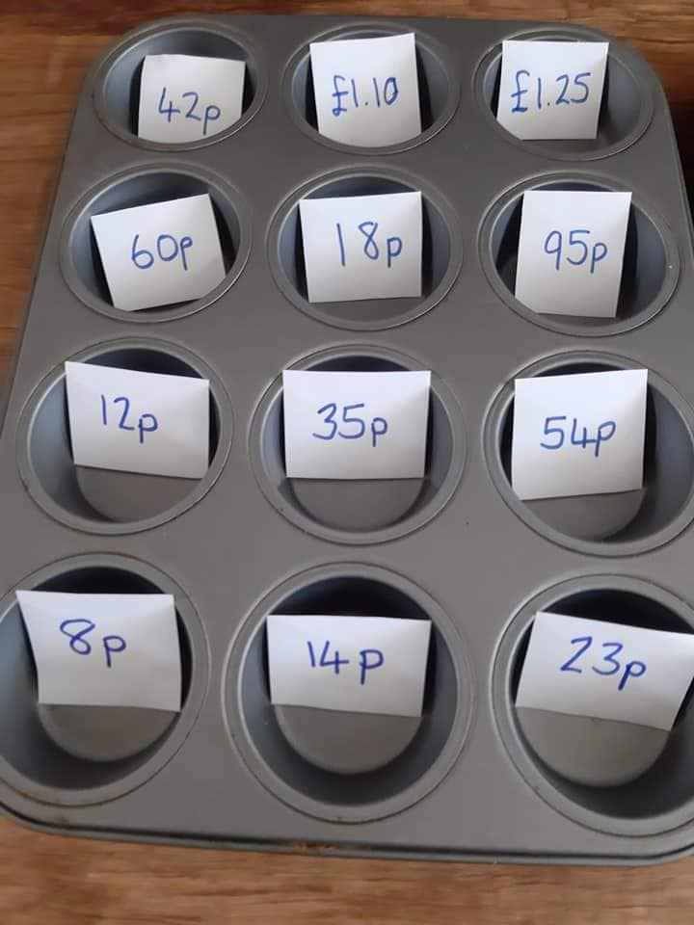  Have a go at making the amounts by counting out combinations of different coins. Always start with the largest coin value that is less than the amount you want to make. e.g 68p - start with 50p  25p - start with 20p  £1.87 - start with £1.00  Challenge: Write down the different combinations of coins for each amount. e.g. to make 14p I might use a 10p coin and 4 1p coins. Could I make 14p using only 2p coins? | Writing a non-chronological report  Let’s start organising some of our super sentences. A report is organised into chunks with a special title for each section. These titles are called subheadings.  We would like you to start writing your report today using the subheading. Try to write more than 1 sentence under each heading.  Type of penguin:  Where do these penguins live?  What is their diet?  Some interesting facts are..  Don’t forget to include your diagram in your report.
Friendship Friday  10 minutes  today  https://www.doorwayonline.org.uk/activities/text-type/text-type.html  Let’s get our typing up to speed. Really focus on using the correct fingers to hit the spoken keys. | https://www.youtube.com/watch?v=mGINvN27TWA  A story about friendship that grows even though the friends can’t be together. | Literacy  When we write we need to organise our work. We usually organise our work into paragraphs. All the sentences in a paragraph are giving information about the same thing.  Read the sentences (with a grown up if you need to) and decide under which heading the sentences belong.  https://docs.google.com/document/d/153TSLUQt1HeDeXfeVZEcaW-NRcWR1xvJjAUvXtq_Ovo/edit?usp=sharing  Where do Weddell Seals live?  What is their diet? | Maths TT Rockstars or  Hit the Button Times Table x2  Weddell Seal spotting  On day 1 I spotted 2 Weddell Seals on my trip to Antarctica. Every day I spotted 2 more. Can you complete the table? Use the completed table to answer these questions.  How many Weddell seals had I seen on day 8?  How many seals had I seen on day 12?  How many seals had I seen on day 6?  Which day did I see 20 seals? Which day did I see 18 seals?  Which day did I see 14 seals?  Which day did I see double the amount of seals that I saw on Day 3?  Day 1 2  2  3  4  5  6  7  8  9  10  11  12 | Presenting your findings  Today you are going to make a short presentation all about your chosen penguin. Remember to speak clearly and include lots of detail. You might even like to create a presentation on the computer to share your facts with your friends. We can’t wait to hear what you have found out.  As a special treat for all your hard work you could watch this super documentary all about Antarctica.  https://www.youtube.com/watch?v=ydFZdu98oVc
Mindfulness  & Brain Break Activities to build into your routine | Penguin Dance with Jack Hartmann  https://www.youtube.com/watch?v=uf0uKmKwnKs&list=PLDRDbe1SEBVd22PPBbDpy91UUo_rCYJoB&index=8&t=0s | Pedro the Penguin - An Antarctica Adventure https://www.youtube.com/watch?v=jSZvMHlw9vs | Lose yourself in Antarctica  https://www.youtube.com/watch?v=t57DPnH06V0 Can you see the Aurora Australis and the millions of stars in the Milky Way? How does this make you feel? Look carefully.  What else can you see?  The temperature here can be -70°C. I can’t even begin to imagine how cold that feels

