Rumney Primary School Home Learning Days 26-30
💗CHILDREN’S MENTAL HEALTH WEEK💗
💗LET’S LOOK AFTER EACH OTHER!💗
If you have any queries and wish to contact us then please email us directly. We are here to support your child, their learning and yourselves so your child’s learning can be at its best. Parents/carers of children with IEPs will be emailed directly and support and guidance in relation to their targets will be given.
Miss Jones - Little Acorns - sjones@rumneyprm.net
Mrs Dash - Holly Trees - jdash@rumneyprm.net
We are here for you to support you however we can. Please keep in touch via Twitter so we can share in your child’s learning. Please note:
- Parents should access the year group Twitter page for information and school updates. Throughout the week we will post further activities to support your child’s learning. You can also communicate with us via Direct Messages on Twitter.
- We ask that parents ‘post’ pictures/messages on @RumneyPrmYearTwo Twitter page to show engagement in home learning.
- Contact will be made with families who are not engaging with home learning so guidance and support can be offered.
Mighty  Monday  10 minutes today  https://www.doorwayonline.org.uk/activities/text-type/text-type.html  Let’s get our typing up to speed. Really focus on using the correct fingers to hit the spoken keys. | 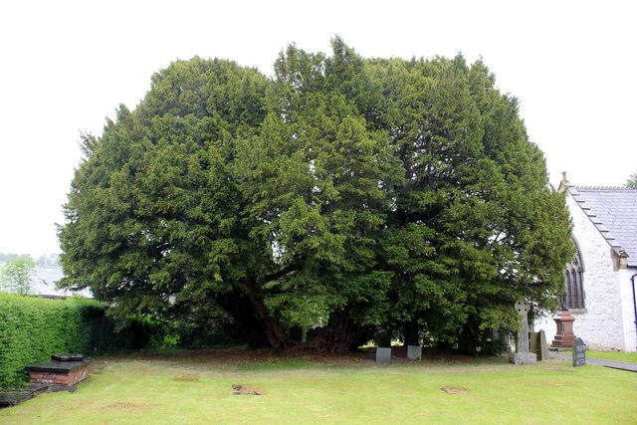This tree is about 4000 years old. It is the oldest Yew tree in Wales. Wood was one of the first materials used by humans. 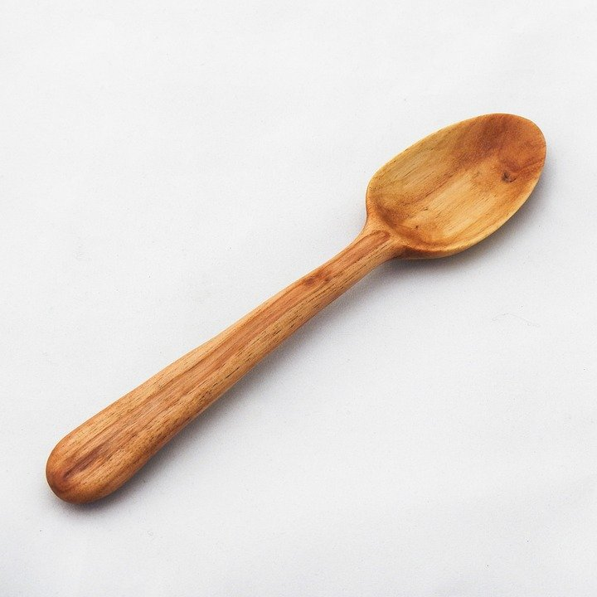  What is the connection between the spoon and the tree? How would you make a spoon from a tree? Look around you, what can you see that is made of wood? Think of 5 adjectives to describe wood.  How else do trees help humans? If you could plant a tree which tree would your family choose? | Literacy Phonics/Spelling task –  This week we are focusing on the trigraph air  Watch the video: https://www.youtube.com/watch?v=uZHKK9jnfFQ  Something different today. You need to make a grid on paper. Sound out the word, write it in the box, then draw the picture. At the end of each picture, sound out the word. Stand up, write the word in the air in big letters.  Remember to flick your fingers to get the sound you need and form your letters correctly. The air is one flick but you must write the 3 letters together. should be the same size. Tall letters are b d f h k l t These should be written taller than the rest of your letters.  air pair hair fair lair chair  hairy fairy dairy stairs haircut funfair  Challenge  hairiest repair airport  upstairs downstairs  Click on link below for online reading/spelling practise: Review of phase 3 phonics.  username rumney  password Rumney21  https://www.phonicsplay.co.uk/resources/phase/3/space-race  https://www.youtube.com/watch?v=3NOzgR1ANc4 How many tricky words can you spell? Make a note of any you can't. Practise these throughout the week. | Maths Practise your 10 x table using Hit the Button  Can you fill in the gaps in the sequences below?  Remember to think about whether the numbers are increasing or decreasing and then consider by how much they go up and down.  - 2,_ ,6 _ , 10,__  - 10, 20,__, __  - 15, __, 25,__ , 35,__  - __, __, 15, __, 25, __, __  - 60, __, 40, 30, __, __, __  - 12, __,8, _, 4, _, _  - 55, __, 45,__,__,__, 25,__  - 90, __,__, 60,__, __, 30  - 12,__, 18, __,22,__,__  - 22,__,18,__,__,__,__  http://ictgames.com/rangeArranger/  Challenge  https://docs.google.com/document/d/18SfB95JRyvwTjq2h5tyBjy_Y9VzfayIbIoQPzyGwUNs/edit?usp=sharing | 100 Exercises a Day  To start these are your 100 exercises that you need to complete:  https://docs.google.com/document/d/1f226oTVbgoOhyhtI4PTkz_DjWsaFyk8Zl5BNqejnHws/edit?usp=sharing  Tomorrow you need to plus/minus amounts to change the amount of exercises you do  e.g.  Instead of 10 sit ups/10 jumping squats you might want to do  7 sit ups/13 jumping squats instead.  Both of these exercises still add to 20.  Change your exercise routine every day this week, but keep every set within 20. | PE  Cardiff Games - 1 MinuteChallenge  Squats  https://youtu.be/ripcNTmFbdg  PE  Speed bouncing.  How many can you do in 20 seconds? Can you beat your own time?  Remember to keep your feet together and bend those knees!  https://www.youtube.com/watch?v=_24zvLccN0s
Thoughtful Tuesday  10 minutes today  https://www.doorwayonline.org.uk/activities/text-type/text-type.html  Let’s get our typing up to speed. Really focus on using the correct fingers to hit the keys. | Watch the video. https://www.youtube.com/watch?v=ryG9Oo0_Q7s&feature=youtu.be  Have you ever noticed how cats are interested in things? They poke them. They sniff them. Why do they do that?  What did the cat find out about the robot?  Would the cat have conquered the robot and become its friend if he had run away straight away?  How do your family keep you safe when you want to explore new things?  Is it good to try out new things? | Literacy Sentence construction  Get someone to test you on your words from yesterday. Write a sentence with that word in. Remember to use a capital letter to start EVERY sentence and end it with a full stop.  Practise your spelling words in a different way every day this week.  Choose from the following activities  In school we use a range of kinesthetic learning opportunities for spelling as well as Look, Say, Trace, Cover, Write & Check when practising our key words.  https://docs.google.com/document/d/1HmojpOA0g_avkw97k9UFd4Etg0djg8D8wJ_Ri53wsdw/edit?usp=sharin  Play the buried treasure phonics game. How many coins will you collect?  Phase 3 air  https://www.phonicsplay.co.uk/resources/phase/2/buried-treasure  Have a listen to what sound Geraldine the giraffe has found today.  https://www.youtube.com/watch?v=NcHIX2xK--A  Test your phonic knowledge by getting the alien to his spaceship  https://www.phonicsbloom.com/uk/game/alien-escape-full?phase=3&src_url=/uk/game/list/phonics-games-phase-3 | Maths Hit the Button Times Tables x 10  This week we are going to make a pictogram where every symbol represents 2 birds  First you need to create a tally chart to show this information.  Your table will need 7 rows and 2 columns  Blackbirds 15  Sparrow 12  Goldfinch 8  Siskin 9  Starling 13  Nuthatch 6  Remember to keep your tally charts neat and well presented.  Watch the video and make your pictogram with me. | 100 Exercises a Day  Puzzle  Look through the features of non fiction texts.  Use the template to complete the book review of Antarctica: Land of the Penguins  Complete each section thinking carefully about your answers.  https://drive.google.com/file/d/19pAuVIS0vCmNYbwIZXNvvMPlDXHLRyin/view?usp=sharing | PE  Cardiff Games - 1 Minute Challenge  Star Jumps  https://youtu.be/pbZKufNbm5g  It’s time for some dancing. This time it’s Bhangra!  https://www.youtube.com/watch?v=OYGe5esk2Yc
Welsh  Wednesday  10 minutes today  https://www.doorwayonline.org.uk/activities/text-type/text-type.html  Let’s get our typing up to speed. Really focus on using the correct fingers to hit the spoken keys. | Is this really what you would expect seals to sound like? What does it sound like to you? Can you make your mouth make these sounds?  https://soundcloud.com/wildlife-sound-recording/grey-seal | Literacy  Draw and label a baby seal following the tutorial here.  https://www.youtube.com/watch?v=Ast_PAO7qH8  Label with  blunt claws, back flippers, closable ears, closable nostrils, eyes, front flippers, fur, nose, tail, whiskers,  Remember labels must be copied correctly.  Use a straight edge to draw your lines.  Write your words sitting on the line. | Loom activity  Watch the video and follow me to create an online garden bird bar chart.  https://nces.ed.gov/nceskids/createagraph/default.aspx  Log onto this website and complete the bar chart following the steps.  Email using the link to Holly Trees  DashJ6@Hwbcymru.net  and Little Acorns JonesS959@Hwbcymru.net | Puzzle Wednesday and Thursday  This activity will take more than one session as you need to gather facts, make your quiz cards and find 4 options for answers.  Who Wants to be an Antarctic Millionaire?  Use the book Antarctica:Land of the Penguins to gather facts to make a quiz for your grown ups/family/friends. Write your questions on cards and write the correct answer & 3 wrong answers underneath. Make the answers similar to catch the contestant out, e.g if you ask which place is in Antarctica the answers could be a) North Pole b) East Pole, c) South Pole, d) West Pole  On the back write the amount your question is worth. Remember to make the easy questions the lowest amounts.  Question 1 £100 Q 2 £500 Q 3 £1000 Q 4 £5000  Q 6 £10,000 Q 7 £50,000 Q 8 £100,000 Q 9 £250,000 Q 10 £500,000 Q 11 £750,000  Q12 £100,000 / 1 million  Quizmaster read out your questions and give the contestants the choice of 4 answers.  If they do not know they can do 50/50 when you give them the correct answer and 1 other.  They can phone a friend  Record some of your quiz and share it with us.  Can you ask your questions to another friend or family member via WhatsApp video call or other video messaging service?  A grown up can help you read the information but try to decide on the questions/answers yourself. | PE  Cardiff Games - 1 Minute Challenge  Sofa Wall Catches  https://youtu.be/HsZmaCUi9Oc  Play charades using verbs such as run, jog, swim, kick, sprint, tackle, dance, serve, rally, squat, jump, hop, limbo
Thankful  Thursday  10 minutes today  https://www.doorwayonline.org.uk/activities/text-type/text-type.html  Let’s get our typing up to speed. Really focus on using the correct fingers to hit the spoken keys. | What am I?  Fish chomper  Egg carrier  Seal teaser  Ocean swimmer  Ice waddler  Squid chomper  Water surfer | Literacy  We are going to look at Kennings poetry. Last week we learned the digraph er and every line in a Kennings poem ends in an er.  Verbs  sleep, nap, catch, chase, swim, grind, hunt, play, chomp  You are going to create a word bank using your research skills to answer the following questions  Where do seals sleep?  What prey do seals catch or chase?  Where do seals swim?  You may have more than one answer which will give you more opportunities to play with your words.  Keep your words safe for our next Kennings activity. | Maths  Create a Table  On day 1 I spotted 10 albatross on my trip to Antarctica. Every day I spotted 10 more. Can you make a table to show how many I saw altogether?  You have completed tables in previous activities. Use what you know to create a table that you can use to answer these questions.  - How many albatrosses had I seen on day 8?  - How many albatrosses had I seen on day 11?  - How many albatrosses had I seen on day 5?  - Which day did I see 20?  - Which day did I see 70?  - Which day did I see 120?  - Which day did I see double the amount of albatross that I saw on Day 6? | 100 Exercises a Day  Puzzle  Continue with yesterday's activity. | PE
Friendship Friday  10 minutes  today  https://www.doorwayonline.org.uk/activities/text-type/text-type.html  Let’s get our typing up to speed. Really focus on using the correct fingers to hit the spoken keys. | Reflecting  What have you done this week that was tricky?  Have you learned anything new?  Can you think of any mistakes you made?  Did you learn anything from making a mistake?  Is there anything that you would like to get better at?  What are you most proud of this week? | Literacy Teams Meet  Question & Answers - 10 o’clock via Microsoft Teams.  Check your Hwb emails and respond to say you are accepting! | Maths TT Rockstars or  Hit the Button Times Table x2  Look at your tables in a different way with a triangle. There’s a lot more to knowing your tables than just saying them so we are going to look at them using a triangle of numbers. | 100 Exercises a Day  Puzzle  You are going to write a Kennings poem about an Antarctic bird/animal  When you have finished you are going to email your poems Little Acorns JonesS959@hwbcymru.net  Or  Holly Trees  DashJ6@hwbcymru.net  Ask your grown up to help you but you do the actual steps yourself. This will really help when you have to do it back in school. | PE  Design and build your own obstacle course.  What will you use as your obstacles? Plan a specific route and list the equipment you will need.  Time yourself and your family completing the course. Who will be the fastest?
Mindfulness  & Brain Break Activities to build into your routine | Penguin Dance with Jack Hartmann  https://www.youtube.com/watch?v=uf0uKmKwnKs&list=PLDRDbe1SEBVd22PPBbDpy91UUo_rCYJoB&index=8&t=0s | Choose to see the Magellanic penguin in its nest, penguins swimming or on their outcrop. Be patient.  https://explore.org/livecams/penguins/live-penguin-cam  Pedro the Penguin -goes to the fair. More Cosmic kids adventures.  https://www.youtube.com/watch?v=Rzw-Oir8UPw | Pop in and check out the penguin enclosure via Penguin Cam - other animals are also available for watching too.  https://www.edinburghzoo.org.uk/webcams/penguin-cam/ | Print and complete a penguin mindfulness colouring, or if you don’t have access to a printer you can design your own.  https://www.penguins.org.au/virtual/mindfulness-colouring/ | Go Noodle - Penguin Song  https://www.youtube.com/watch?v=5zEbxH-ySQE

