Rumney Primary School Year 1 - Home Learning
If you have any queries and wish to contact us then please email us directly. We are here to support your child, their learning and yourselves so your child’s learning can be at its best. Parents/carers of children with IEPs will be emailed directly and support and guidance in relation to their targets will be given.
Mrs Lewis - Cherries - slewis@rumneyprm.net
Mr Fryer/Mrs Moore - Apples - dfryer@rumneyprm.net gmoore@rumneyprm.net
Please note;
- Parents should access the year group Twitter page for information and school updates. Throughout the week we post further activities to support your child’s learning. You can also communicate with us via Direct Messages on Twitter.
- We ask that parents ‘post’ pictures/messages on @RumneyPrmYearOne Twitter page to show engagement in home learning.
- Contact will be made with families who are not engaging with home learning so guidance and support can be offered.
Day 1 | Literacy-Speaking & Listening  Get cosy with your favourite teddy and watch another super Julia Donaldson Story.  https://www.youtube.com/watch?v=75aXrJgMVow - youtube  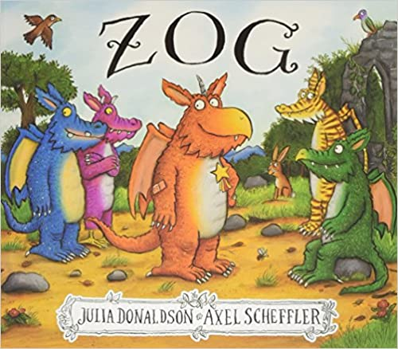  Challenge  Time to draw and cut out a dragon puppet and act out some of the new skills that Zog learns to do. You could use this template-: https://www.createinthechaos.com/paper-bag-dragon-puppet/ | Maths -Number  Counting in 2s  A song to help get you started  https://www.youtube.com/watch?v=GvTcpfSnOMQ&t=2s  A video lesson on counting in 2s to help you on your way :  https://www.loom.com/share/47a62604a7f9435b8e49e672d964048d  Challenge  Can you count in 2s as far as you can go and paint them on the 100 square-:  https://www.topmarks.co.uk/learning-to-count/paint-the-squares  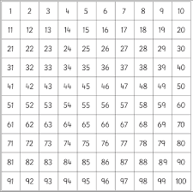 | Art  Can you make some fiery flames like the ones that fire out of a dragon’s mouth. Use a variety of orange and red colours.You could use food packaging,old Christmas cards, sweet wrappers.  Cut them out using your super scissor skills with a little help off a grown up)  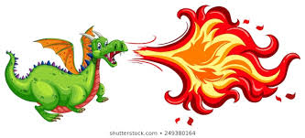  Challenge  Can you hold the flames in front of your mouth to pretend that you are a dragon with real flames! What noises would a real dragon make?  Try not to scare your little brothers and sisters too much!
Day 2 | Literacy-Writing  Remind yourself of the story by having another little listen  https://www.youtube.com/watch?v=75aXrJgMVow - youtube  Now Mrs Moore will show you your learning job-:https://www.loom.com/share/30de48dbdcd74cbdb5cfa0501768fc34  Imagine you are Zog’s teacher -  Can you create a certificate for Zog for all his hard work. - see Certificate template.  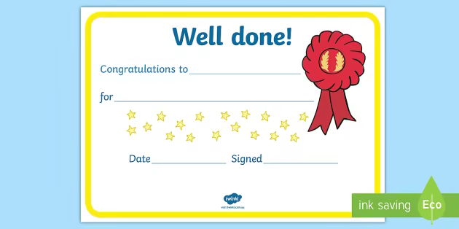  Challenge  Can you think of reasons why you might get a certificate at the moment. | Maths - 3D shapes  A song to help you on your way.  https://www.youtube.com/watch?v=ZnZYK83utu0  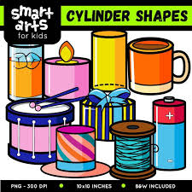  Can you find some of these shapes in your home? What shape is a ball?  What shape is a tin of beans?  What shape is that cereal box or Amazon parcel?  If you have some empty boxes, tubes you could get them ready for Friday afternoon’s task  Challenge  Can you sort some 2D and 3D shapes?  https://www.education.com/game/2d-3d-shapes/ | Welsh  A special video from Mrs Moore to help with our Welsh weather words.  https://www.loom.com/share/c874d4b55fd64f15a3fcfcc074b3b63a  Ooh it’s getting very cold can we all remember our weather song  Sut Mae'r Tywydd Heddiw?  Draw 3 weathers and write the welsh word underneath.  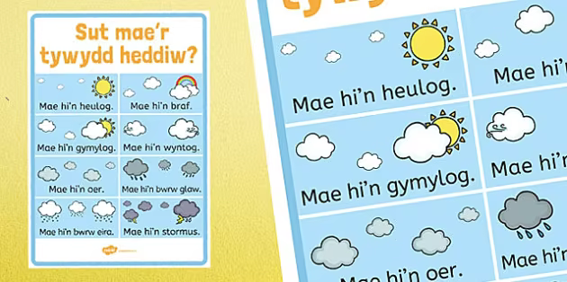  Challenge  Can you sing along to one of our favourite class songs.  https://www.youtube.com/watch?v=WrjZzVQOEj4
Day 3 | Literacy-Reading/Handwriting  https://home.oxfordowl.co.uk/reading/ -  Spend 10 minutes reading a book to your grown up.  Time to write out the letters g y and p - can you remember how we write them on a line?  Challenge  Have a go at writing some words that start with ‘g’, whilst remembering the tail of the letter goes under the line.  ‘got’, ‘get,’gate’, ‘gum’  Can you write some more words that start with ‘y’, ‘s’? | Maths- Number  Zog has two big, furry feet and so has his friends.  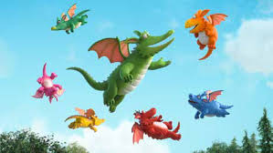  How many feet would they have altogether? We can write it as 2+2+2+2+2+2+2,a repeated addition sum which is the same as 7 lots of 2.  Can you draw the 7 lots of feet or even draw around your own?How many feet do you have now?  Challenge  Can you find objects around the house that come in pairs? Count them in 2s and add them together | P.E - Ball skills  Take a ball, any ball you have big or small(or a rolled up pair of socks) and practise with a sibling or grown up passing the ball back and forth If it gets too easy move a little further apart!  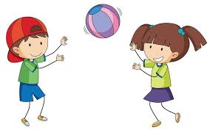  Improving our gross motor skills is so important - learning to catch is a great life skill!  Challenge  Count how many passes can you do without dropping the ball? Let us know how many you get up to. Competition time!

Day  4 | Literacy -Oracy  Get your special possession ready for our virtual meeting - we can’t wait to see you on the screen of your ipad/ tablet with your grown up there.  It could be your special teddy, toy or a photograph of a special time!  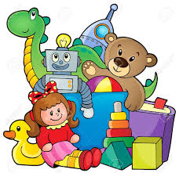  Why is it special?  Who bought it for you?  Why did you enjoy that special time- it could be a trip to the beach or a day out at the park?  Your teachers can’t wait to see what you bring to our chat! | Maths-Time  Can you get a clock or watch ready for today’s lesson on o’clock? Remember it has to have hands!  https://www.loom.com/share/fcf0494009b343ed9933d78bfa3af5f1  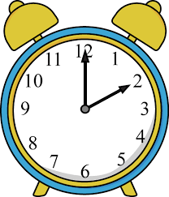  Challenge  Can you find these times on your clock/watch-:  8 o’clock  10 o’clock  1 o’clock | Year 1 Virtual Meeting Sessions  This afternoon and tomorrow  for Apple and Cherry classes
Day 5 | Literacy -Writing  Time to write a review for Zog. Draw a beautiful picture at the top and write a sentence or tho telling us about your favourite part.  A review sheet can be found here and printed if possible.  https://primarysite-prod-sorted.s3.amazonaws.com/stedwardsbirmingham/UploadedDocument/c54dd9b91d194a0bbfa12d9a3c1ece23/zog-book-review-sheet.pdf  Challenge  Ring a friend and ask them what part of the story they enjoyed best. Remember it’s good to talk. | Maths-Subtraction  Find some small objects ( pasta pieces/ Lego) to help you with some taking away and try these sums  5-1=  6-2=  8-2=  7-1=  9-1=  https://uk.ixl.com/math/year-1/subtract-with-pictures-numbers-up-to-10  Challenge  Write some take away sums of your own. Taking a one digit number away from a two digit number.  Eg; 12-2=  14-1=  16-2= | DT/Art  Did you find some 3D (solid) shapes on your Shape Hunt? Fill them with rice, pasta or anything that makes a rattling sound, then you can make a musical instrument. Make sure you seal it up to stop the contents flying around.  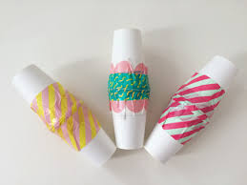  You could also make a guitar out of a cereal box:  https://www.youtube.com/watch?v=V3KGrxmic6k  Challenge  Can you shake your shaker or strum your guitar along to the music in the Welsh weather song?

