Rumney Primary School Year 1 - Home Learning
If you have any queries and wish to contact us, please email us directly. We are here to support your child, their learning and yourselves so your child’s learning can be at its best. Parents/carers of children with IEPs will be emailed directly and support and guidance in relation to their targets will be given.
Mrs Lewis - Cherries - slewis@rumneyprm.net
Mr Fryer/Mrs Moore - Apples - dfryer@rumneyprm.net gmoore@rumneyprm.net
Please note;
- Parents should access the year group Twitter page for information and school updates. Throughout the week we post further activities to support your child’s learning. You can also communicate with us via Direct Messages on Twitter.
- We ask that parents ‘post’ pictures/messages on @RumneyPrmYearOne Twitter page to show engagement in home learning.
- Contact will be made with families who are not engaging with home learning so guidance and support can be offered.
Day 1 | INSET Day
Day 2 | Literacy-Speaking & Listening  The last of our books by Julia Donaldson today. Time to sit back and relax and enjoy the story of Spinderella  https://www.youtube.com/watch?v=avuq4Ee4Hb4  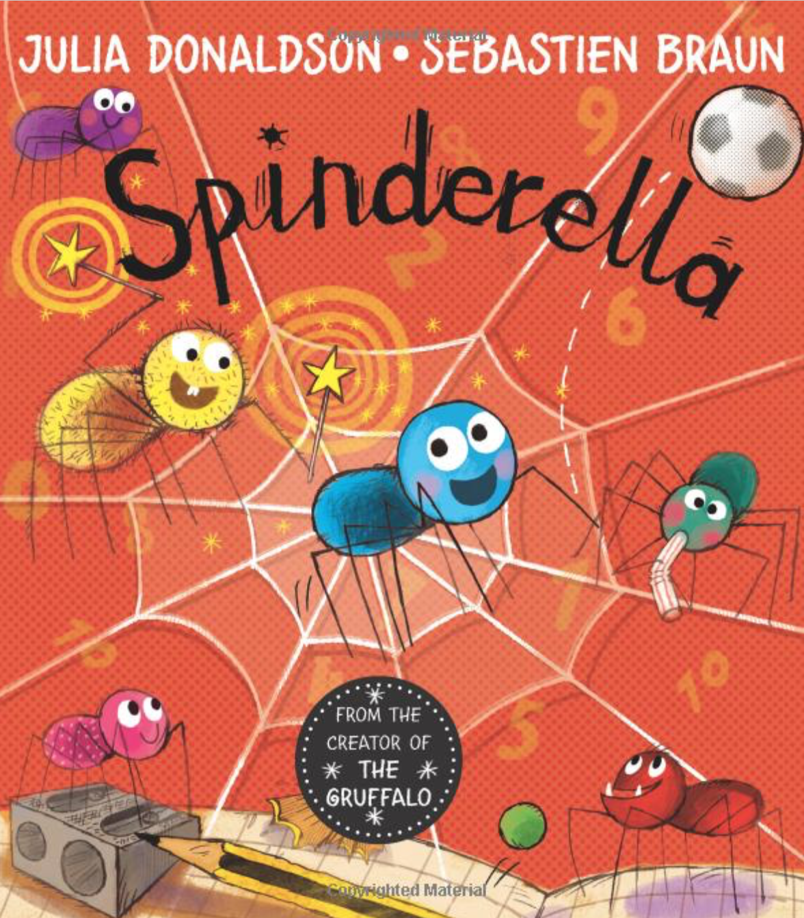  Challenge  Why does Spinderella think that counting and numbers are important? How do you think she felt when the teams were not even? Can you remember a time when you felt something was unfair? How did you make it fair? | 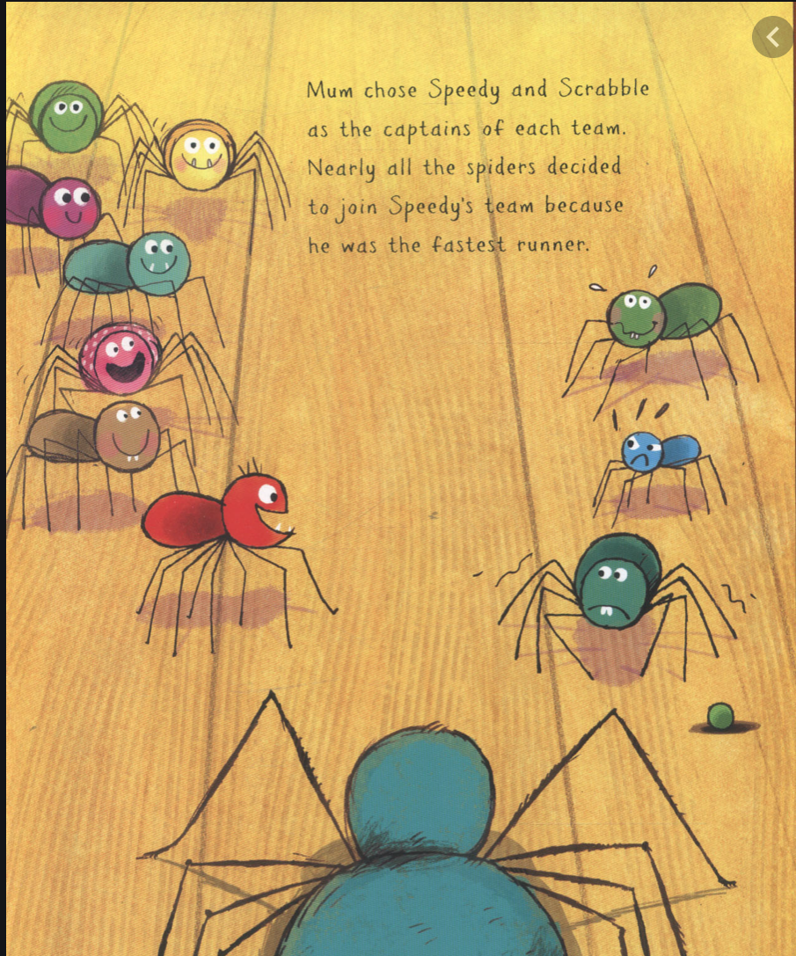  Maths - Halving  In the story of Spinderella, the spiders enjoy playing football. At first, the game isn’t fair because one team has more players than the other team?  Spinderella discovers that if you halve the total number of players then you will have the same amount on each team.  Imagine you are organising a football match. Can you halve each of the following numb ers of players so their are equal teams.  Watch this Loom video to help you:  https://www.loom.com/share/0b5b10104dc649bd912bd82371f630ae  - 8 players b) 12 players  c) 16 players e) 14 players  Challenge  Try halving 9 players. What about 15? Why is this not so easy? | PE  Cardiff City FC have set some challenges this week.  If you are unsure of what a lunge is, watch CCFC player, Phoebe Poole in action.  https://vimeo.com/504360048  How many can you do? Can you get the rest of your family to try the challenge? You could even put all of your scores into a table if you remember how.
Day 3 | Literacy- Reading  Read and listen with Mrs Lewis to these spider facts being read out on the Loom Teaching Video  https://www.loom.com/share/8b51644bc6bf42e2ac675329cd3a1799  Challenge  Can you remember what was said in the video. Draw a spider and write out some facts which you have learned. | Maths - How many football boots?  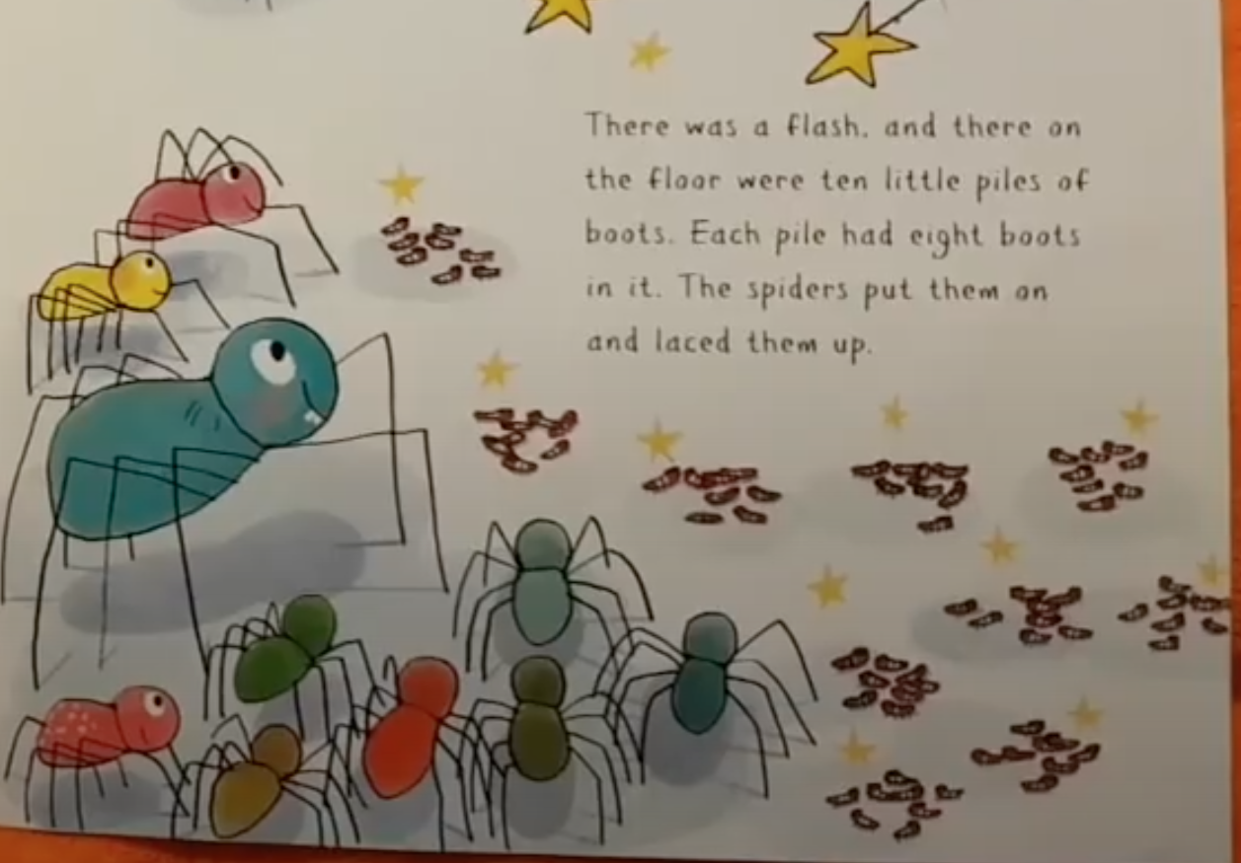  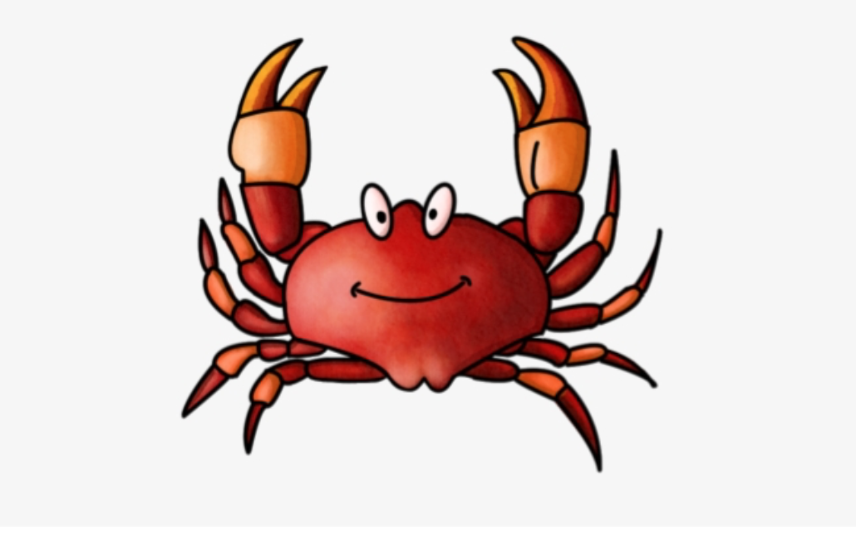  The spiders in the story need football boots to protect their feet. They each have eight legs, so the Hairy Godmother counts out groups of eight boots.  Crabs have 10 legs.  If the Hairy Godmother needed to provide boots for crabs, she would need piles of ten boots for each crab. How many boots would she need in total for:  - 4 crabs b) 6 crabs  c) 2 crabs d) 8 crabs  Challenge  Can you write these as sums?  e.g. 4 x 10 = | Chinese New Year -The Year of the Ox  Find out all about Chinese New Year with Mrs Moore in this Teaching Video. Click on the link below-::  https://www.loom.com/share/4fffbcc113514c8fb60b2d1386f1d7f2  Challenge  Can you draw an ox?  Can you find out what animal represents the year you were born ?  Can you find China on the map?
Day 4 | Literacy- Phonics  This week, we are going to practice the ng sound. This is a sound that comes in the middle or end of words.  Watch this video to get to know this sound.  https://www.bbc.co.uk/bitesize/topics/zvq9bdm/articles/z6bkbdm  Click on the link below to try a game. Can you read each word and then click on the correct word to match each picture.  https://wordwall.net/resource/10484115  Challenge  Finally, can you write some of the ng words down in a list? Can you write a sentence for 1 or 2 of them? | Maths-Number ordering  https://www.bbc.co.uk/bitesize/topics/zhsspg8/articles/zn4ynrd  We have read 6 Julia Donaldson books during this half term.  Can you remember which order we read them?  Which was 1st 2nd 3rd 4th 5th and 6th?  Can you put them in the correct order?  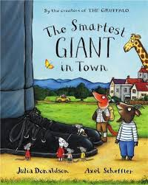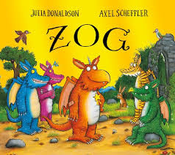  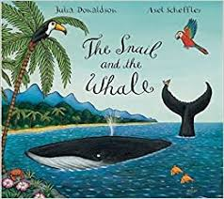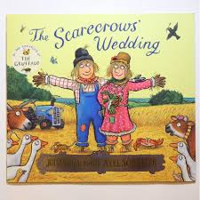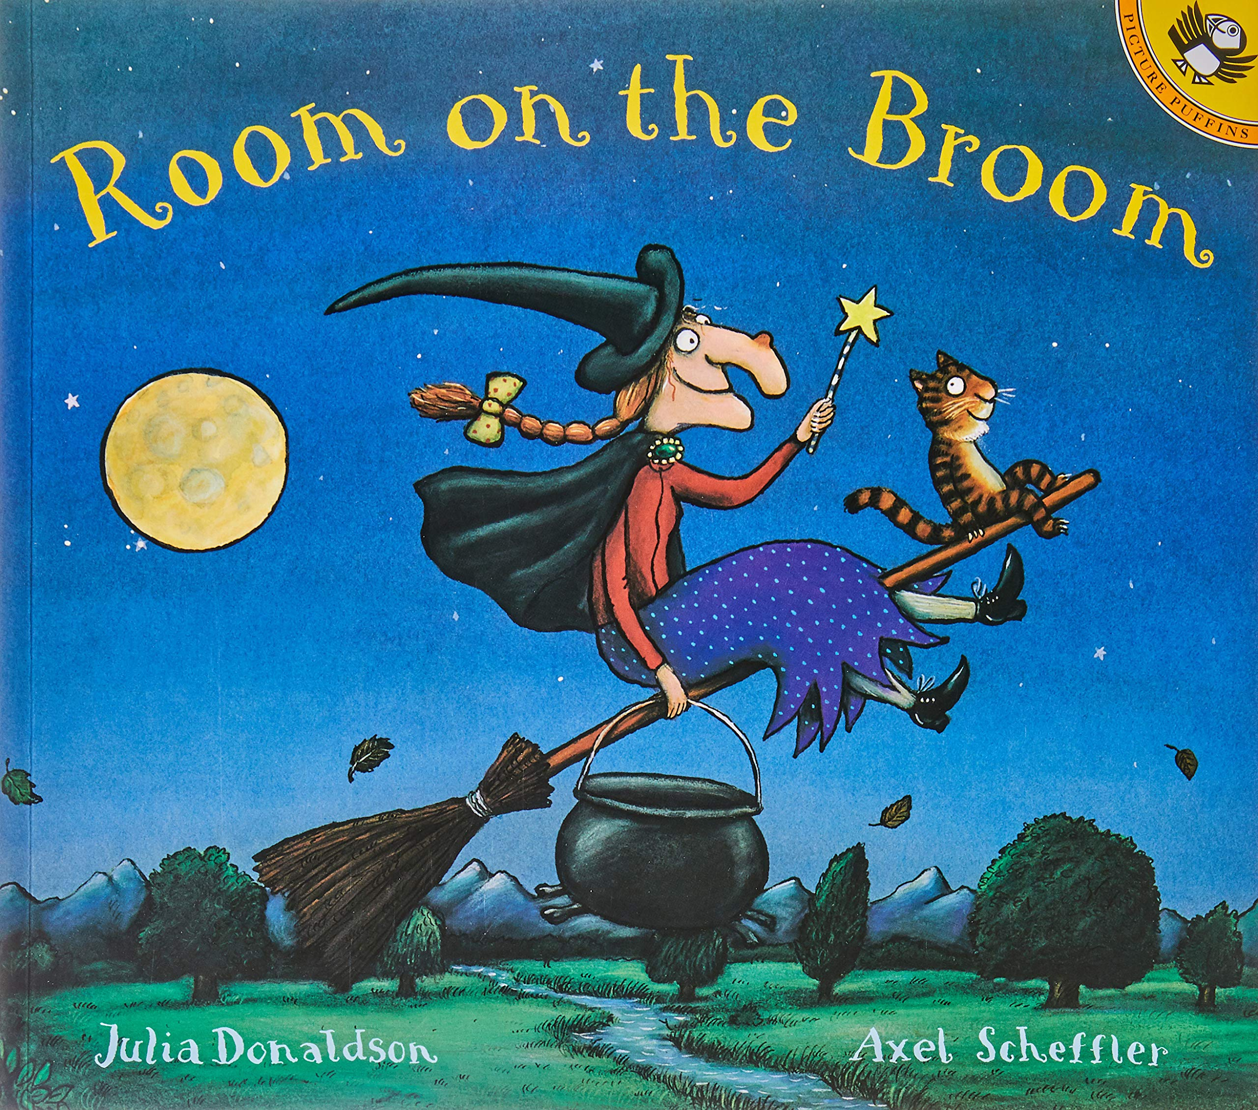  Challenge  Can you make labels of 1st, 2nd, 3rd , 4th, 5th, 6th to match the order we read the books? | Chinese New Year -DT  Practise cutting a triangle as bunting for this Chinese New Year decoration:  Challenge  Cut and decorate a Chinese lantern with Mrs Price-;  https://drive.google.com/file/d/15m72x_PFk60DRDQwh4lMz-cq-hVPSDfB/view?usp=sharing  or you could use this template  https://drive.google.com/file/d/1GkHQaPK7VCTpms0GDNI8Q555_1AUa5HV/view?usp=sharing  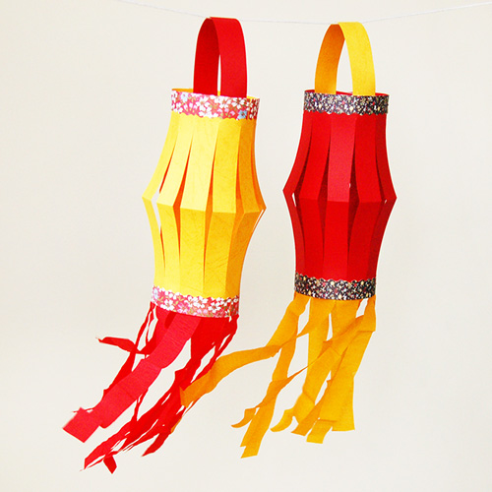
Day 5 | Video call with your teachers  Apple class- Friday  Cherry class- Thursday pm and Friday  It’s the last day of half-term. You have worked so hard. We would love to have the chance to have a Teams meeting to let you know how well you have done.  Look out for an invite from your teacher! | Maths -Tally Chart  Today’s maths activity is a counting and recording activity. We are going to make a tally chart of the number of socks( or tshirts) you have which are the colours on the Tally Chart below, Remember to make a tally mark every time you see the colour on an item of clothes  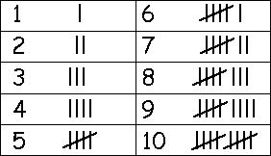  Colour Tally Total  Red  Blue  Yellow  Green  Challenge  Can you say which colour has the most tallies?This is the most popular colour. Which is the least popular colour?  Maybe you could add colours to your Tally Chart Grid | PSE  It’s the end of Home Learning for this half term and you have done lots of good work. Can you draw a picture of 3 things that you have improved since you haven't been in school?. Could it be reading, balancing or practising your ball skills?  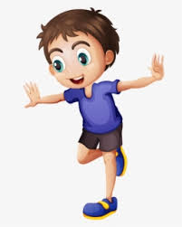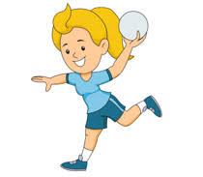  Challenge  Can you write a sentence to go with each picture starting with ...  I am getting better at..

