Rumney Primary School Year 1 - Home Learning
If you have any queries and wish to contact us, please email us directly. We are here to support your child, their learning and yourselves so your child’s learning can be at its best. Parents/carers of children with IEPs will be emailed directly and support and guidance in relation to their targets will be given.
Mrs Lewis - Cherries - slewis@rumneyprm.net
Mr Fryer/Mrs Moore - Apples - dfryer@rumneyprm.net gmoore@rumneyprm.net
Please note;
- Parents should access the year group Twitter page for information and school updates. Throughout the week we post further activities to support your child’s learning. You can also communicate with us via Direct Messages on Twitter.
- We ask that parents ‘post’ pictures/messages on @RumneyPrmYearOne Twitter page to show engagement in home learning.
- Contact will be made with families who are not engaging with home learning so guidance and support can be offered.
Day 1 | Literacy-Speaking & Listening  Get cosy with your favourite teddy and watch another super Julia Donaldson Story.  YouTube: https://www.youtube.com/watch?v=cfiPrA8E3qE  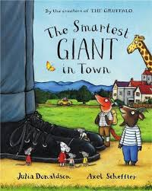Challenge  Can you remember what item the Giant gave to who?” First he gave his tie to the cold giraffe” Put the items in alphabetical order. | Maths -Measure  Can you put on a pair of your grown ups shoes so that you have giant feet like on the cover of the book? Have a go at walking across the room in the shoes and count how many steps you take. write down how many steps you take in two different rooms. Take your time!! Remember to stay downstairs and not wear your grown-ups shoes near the stairs.  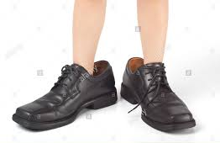  Challenge  Wear your own socks, slippers or shoes and count in twos as you jump around the rooms,  Can you add the total number of twos in each room? | Art  Can you design a new tie for the giant. Will it have spots or zigzags or both? Can you make it super long by sellotaping papers together? Jazz it up with whatever you can find, sequins, crisp packers cut up...anything goes!  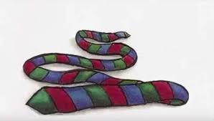  Challenge  Can you use your new measuring skills and measure it with blocks or a tape with the help of a grown up!
Day 2 | Literacy-Adjectives  Here is a picture of the Smartest giant in the story and a Teaching Video to help you write some adjectives-:  https://www.loom.com/share/db3d72cc73ad435eb4829bea2d1d04f7  Can you describe him and what he is wearing?  Start your sentence by writing-:  This is the giant  He is …..  Remember to use colours and materials.  Challenge  Can you describe every item of clothing that you are wearing.today?  Remember to use your adjectives-:  I am wearing my pink fluffy pyjamas. | Maths - Money  Watch this clip to learn about coins and their values:  https://www.loom.com/share/ad2d81b572904ad6a08ad5a8b23b9383  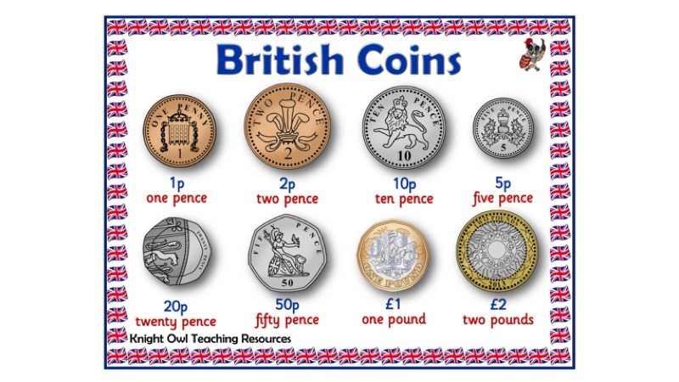  Have a look in your grown ups purse/wallet and see what coins you can find. Draw around the coin and write the amount that it’s worth. e.g. 1p or have a go at coin rubbings.  Challenge  A teaching video to get those brains working…..  https://www.loom.com/share/741f4ce5336f4158ba0a25f30bd4d0f6  Can you set up a clothes shop for the Giant? Add price tags to the clothes and pay for the money using your coins. E.g. shirt 10p socks 2p etc  You may need to make some coins using paper or foil, Can you add up how much you spend?  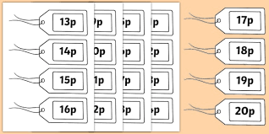 | Science/DT  Floating and sinking  https://www.bbc.co.uk/cbeebies/watch/messy-goes-to-okido-why-do-things-sink-and-float  We saw a boat floating on the water in the story  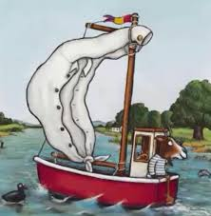  Can you find some objects in your home that float?  https://www.twinkl.co.uk/resource/t-t-5448-float-or-sink-activity-sheet  Challenge (STEM challenge)  Time for you to have a go at making a boat that floats. You will need a grown up to help you and here are some ideas of the materials you could use-::  https://www.youtube.com/watch?v=jj-vKtmtljw  https://www.youtube.com/watch?v=P4mQlCxprT4
Day 3 | Literacy - Spelling patterns  The giant’s shirt was a sail on the boat.  Do you remember the oa sounds in our spelling work?  https://www.bbc.co.uk/bitesize/topics/zvq9bdm/articles/zh4j47h  Listen to this teaching video to help you  then you can write the ‘oa’ words  https://www.youtube.com/watch?app=desktop&v=M8nGaspuWAQ  goat  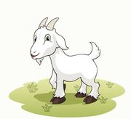  boat  float  soap  Challenge  Can you find some more words oa words?  Can you put them in alphabetical order?  Keep these words for tomorrow’s Home Learning | Maths- Sorting  Teaching video to help-:  https://www.loom.com/share/c48f5945d85240d798eb428f69cd7181  Can you sort socks,sweets for different criteria?  Put the spotty socks together or the stripey socks.  Put the blue and stripy socks together  Challenge  Make a Venn Diagram (Draw 2 overlapping circles)  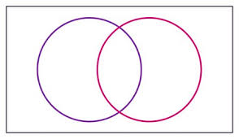  Sort socks or other items of clothing for colour,pattern or size. | Life skill  Can you help your grown ups to sort out the washing? Can you pair some socks? Can you fold any clean laundry and put your clothes in the correct drawers or learn to hang up clothes on a hanger?  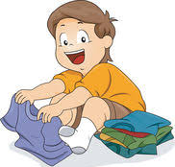  Challenge  Help your grown up to put the washing in the washing machine (under adult supervision)  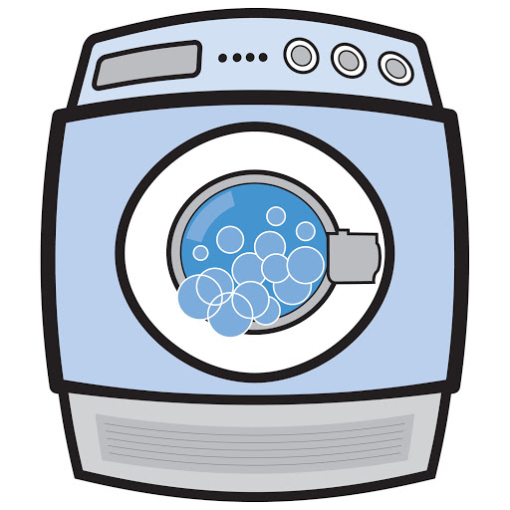  What numbers can you see on the dials? This will be the temperature to tell us how hot the water is or the number of minutes it will take for the washing machine to finish a washing cycle .Can you write the number you see on the dial?

Day  4 | Literacy -Reading/ Writing/Spelling  Spend 10 minutes reading a book to your grown up.  https://home.oxfordowl.co.uk/reading/  Write the oa words you found yesterday in a sentence. Remember your capital letter at the beginning  I can see a goat.  I can see a boat.  Challenge  Can you look at the pictures in the book and use your describing words?  The boat is red and white with a big sail.  The giant is tall with large feet and long legs.  The goat is …….  The mouse is…..  The giraffe is…... | Maths - Number- Place Value  https://www.topmarks.co.uk/learning-to-count/place-value-basketball  Challenge  https://www.bbc.co.uk/bitesize/articles/zncq4xs  Can you partition these numbers?  51,62,75,48,92,102  Can you set them out like this?  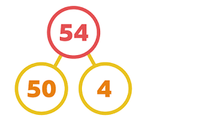 | Geography-Mapping skills  Draw a map of the Giant’s journey after going to the Smart Shop- what did he see on his way home? A river, a tiny house, a campsite. What else do you remember?  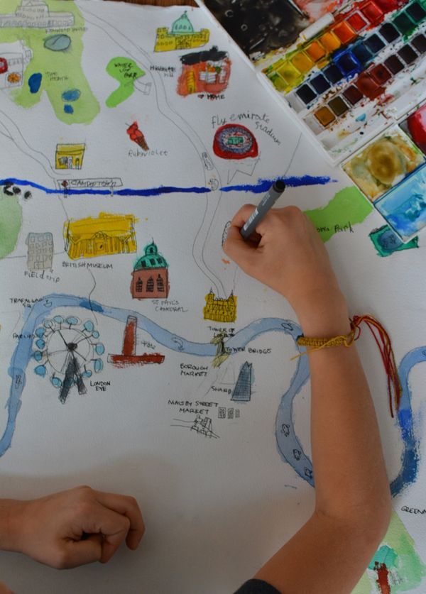  Challenge  Can you give you hide an object in a room in your home and give your grown up or older siblings directions to find it. Practise your left and right directions and how many footsteps you need to take to find it.
Day 5 | Literacy -Writing  Teaching video to help-:  https://www.loom.com/share/d9a31794bacb41d5b6a8d60cec89ac3e  Can you write a thank you letter from the Giraffe to the Giant thanking him for his tie.  Remember to tell the Giant why you like it so much.  Here is a letter template if you need one-:  https://www.twinkl.co.uk/resource/t-l-4271-thank-you-letter-writing-template  Challenge- Oracy  Can you read your letter back to your grown up all by yourself? Maybe ring a family member and tell them all about the story and the lovely letter you have written. | Maths-Time...to get your clocks ready!  You did so well with your ‘o’clock’ work last week, that this week your teachers have decided you are clever enough to try half past.  https://www.youtube.com/watch?v=rQUU85Sew7o  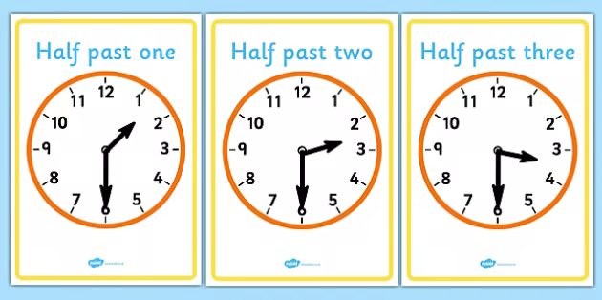  Challenge  Can you find these half past times on an analogue and a digital clock?  http://cleverlearner.com/telling-time/images/2nd-grade_telling-time-half-past-the-hour-3s.png  https://twistynoodle.com/draw-the-hands-on-theclock-half-past-worksheet/ | Music  Time to get singing! Can you learn some of the lyrics to this song? Have some fun with your grown up listen a few times and sing it together. Maybe you can add the instruments you made last week!  https://www.youtube.com/watch?v=iJ4CHVIIv78  Challenge  Using the boat you made on Tuesday can you add your own actions to the song. Imagine the boat is sailing into a storm. What sounds would you hear?  How would you describe them?  We would love to see those videos of singing and actions….keep them coming on Twitter or email them to your teachers

