Rumney Primary School Home Learning - Monday 11th May (Week 6)
This week we will be continuing our topic Brave and Bold. The focus this week will be on our fantastic
FireFighters. Take a look at our ideas but please feel free to explore any of your own ideas.
Literacy | 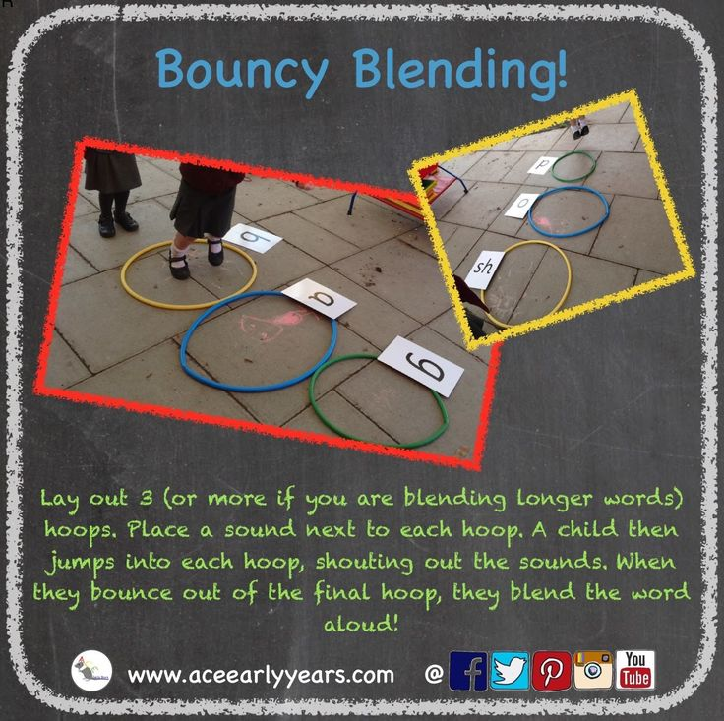  - Watch the youtube clip https://youtu.be/ZxzewVTDas0 Discuss the video. When might you need to call 999. Do you know your address in case you had to call the emergency services?  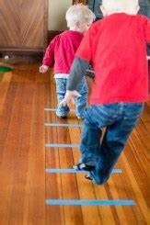  - Jump up the rungs on a ladder like a firefighter (see picture) to do your “bouncy blending” to sound out words eg. c-a-t, d-o-g, t-r-ee, ch-i-p  Continue to  - Read and talk about different story books. Can you spot any of your keywords in your book?  - Choose a keyword and talk about different sentences it could be used in. Think about each word in the sentence. Perhaps you could try and write out these simple sentences.
Maths | - Sing the action song Five Little FireFighters https://youtu.be/UZv-WS6lhKg  - Put your 10 fingers up in the air. If you put one down how many are left up? 9 + 1 =10 If you put 5 down how many are left? 5+5 =10 (you don’t have to write anything down, just enjoy doing this practically).  - Using chalk, write the numbers to 10 on a wall/ pavement outside (or on a tiled bathroom wall at bathtime) Can you find 2 numbers that make 10? ie. 6 and 4, 3 and 7 etc. (use your fingers to help you). Can you be a firefighter and squirt the numbers with a water gun, empty washing up bottle or bath toy?  Continue to  - Forming numbers correctly - using number formation rhymes  - Say ‘two more’ and ‘two less’ than given numbers up to 20 (and then beyond)  - Simple addition and subtraction using objects in the house e.g. teddies or counters. Use the signs +, - and =
ICT | 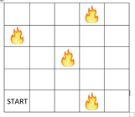  - Learn your address so that you could tell the emergency services. Can you find your house on GoogleMaps?  - Draw a grid 5 squares by 5 squares. Draw a little flame or colour a square in red. From the start square, direct your little figure/ lego person to get to the fire to put it out eg. “go forward 3 squares, turn and go forward 2 spaces.” (You could do this on a bigger scale with masking tape to create the grid and your child dressed as a firefighter!)  Continue to  - Sing along to the Jolly Jingles (phase 2 and 3) https://www.dailymotion.com/video/x2wpdvv  - Use www.topmarks.co.uk - set to ‘early years’ games in the drop down bar
General | 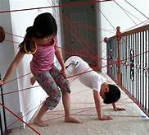  - Can you be brave and crawl or climb through an obstacle course like a Fire Fighter to rescue your cuddly toy?  - What type of firefighter crafts could you do? Maybe you’d like to try this hand print.  It fits perfectly with our song Five Little FireFighters,  - Join in the next “Clap for Carers” to thank those who are Brave and Bold.

