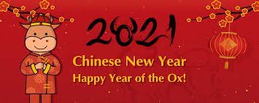
Rumney Primary School Nursery Home Learning 5 - 8.2.21
Spring Term Topic - ‘Down on the Farm’
This week’s focus: Chinese New Year
*Literacy  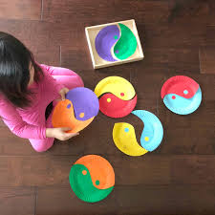 | 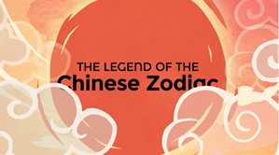  - Listen to and watch the video to find out about Chinese Lunar New Year  - Find out which of the animals on the Chinese Zodiac represents the year that you were born. Can you describe your animal?  - Look at the Chinese ‘yin yang’ - opposites often depend on each other e.g. day & night, hot & cold. Play this opposites game.  - Watch a video about how a Chinese family celebrates the New Year. What colour means ‘good luck’? Why do they clean their houses before the New Year? What was given to the children for New Year? What did the family use to eat their food (instead of a knife and fork)?
*Maths  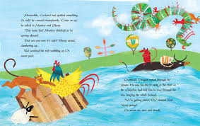 | - Feed your Number Monster numbers by counting backwards from 10 - 1  - Draw pictures of the rat, ox, tiger, rabbit, dragon, snake, horse, goat, monkey, rooster, dog and pig and number them 1-12 on the back of each picture card. How many can you remember in the correct order? Turn them over to check and then feed them to your Number Monster!  - How would you get across the river to the other side if you were in The Great Race? Use 2D and 3D shapes to build maybe a raft, boat or a bridge. Fill a washing up bowl/container, sink or bath with water to test your ideas. Remember to post your photo or videos on Twitter as I would love to see them!  - During the Chinese New Year meal they eat round shaped food which reminds them ‘to be altogether’. What round food can you find in your kitchen? How many different round foods did you find?
ICT based  (tablet/  computer) | - www.topmarks.co.uk website - set to ‘early years’ games in the drop down bar  - https://www.bbc.co.uk/teach/school-radio/nursery-rhymes-songs-index/zhwdgwx A huge selection of Nursery rhymes and songs to  - Play The Chinese Dragon Game and see if you can put the numbers in order.
General | 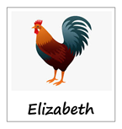  - Follow us on Twitter (Twitter Account: @RumneyprmNurse1) for regular updates and learning jobs  - Look out for any messages sent out via the Schoop app (Schoop ID: 10411)  - Draw/paint a picture of the animal that represents the year you were born, e.g. draw a rooster  - Watch my video on Twitter to show you how to make a Chinese lantern out of paper  - Dance along to a lion dance (watch the beginning and then fast forward to halfway through when they dance on the pedestals - it’s quite impressive!)
Any words in blue writing have a hyperlink so click on them to take you to the resources.

Home Learning Expectations;
We would expect your child to complete one activity daily from all of the above boxes e.g. a literacy task, a maths task, an ICT based task and a general task.
Keep the activities short and fun to engage your child. The most important thing is to spend time with your child and talk about the activities.
If you have any queries and wish to contact your child’s class teacher then please email directly.
Mrs. Proctor - jproctor@rumneyprm.net
Please note;
- Parents should access the year group Twitter page and Schoop for information and school updates
- If possible, we ask that parents post at least one picture/message/email a week to show/outline how children have been engaging in home learning
- Parents are encouraged to contact the class teacher for guidance and support if they are having difficulties accessing the home learning information

