Rumney Primary School Home Learning (Ideas 6) - Nursery
Week Beg. 11.5.20 This week the ideas are based on the rhyme and story of ‘Incy Wincy Spider’ by Igloo Books

Literacy | 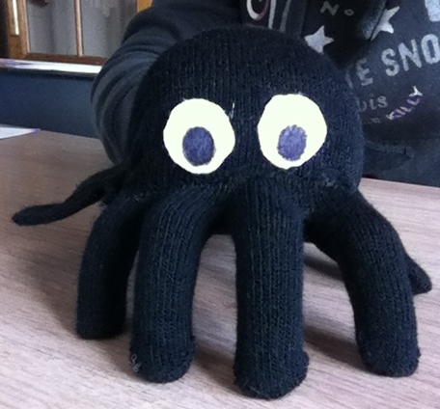  - Watch and listen to the story of ‘Incy Wincy Spider’ by Igloo Books and read by Mrs Proctor  - Can you find all the rhyming words in the story? How many pairs of rhyming words did you find?  - Make a spider puppet using an old glove and take your spider on an adventure around your house or in your garden. Can you make your adventures into a story and share it with your grown up at bedtime?  - Ask one of your family members to film you performing Incy Wincy Spider action rhyme and upload it to Twitter  - How many objects can you find ’in your house or garden that begin with the letter ‘s’?  - Practise writing ‘s’ in sand, sugar, using chalk, pencil, in the air etc. Try writing big, small and middle sized ‘s’ letters.
Maths | 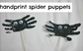  - Make a spider puppet - make two black handprints (without thumbs!), cut it out and attach it to a stick. How many legs has your spider got?  - Play the ‘Incy Wincy Spider’ game  - Practise writing the number ‘8’  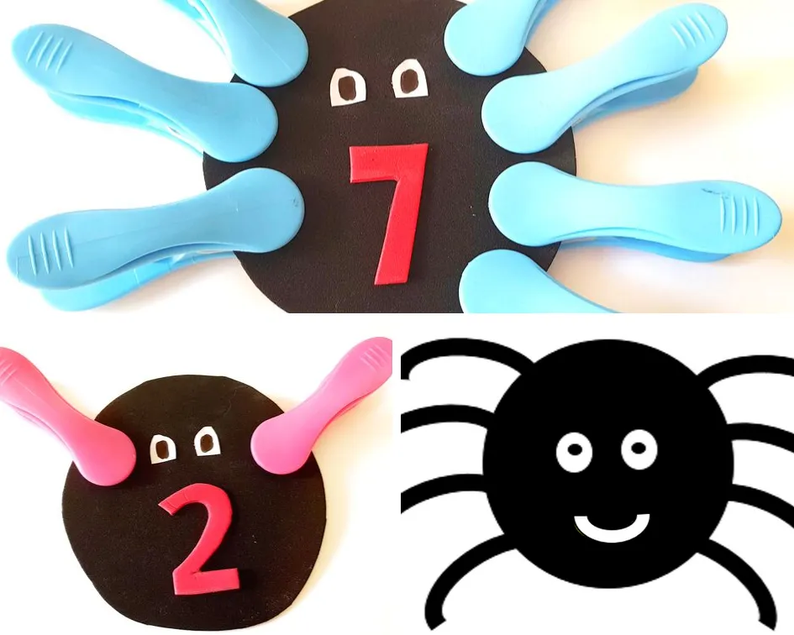  - Can you find 8 black objects in your house?  - Cut up different lengths of string or wool (Incy Wincy’s web) and put them into a bowl. Take it in turns to take a string out of the bowl. The person who has the longest string wins!  - Play the ‘Peg Leg Spider’ game. Cut out black circles (spider’s bodies) and write a number to 8 on each one. Can you match the numbers with pegs to give the spiders legs?
ICT based  (tablet/  computer) | - https://youtu.be/buE6l32rCHo (Incy Wincy Spider & other Nursery Rhymes  - Continue learning the letter sounds (for s, a, t, i, p, n, ck, e, h, r, m, d) by watching the ‘Jolly Jingles’  - Following your minibeast hunt last week, see if you can find out more about them on CBeebies
General | 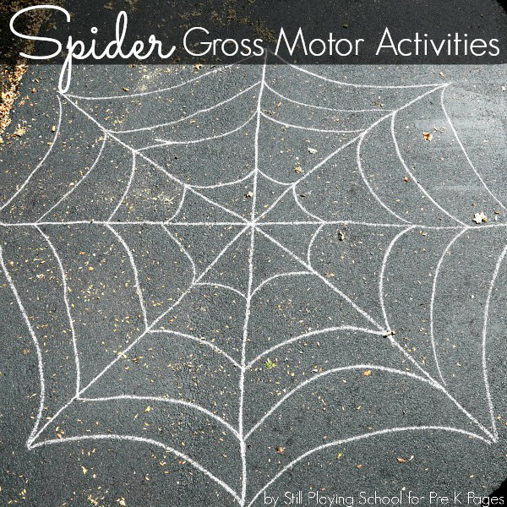  - Create your own ‘Creepy-Crawly Disco’ and watch ‘The Ugly Bug Ball’ video. Can you dress up to look like one of the minibeasts and move like them?  - Chalk or tape a giant spiders’ web onto the floor. Play games walking along the web lines or jumping in the spaces.  - After listening to and watching the ‘Incy Wincy Spider’ story, what activities can your spider do?

