Rumney Primary School Home Learning (Ideas 5) - Nursery
Week Beg. 4.5.20 This week the ideas are based on the story of ‘The Very Clumsy Click Beetle’ by Eric Carle and
the poem ‘Beetle’ By Andrew Martyr
Literacy | - Watch and listen to the story animation of ‘The Very Clumsy Click Beetle’ by Eric Carle and the poem ‘Beetle’ by Andrew Martyr read by  Mrs Proctor  - Can you teach or help someone in your family to learn a new skill? you could show them how to do it or simply use words of encouragement.  - Can you say the beetle poem after watching my video? See if you can learn it and then perform it to your family.  - What words rhyme with flip? pip, tip……..  - The Click Beetle’s name starts with the letter ‘c’. What can you see or find in your house or garden that starts with the letter ’c’? I can spot a carpet in my living room.  - Use the click beetle that you made (in the ‘Maths’ section) and hide it around your house or garden. See if someone in your family can find it? What clues could you give them? Remember to use words such as ‘next to’, ‘under’, ‘on’, ‘in’ ‘behind’. You could say that they are ‘hot’ when they get close to where it is hiding or ‘cold’ if they are too far away.
Maths | - Make a click beetle and see how many times you can flip your beetle from its back to its legs  - Watch this clip of an athlete speed jumping just like the click beetle. How many times can you jump over a small object (e.g. a shoe)?  - Can you find 3 pairs of shoes in your house that the beetle could wear on his 6 feet?  - Close your eyes and get your grown up to muddle up the pairs. How quickly can you match them into their pairs again? Try adding a few more pairs to give yourself an extra challenge!  - When your grown up next does the washing, see if you can match all the pairs of socks. How many pairs did you make?  - Play the Beetle game
ICT based  (tablet/  computer) | - Can you Count the Beetles carefully in this game? (it takes a while to load)  - Use the Paint program on the computer (or draw a picture) to draw a click beetle. Can you make a colourful click beetle? How many different designs can you create?
General | 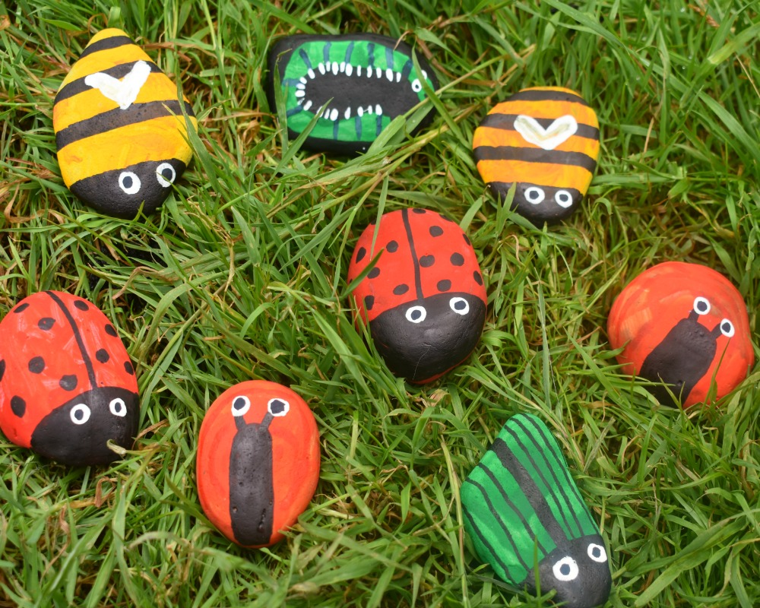  - Watch how a real click beetle flips over!  - Pebble painting - paint a stone/pebble and turn it into a beetle (or other minibeast)  - Can you learn a new skill? Remember to keep trying and send us some photos or videos on Twitter!  - Go on a minibeast hunt in your garden. Where do beetles like to live?
The 75th anniversary of V.E. Day is on Friday 8th May. Every class is taking part in activities to mark such an important milestone in our history. Please encourage your child to take part in one or more of the activities below:
- Make bunting in the Union Jack flag colours - white, red and blue and draw pictures on each triangle. Hang it in your front window on Friday.
- Make a Bravery Medal
- Have a ‘street party’ style picnic in your garden. Help to prepare the picnic by making sandwiches, cakes and squash etc.
- Look at Wales Online gallery of photos which show how people celebrated the end of the war

