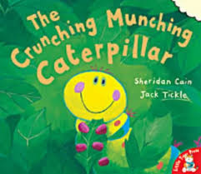
Rumney Primary School Home Learning (Ideas 4) - Nursery
Week Beg. 27.4.20 This week the ideas are based on the story of ‘The Crunching Munching Caterpillar’ by Sheridan Cain
Literacy | - Watch and listen to the story of ‘The Crunching Munching Caterpillar’ by Sheridan Cain and read by Mrs Proctor  - If you woke up and had wings, where would you fly? What would you do?  M r s. P r o c t o r  - Draw the circles of a caterpillar’s boy and write each letter of your name in each circle.  - “I went into the garden and I saw a caterpillar.” Then the next person says, “I went into the garden and I saw a caterpillar and a ladybird.” Keep adding a new minibeast each time. How many words in the list can you remember?
Maths | 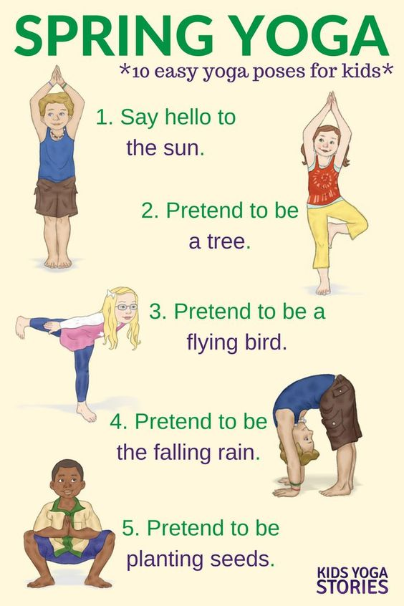  - How many different caterpillar colour patterns can you create? Can you create a 2 colour pattern? Now try a 3 colour pattern, e.g. red, blue, green, red, blue, green…. You could try finger painting to create your caterpillar!  - Count how many animals in the story have wings. Do they all have the same number of wings?  - How many different ways can you stretch your body just like the caterpillar did when he woke up?  - Go on a minibeast hunt in your garden or outdoor space. How many minibeasts can you find and where do they live?  - Make a short and long caterpillar using blas of scrunched up paper or playdoh. Can you make a middle sized caterpillar? How many circles/balls did you use for each caterpillar?  - Practise writing numbers to 10 onto a caterpillar.
ICT based  (tablet/  computer) | - www.Topmarks.co.uk Caterpillar counting, matching and ordering  - Use the Paint tool on the computer (if you have access to one) to draw your own butterfly. Experiment with different colours and patterns.
General | - Wiggle along the floor like a caterpillar and then lie still and count to 20. Stretch your body and stand up. Stretch out your arms. You are now a beautiful butterfly! Flap your wings (your arms) and glide around the room or garden like a butterfly. Can you pretend to soar high into the sky and swoop low down onto the ground?  - Create a butterfly painting https://youtu.be/cGS2BuCtgtU  - Sing a butterfly song to the tune of ‘Twinkle, Twinkle, Little Star’:  Flutter, flutter butterfly  Floating in the springtime sky  Flying by for all to see  Soaring high so merrily  Flutter, flutter butterfly  Floating in the springtime sky

