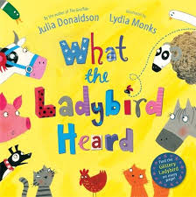
Rumney Primary School Home Learning (Ideas 3) - Nursery
Week Beg. 20.4.20 This week the ideas are based on the story of ‘What the Ladybird Heard’ by Julia Donaldson
Literacy | - Watch and listen to the story of ‘What the Ladybird Heard’ by Julia Donaldson and read by Mrs Proctor  - Play ‘Guess the Animal’. Ask an older brother, sister or grown up to make an animal sound and you have to guess the animal, e.g. ‘moo’ for a cow  - Act out the story by setting up objects/soft toys etc. around your house or garden . You can use any objects to pretend to be animals or you could include dinosaurs or sharks. Use whatever you have in your house. Give your grown up or brother/sister instructions to follow, e.g. Open the gate in the dead of night. Pass the dinosaurs and then turn right. Round the tree, past the cat (Be careful not to wake the rat) Left past the pigs and then straight ahead And in through the door of the prize cow’s shed. Use your imagination and don’t worry if it doesn’t rhyme!  - Draw a picture of the farm animals. Can you pretend to be the ladybird and draw a continuous line to loop around to touch each animal? (just like in the story when she whispered her idea into each of their ears)  - Play ‘Ladybird Whispers’. Whisper a sentence to a family member, e.g. ‘Cows have four legs’ and see if they ca pass on the
Maths | - Count how many animals are mentioned in the story  - Choose a number between 1 and 10. Can you match it with animal noises, e.g. Number 4 - moo, moo, moo, moo If you want to make it harder see if you can jump at the same time as you make the noises!  - Draw a simple map of your farm. How many steps do you need to take to each of the animals? e.g. 4 steps to the pigs, 6 steps to the ducks  - Pretend to be one of the robbers (you could make a mask to wear!) and tiptoe while counting aloud to 10 to get to the cow (put a picture or soft toy 10 steps away from you) pick it up and then tiptoe back while counting back from 10 to 0.
ICT based  (tablet/  computer) | - Sing along to the Jolly Jingles (phase 1 and 2) on Youtube  - www.topmarks.co.uk website - Early Years - Ladybird counting, matching and ordering games  - Follow the link to learn the names of the young of different farm animals. You can cut print them out or just look at them on screen https://static1.squarespace.com/static/5157614de4b06ce8229f34fb/t/5c7717bc7817f7b642d1fc32/1551308734437/OldYoung+Match+Puzzle.pdf
General | 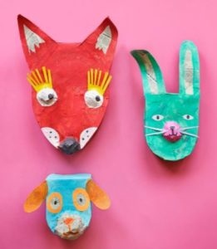  - Make animal masks using paper plates or cereal boxes  - Watch Julia Donaldson singing a song based on her book. Can you sing along to it? https://youtu.be/7NbyiDpY6Ww  - Think about whether the robbers should have stolen the cow? Is stealing right or wrong? What happens when you steal? What happened to the robbers in the story?  - See if you can be helpful like the Ladybird and help each member of your family this week. You could help to tidy up, look after your pet, sort the washing, lay the table etc. Remember to post photos on Twitter!utu.be/7NbyiDpY

