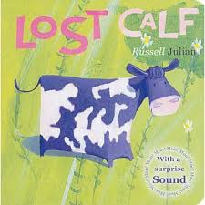
Rumney Primary School Nursery Home Learning 4 - 1.2.21
Spring Term Topic - ‘Down on the Farm’
*Literacy | - Listen to and watch the video of ‘Lost Calf’ by Russell Julian and read by Mrs. Proctor  - Why should young animals and children stay close to their parents?  - Have you ever got lost? How did it make you/your grown-ups feel? Where did they find you?  - Which places did little calf visit in the story?  - Play Hide and Seek with a family member. Try playing the game using a soft toy. Give clues as to where it is, e.g. my toy is hiding under something blue/behind something big/next to something round
*Maths  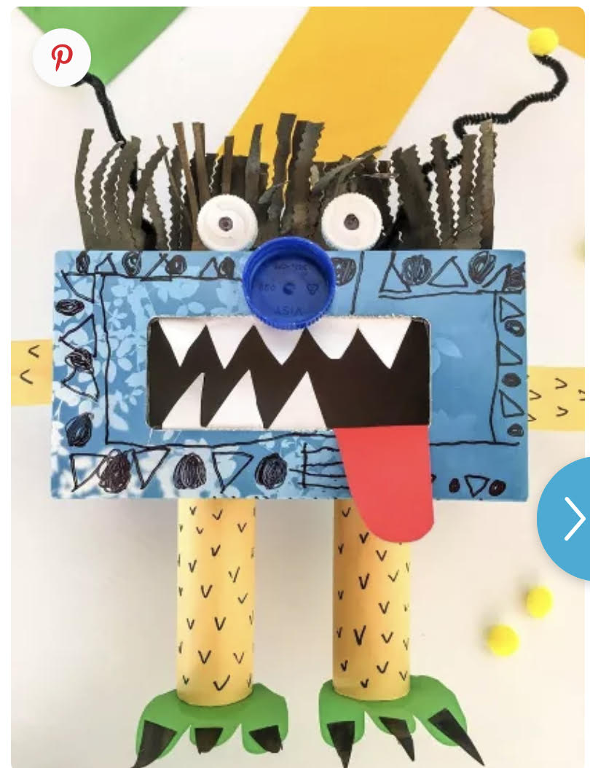 | - Make a ‘Number Monster’ out of an old tissue box or delivery box, decorate it and ask your grown-up to make some simple number cards to 10 or 20. Play games such as turning over a card, saying the number and posting it into the Number Monster’s mouth!  - Play ‘One More/One Less’ by turning over a number card or picking one out of a bag/box, saying the number and then finding one more or one less than the number  - Put the number cards 1-10 or 1-20 (muddled up) on the table in a line going from left to right. Start by finding number 1 and put the numbers in order. Say each number as you feed it to your Number Monster. Now try ordering them 10-1 or 20-1 and count backwards as you feed them to your monster.  - Make some spotty cards (10 cards with spots matching each number up to 10). Touch each spot as you count. The last number you get to tells you how many spots there are altogether. When you have counted a card, feed it to your Number Monster. Order them 1-10/1-20
ICT based  (tablet/  computer) | 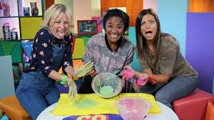  - www.topmarks.co.uk website - set to ‘early years’ games in the drop down bar  - https://www.bbc.co.uk/teach/school-radio/nursery-rhymes-songs-index/zhwdgwx A huge selection of Nursery rhymes and songs to  - Sing along to Mr. Tumble singing ‘Five Little Speckled Frogs  - Messy Playtime - watch this clip and try making these at home! ‘Robo Slime’ is great fun to make.
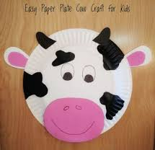  General | - Follow us on Twitter (Twitter Account: @RumneyprmNurse1) for regular updates and learning jobs  - Look out for any messages sent out via the Schoop app (Schoop ID: 10411)  - Listen to ‘Funky Farm’ by The Goodies. Can you create your own song using animal noises?  - Make a cow or lots of cows using paper plates or pressed out cake cases or even circles of paper. Cut out shapes to make the patches, nose, eyes, mouth and ears  - Using your pots and pans from last week, see if you can play low and high sounds, fast and slow sounds. Look out for a video to help you!  - After watching my video, see if you can make homes for your toy animals.
Any words in blue writing have a hyperlink so click on them to take you to the resources.
*Please note that videos will be posted on Twitter weekly to support Maths and Literacy.

Home Learning Expectations;
We would expect your child to complete one activity daily from all of the above boxes e.g. a literacy task, a maths task, an ICT based task and a general task.
Keep the activities short and fun to engage your child. The most important thing is to spend time with your child and talk about the activities.
If you have any queries and wish to contact your child’s class teacher then please email directly.
Mrs. Proctor - jproctor@rumneyprm.net
Please note;
- Parents should access the year group Twitter page and Schoop for information and school updates
- If possible, we ask that parents post at least one picture/message/email a week to show/outline how children have been engaging in home learning
- Parents are encouraged to contact the class teacher for guidance and support if they are having difficulties accessing the home learning information

