Rumney Primary School Year 2
Home Learning Days 31-35
Our Twitter account @RumneyPrmYear2 supports our learning and is added to daily - it is a great way for us to keep in touch and share additional activities.
It is also our way of trying to ensure that the children have shared & similar experiences and so we are grateful to you for being part of our active Twitter learning family.
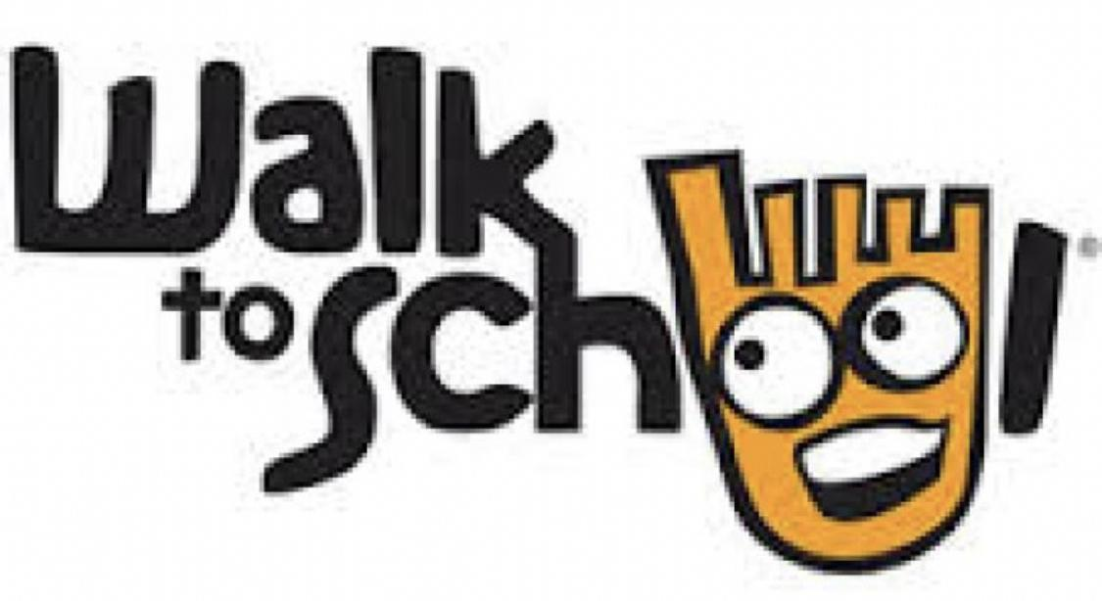
Literacy Monday
Spelling task – pattern see following tweets
Polar Bears
Seals
Arctic Wolves
Penguins
Arctic Foxes
Literacy Tuesday
Get someone to test you on your words from yesterday. This seems to be a popular activity so we’ve kept it the same. Think the children like making their grown ups work 😄. Play pass the sentence with a grown up. Start off a sentence using your word. Ask your grown up to finish the sentence. Can you write it down?
Both of you check that you have written it down correctly. Swap places and repeat for all your words.
Literacy Wednesday
5 minute spelling test
Honey Bee reading comprehension - see resource on Twitter
Literacy Thursday 5 minute spelling test
Capital letters for names of places
Write down 10 streets/roads/avenues in your neighbourhood. Do more if you can. Check you have used a capital letter for each part of the name, Wentloog Road - if you haven’t circle the start letters of each part like a teacher and write the words again. Your writing should be consistent in size and remember capitals are tall letters.
Literacy Friday
Today you are going to write a persuasive piece of writing to answer this question.
Is walking good for you?
Organise your work in this way
Statement to agree or disagree if you can find arguments against.
Start each chunk of writing with a phrase similar to these
I agree with this because
Another reason walking is good for you
Another argument is
In my opinion
Some people believe … and I agree with that.
Finally for these reasons I think that walking …
Check your sentences start with a capital letter. If they don’t. Circle the letter like a teacher and change.

(Make sure you form those letters correctly too- such a lot to think about)
acdgo - all start going around like a curly c
bhkmnpr - bouncy/bungy letters - all start with a down stroke and it bounces up and over
u - you must finish this coming back down with a flick on the line

cup, sun, mum, run, fun, up, mud, tub, dug, got
Challenge 1 Practise then see how quick you can flick your fingers and put the spellings down correctly.

