Rumney Primary School Year 2
Home Learning Days 31 - 35
Twitter is a great way for us to keep in touch and share additional activities. Thank you to all the grown ups for sharing learning/activities with us we look forward to seeing this weeks learning too. .
Puzzle Monday
How strong is your body & mind. Draw 2 circles on a sheet. Name one outer strength and the other inner strength. Outer Strength Do you know any strong people? Why are they strong? Talk to your grown ups about what is physical strength. What physical things do you do? E.g sporting activities, drawing, carrying, lifting. Inner Strength Repeat but now thinking about ways you can be strong inside. E.g confidence, self esteem, feeling valued, safe, calm, patient, thoughtful, kind. Fill in your circles as you think of more ideas
Which do you think is the most important? Outer or Inner? Can you think of ways to make your outer and inner strength stronger? Is it important to practise your inner strength as well? How can you do this to help look after your inner self. Make a poster to remind everyone to look after their inner strength. Hang it where everyone can see it.
Do you know any other strong people? Why are these people strong?
Puzzle Tuesday This week would be our Walk to School Week. Although we can’t take part in this right now we are still going explore the benefits of walking.
Read through the Twinkl slides about walking to school. After every slide try and see if you can explain it in your own words. Then add the phrase I agree walking is good for you because and see if you can put your argument together. Do this for every slide.
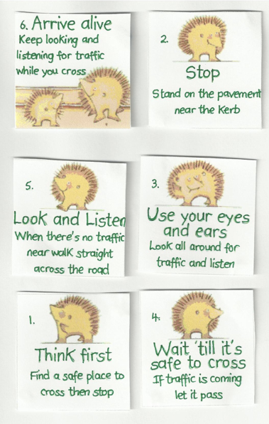
Wednesday
The Green Cross Code
Read through these rules for the Green Cross Code. Put them in the correct order so it makes sense.

Make your own poster helping people to cross the road safely.
Thursday/Friday This activity will take more than one session as you need to complete a walk, take some photographs on a phone or iPad and complete a picture collage using an App like pic collage if possible. Choose a favourite walk that you do as part of your daily allowed exercise. As you go along the way choose things that are of interest to you(could be buildings, flowers, vehicles- try to stick to one theme) and ask your grown up to help you photograph them. Your grown up will give you their top tips for getting good photographs & we will post tips for your collage too. Remember to keep a steady hand. Check you have the photo you want before moving on. If you can’t take photographs maybe you could draw what you see.
With a grown up decide which App is going to be the best for you. There are many free ones so you don’t need to spend a lot of money to do this. Your grown up may already have a favourite. That will be great! Experiment putting your photos into the collage maker or arranging your drawings in different ways to get the best effect. Can you give it a title? Share your work of art with us. We absolutely love seeing your work.

