Rumney Primary School Year 2
Home Learning Days 31-35
Thank you to all the grown ups for sharing learning/activities with us.
Maths TTRockstars 10 mins Monday
Ordering numbers. Can you put these lists of numbers in the correct order? Remember to think about the tens digit first and then look at the units digit if you need to.

- 36, 61, 54, 58, 42, 47
- 24, 27, 61, 26, 62, 65
- 98, 93, 97, 88, 83, 82
- 14, 11, 19, 20, 35, 18
- 53, 43, 48, 33, 36, 60

Challenge: How about trying it with three digit numbers? You might need a grown up to help you this time. You’re going to need to consider the hundreds digit, then the tens digit and finally the units.

- 353, 412, 284
- 465, 432, 398
- 687, 681, 632
Maths TTRockstars 10 mins Tuesday
Can you remember your directions from last week? You used words like clockwise, anti-clockwise and quarter turns. Can you put those skills into practice again this week?

Consider the route you take to come to school. Can you write down the directions you take? Remember to write down which direction to turn when leaving your house. Try to include instructions about how far to walk using an estimate of how many metres (If you have a tape measure, check how long a metre is).

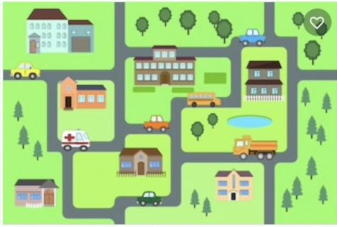
If you come to school by car, try to remember all the turns the car needs to take on the way.
Challenge
Draw a simple map of your route. It’s a good idea to draw on any buildings or landmarks to help get your bearings.
Maths TTRockstars 10 mins Wednesday
Let’s use the map we drew yesterday or ask an adult to help you draw one. Mark on the map the route you take to school. Use a coloured pen or pencil if you have one. Now try to think of a different route you might take. Mark this on the map. Can you write out the directions you would need to take to go this way? Which way is the quickest?
Challenge - How many steps do you think it takes you to get to school? Why not go on a walk with your grown ups and head past the school to check how close you were with your prediction.
Maths TTRockstars 10 mins Thursday
Quick fire Odds or evens?
Get a grown-up to test you on whether a number is odd or even. See how quickly you can tell them whether the number they shout out is odd or even.
What tells you whether a two digit number is odd or even? Can you write down an explanation for somebody else to help them understand too?

Challenge - Time yourself answering 10 quick fire questions from your grown-up. Can you beat your time? Try to get quicker and quicker.
Friday
Your challenge today is to set up a pretend shop in your house. Add some price tags to some of your toys around the house. Make sure everything is less than £1 and give each item a price which is a multiple of 10.

E.g.
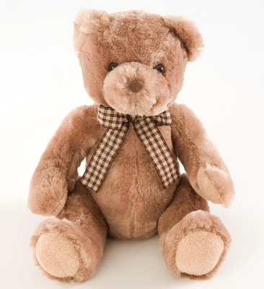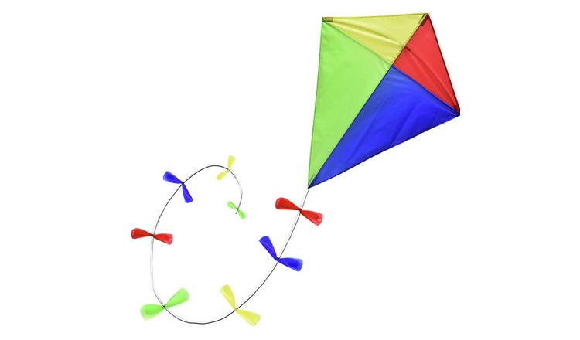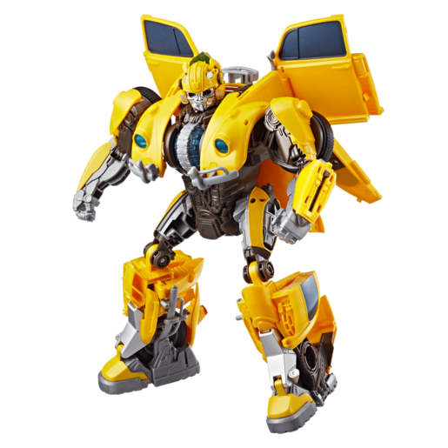
30p 50p 70p 90p
Ask a grown up or brother or sister to bring a pound to your shop (It doesn’t have to be real) and buy a toy. Work out how much change to give them.

Challenge - Now, have your shopper bring £2 to the shop. Practice making sure you give the right change.

