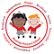
Rumney Primary School Year 2
Home Learning Days 26-30
Our Twitter account @RumneyPrmYear2 supports our learning and is added to daily - it is a great way for us to keep in touch and share additional activities. Thank you to all the grown ups for sharing learning/activities with us.
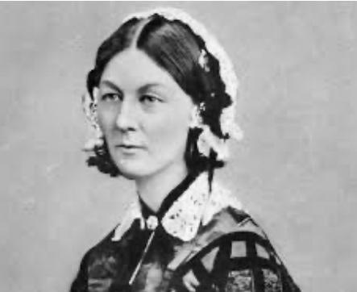
Literacy Monday
Spelling task – pattern see following tweets
Polar Bears
Seals
Arctic Wolves
Penguins
Arctic Foxes
Literacy Tuesday
Get someone to test you on your words from yesterday. Play pass the sentence with a grown up. Start off a sentence using your word. Ask your grown up to finish the sentence. Can you write it down?
Both of you check that you have written it down correctly. Swap places and repeat for all your words.
Literacy Wednesday
5 minute spelling test
Reading detective time Florence Nightingale
The information is on Twinkl but I will be putting the link/and pics on here for you to read.
Answer the questions set for you. Can you write the answers down in full sentences. Check capital letters/full stops.
Literacy Thursday 5 minute spelling test
BBC bitesize link will be sent on following tweets
Read through the Florence Nightingale Biography/Twinkle PowerPoint Slides. Make some notes that you find interesting. Look at the headings that you need to write about to help you decide what is important. Tomorrow you will be writing your own Florence Nightingale biography.
Literacy Friday
Today you are going to write about Florence Nightingale in your own biography. Remember to look at your notes but write in full sentences today. Structure your work under the following sections.
Title
Introduction saying why she was special. Remember we are writing in the past tense because this happened in the past.
Early Life
Becoming a nurse
Crimean War
After the War

(Make sure you form those letters correctly too- such a lot to think about)
acdgo - all start going around like a curly c
bhkmnpr - bouncy/bungy letters - all start with a down stroke and it bounces up and over
u - you must finish this coming back down with a flick on the line

cup, sun, mum, run, fun, up, mud, tub, dug, got
Challenge 1 Practise then see how quick you can flick your fingers and put the spellings down correctly.

