Rumney Primary School Home Learning - Monday 29th June (Week 12)
This week we will be reading and completing tasks based on the book ‘Chalk!’
Literacy | - Watch this clip to find the book ‘Chalk!’ It’s an unusual book this week because this book has no words. https://video.search.yahoo.com/search/video?fr=mcafee&p=chalk+book#id=3&vid=ce4d83186b81e92c718722fad9e5ec3b&action=view  - Explore this book again and pause the story after each page. Tell your grown up what is happening on each page, look at the pictures carefully and note the expression on the characters faces and how they might feel.  - If you could draw something that could come to life what would you draw? Draw your picture using chalk like the children in the story or on paper with felts, crayons etc.  - Write a sentence to say what you have drawn and why. “I will draw a ... I want it to come to life …”  Continue to  - Read and talk about different story books. Can you spot any of your keywords in your book?  - Think of more ingenious and fun ways to learn your keywords this week. Write in shaving foam/ flour/ mud/ sand etc.
Maths | 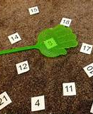  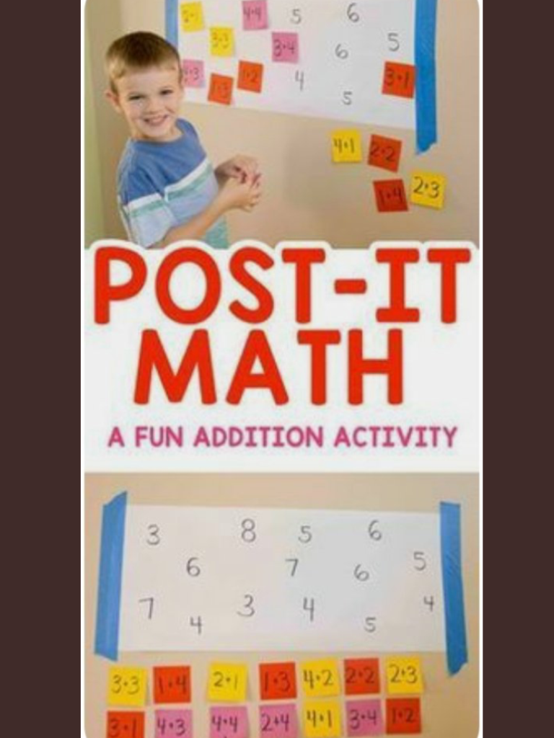  - Play ‘swat!’. Write numbers 1-20 on paper (or chalk outside). When your partner says a number ‘swat’ the number. When your partner shows you a question eg. 5 + 5 = ‘swat the answer. (You don’t have to have a fly swat, you can use your hand).  - Play ‘post it maths’ (see picture). Using the number to 20 cover the answer with the ‘post it’ question.  - Practice your adding skills https://uk.ixl.com/math/year-1/add-with-pictures-sums-up-to-20  Continue to  - form numbers correctly - using number formation rhymes  - use arrow cards all the way up to 30 (or 50 if you can!) Can you make the number that your adult says? Can you add one more to that number? Can you take away from that number?
ICT | - Record your voice/ video yourself explaining what happens on one page of the story. Listen back to your recording. If you're feeling confident you could turn down the sound on the video link of the story and you could video yourself telling the whole story for a friend or your brother or sister!  Continue to  - Use Carol Vordeman account https://www.themathsfactor.com whilst it is still free (they start charging after 5th July!)  - Practice your tens and untis https://www.splashlearn.com/math-skills/first-grade/place-value/numbers-up-to-20
General | - Explore symmetry (being the same on both sides) by creating a painted butterfly or moth https://video.search.yahoo.com/search/video?fr=mcafee&p=symmetry+for+kids#id=2&vid=75622c0bc6573509824dfda50f82d654&action=click  - Create a butterfly or moth outside using chalk (see picture) Try to make it the same on both sides (you could use shells, pebbles, crisp packets etc to decorate your butterfly…. remember you will need one for each side to make it the same)  - Draw around your body (outside, on old wallpaper, on big boxes etc). Discuss how the children felt at different times in the story. Talk about and find on the body where you might feel angry eg. clenched fists, clenches teeth, tummy, face etc.
Chalk https://video.search.yahoo.com/search/video?fr=mcafee&p=chalk+book#id=3&vid=ce4d83186b81e92c718722fad9e5ec3b&action=view
Adding skills https://uk.ixl.com/math/year-1/add-with-pictures-sums-up-to-20
Ten and units https://www.splashlearn.com/math-skills/first-grade/place-value/numbers-up-to-20
Making a butterfly https://video.search.yahoo.com/search/video?fr=mcafee&p=symmetry+for+kids#id=2&vid=75622c0bc6573509824dfda50f82d654&action=click

