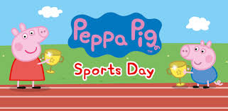
Rumney Primary School Home Learning (Ideas 8) - Nursery
Week Beg. 8.6.20 This week the ideas are based on ‘Peppa Pig Sports Day’ by Neville Astor
The races for this week are: Long Jump and High Jump
Literacy | - Watch and listen to the story of ‘Peppa Pig Sports Day’ by Neville Astley  - Can you remember all the races Peppa and George took part in?  - How did George and Peppa feel when they did not win their races?  - It was ‘a draw’ at the end of the Tug of War competition. What is ‘a draw’?  - Play ‘Kim’s Game’ by putting up to 10 objects on a tray (with some sports themed objects, e.g. an egg, spoon, ball). Try to remember the objects before they are covered with a cloth and close your eyes while your grown up removes one object. Which object is missing?
Maths | - What was the first race that George Pig took part in?  - What was the first race that Peppa Pig took part in?  - What was the last race they both took part in?  - Mark out a starting line in your garden or outdoor space. Run up to the line and jump as far as you can remembering to land on your two feet. Ask your grown up to measure how far you jumped. Have another few goes to see if you can jump further. Remember you’re trying to beat your own jump not anyone in your family (but they can join in too!). Have a look at this long jump video to get some tips!  - Set up a small soft objector a skipping rope a little way off the ground to jump over. Make sure that you have a soft landing, e.g. the grass just in case you fall to avoid any injuries. Watch this high jump video for ideas. Try raising the rope or finding a slightly larger soft object to jump over. How high can you jump?  - Remember to upload the videos of your Sports’ Day races to Twitter.
ICT based  (tablet/  computer) | - Continue learning the letter sounds (for s, a, t, i, p, n, ck, e, h, r, m, d) by watching the ‘Jolly Jingles’  - Click on the link to play ‘Phonics Pop’ http://www.ictgames.com/phonicsPop/index.html  - Practise number/letter formation and name writing using this... http://www.ictgames.com/mobilePage/writingRepeater/index.html  - Practise finding one more and one less than numbers within 10
General | 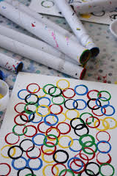  - Try this fun ‘Warm up’ before you start your races.  - The children love this ‘Hop Little Bunnies’ action song. They lie on the floor pretending to be the bunnies asleep and then hop around when the bunnies wake up!  - The Tokyo Olympics was meant to take place this summer but will now begin in July 2021. See if you can make the 5 coloured Olympic rings, which represent each continent, by printing, collaging or using art and craft materials, e.g. the  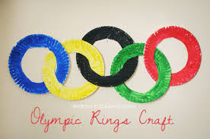  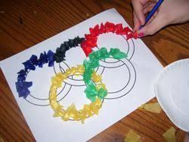  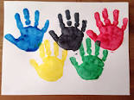  outer edges of painted paper plates!

