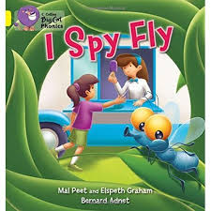
Rumney Primary School Home Learning (Ideas 6) - Nursery
Week Beg. 18.5.20 This week the ideas are based on the rhyme and story of ‘I Spy Fly’ by Mal Peet and Elspeth Graham

Literacy | - Watch and listen to the story of ‘I Spy Fly’ by Mal Peet and Elspeth Graham and read by Mrs Proctor  - If you were a fly which food would you like to eat? Where could you find it?  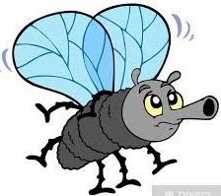  - A fly loves to buzz around, can you make a ‘buzzing’ sound ‘buzzzzzzz’ and fly around your house or garden?  - Using the story map https://www.dropbox.com/s/9x0hwi7drldkin4/I_Spy_Fly_map.jpg?dl=0 to retell the story of the fly’s journey around the park  - Find out some fun facts about flies! https://youtu.be/RJ9VvCS13sA
Maths | - How many different creatures did the fly meet on his journey?  - Create a map of the fly’s journey.  - Click on these links to play the ‘I Spy minibeast’ game https://www.dropbox.com/s/dl1q5np9lrokro4/I%20Spy.pdf?dl=0 https://www.dropbox.com/s/8m7ozaaj77ihxdw/Checklist.pdf?dl=0 Try hiding pictures of the minibeasts around your house or garden.  - How many things can you think of that can fly, e.g. an aeroplane?  - Click on the links to play the ‘Frog Fly Posting’ game https://www.dropbox.com/s/s86brz7uadx71jx/Activity%20Guide.pdf?dl=0 https://www.dropbox.com/s/ymk3xq1zmn4o37y/Frog%20Sheet.pdf?dl=0 https://www.dropbox.com/s/fa1y330bibmg23j/Fly%20Cut-Outs.pdf?dl=0
ICT based  (tablet/  computer) | - Continue learning the letter sounds (for s, a, t, i, p, n, ck, e, h, r, m, d) by watching the ‘Jolly Jingles’  - Click on the link to play ‘Phonics Pop’ http://www.ictgames.com/phonicsPop/index.html  - Practise number/letter formation and name writing using this... http://www.ictgames.com/mobilePage/writingRepeater/index.html
General | - Make a paper aeroplane with your grown up. How far can you make it fly? Try measuring the distance with your feet. https://youtu.be/r9ReNKZiZNc  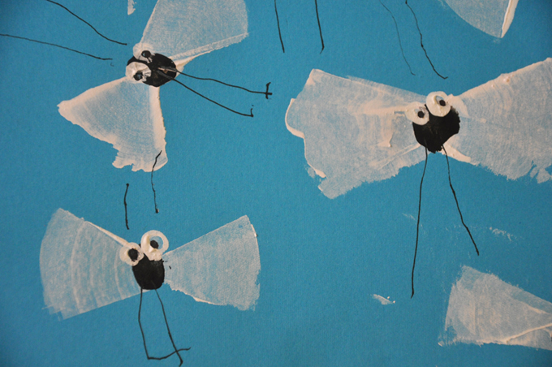  - Play ‘Fly Hide and Seek’. You hide and your grown up has to find you. Make a buzzing sound to give them a clue!  - A fruit fly loves to eat fruit. What is your favourite food? Ask the people in your family too.  - Use the straight edge of a small rectangular piece of cardboard dipped in white paint to create the flies’ wings. Use a black pen to create the legs and and paint for the eyes.

