Rumney Primary School Year 2
Home Learning Days 36 - 40
Thank you to all the grown ups for sharing learning/activities with us.
Maths TTRockstars 10 mins Monday
Can you use your practise on completing sequences to fill in the gaps in the sequences below. Remember to think about whether the numbers are increasing or decreasing and then to consider by how much they go up and down.
3 _ 9 _ , _, 18 _, 8, _ , 16, _, _
15, _, 21, _ , 27,_ _, _, 15, _, 25, _, _
11, _, 31, 41, _, _, 71 12, _ 8, _, 4, _, _
55, _, 45, _, _, _, 25, _. 90, _, _, 60, _, _, 30
16, _, 24, _, _, 36, _, _ 32, _, 28,_, 24, _, _
Challenge Set some of your own sequences for a grown up to solve. Try to do some that go up and some that go down. Try to make sure you do different sized jumps to really test them!
Maths TTRockstars 10 mins Tuesday
Funky fractions
Today we are going to look at shapes. We will be folding them to make halves and quarters.
First you need to find some 3D shapes that have round faces, square faces and rectangular faces.
Next you need to draw around your round faces, square faces and rectangular faces. You can use any paper or card for this. Look if there is any in your recycling.
Then cut them out.
Now you are ready to fold and cut them into halves and quarters.
To fold your shape into halves you fold it edge to edge and make one fold. You can then cut your shape into 2 halves. Write half on each half.
To fold your shape into quarters you fold it edge to edge and fold. Then you need to fold that piece in half again. Write quarter on each quarter.
Challenge
Does this work with a triangle? Can you halve it? Can you quarter it? Talk to your grown up about it.
Wednesday Maths TTRockstars 10 mins
Funky fractions
What fraction of these shapes are pink.
Remember a fraction is a piece of something.
First write the out of line _
Next count the total number of rectangles in your shape and write that number under the out of line e.g
_
4
Then count the number of pink rectangles and write it above the out of line. Now you have written the fraction that is pink 👏🏻
Some of these are tricky and we’ve tried to catch you out. Can you see another way you can write your fraction?
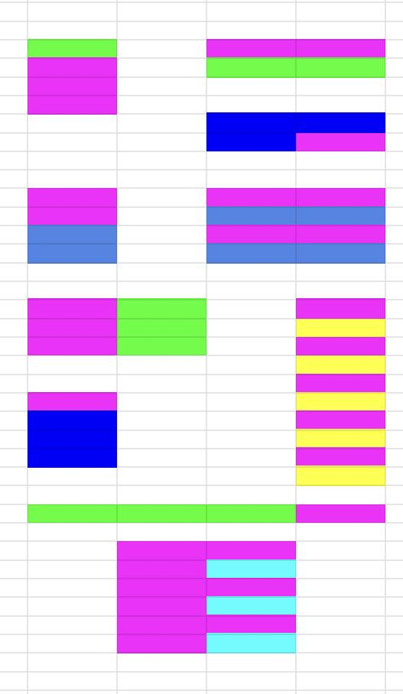
Challenge
Can you direct your grown up through a maze using instructions like those above? You could make your maze with ribbons, tape or strips of paper.
Maths TTRockstars 10 mins Thursday
Quick fire Subtraction
It’s that time again. Repetition of these quick fire questions keep those brains sharp and fast. Grown ups to read these sums out. If you don’t answer in 5 seconds they can answer for you. We are hearing some very good news about how quick you are getting.
If you are finding it tricky concentrate on one line at a time and go over and over this.
10 - 5, 10 - 3, 10 - 7, 10 - 6, 10 - 2, 10 - 4
20 - 6, 20 - 3, 20 - 5, 30 - 4, 40 - 5, 30 - 1
40 - 4, 50 - 6, 70 - 3, 60 - 2, 50 - 4, 80 - 5
90 - 4, 30 - 6, 40 - 4, 50 - 6, 90 - 2, 20 - 7
90 -5, 30 -8, 40 -2, 50 -5, 90 -‘ 9, 20 - 4

Friday
Twitter activity on Ordinal Numbers
1st 2nd 3rd 4th 5th and on they go … all these are ordinal numbers
Today is Friday 5th of June
Yesterday it was the ? of June
Tomorrow it will be the ? June
Can you write ordinal numbers for the birthdays in your family?

