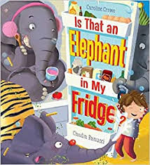
Rumney Primary School Home Learning (Ideas 12) - Nursery
Week Beg. 29.6.20 This week the ideas are based on ‘Is That An Elephant In My Fridge?’ by Caroline Crowe

For the last few weeks of term I thought that I would read a selection of funny books to the children accompanied by a range of activities rather than basing them on a specific topic.
Literacy | - Watch and listen to the story of ‘Is That An Elephant In My Fridge?’ by Caroline Crowe and read by Mrs. Proctor  - The little boy, Fred, tries to get to sleep by ‘counting sheep’. How do you get to sleep. Draw a picture of what you think about.  - What were the first and second elephants wearing at the beginning of the story?  - I can see a carton of milk in Fred’s fridge. What else can you spot?  - How many different foods can you name (and count) in your fridge?  - What is your favourite food? Draw a picture of your favourite food.
Maths | - Bubble blowing - how many bubbles can you blow? See if you can blow 10 bubbles.  - Ask your grown-up to take a photo to post on Twitter of the largest bubble you can blow, just like the elephants in the story!  - Circus tricks - Can you throw and catch a ball (try a big ball then a smaller ball). Count how many times you throw and catch it  - Now see if you can balance on one leg without holding on. Count how long you can do this for.  - Extra challenge: Can you throw and catch a ball while standing on one leg?  - In the song below (The Ants Go Marching Two By Two) the ants marched in pairs. See if you can arrange your cuddly toys in twos just like the ants. How many toys do you have altogether? (when the children count, encourage them to whisper number 1 and then shout number 2, whisper number 3 and shout number 4 and so on)
ICT based  (tablet/  computer) | - Continue learning the letter sounds (for s, a, t, i, p, n, ck, e, h, r, m, d) by watching the ‘Jolly Jingles’  - Practise number/letter formation and name writing using this... http://www.ictgames.com/mobilePage/writingRepeater/index.html
General | - Make your own musical instruments using recyclable materials. See if your family members can join in to create your own ‘marching band’, just like the elephants in the story! This video will help you to practise our marching...https://youtu.be/Pjw2A3QU8Qg  - Can you make a high sound and a low sound using your instruments?  - Now try to make fast and slow sounds  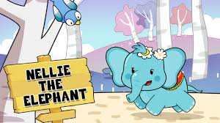  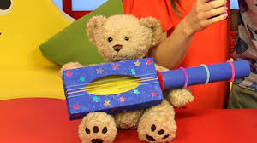  - Watch ‘Nelly the Elephant’ and see if you can sing along!

