Rumney Primary School Home Learning (Ideas 11) - Nursery
Week Beg. 22.6.20 This week the ideas are based on
The races for this week are: ‘Marathon Challenge’ and Create Your Own Obstacle Course’
Literacy | - Watch and listen to the story of ‘The Gingerbread Man’ read by Mrs. Proctor  - Create a simple drum using an upside down box or a saucepan and using your hands or a wooden spoon to strike the object, try to keep a steady beat while you sing ‘Run, run, as fast as you can, you can't catch me, I'm the Gingerbread Man!’  - Which 2 words rhyme in the Gingerbread Man’s little song?  - What is the first letter sound of each of the people and animals that chase the Gingerbread Man? e.g. ‘b’ for ‘boy’  - Pretend you are the Gingerbread Man, how would you escape the jaws of the fox?
Maths | - How many people and animals tried to catch the Gingerbread Man towards the end of the story?  - Who was the 1st to chase him? Who was the 2nd to chase him? Who was the last to chase him?  - Marathon Challenge: Pretend to be The Gingerbread Man and see how many times you can run between your markers in one minute (and then 3 minutes if they are able). See if you can beat your number of runs.  - Create Your Own Obstacle Course: Use objects in your home or garden and set up an obstacle course. Think about creating ways of moving over, under, around, through etc to add interest. You can include some of the elements on the information sheet I posted on Twitter but some of them will be a bit too challenging for the Nursery children!  - Bake gingerbread people with your grown up. See if you can help to weigh the ingredients. Which ingredient was the heaviest?
ICT based  (tablet/  computer) | - Continue learning the letter sounds (for s, a, t, i, p, n, ck, e, h, r, m, d) by watching the ‘Jolly Jingles’  - Practise number/letter formation and name writing using this... http://www.ictgames.com/mobilePage/writingRepeater/index.html  - Get building using different shapes on Cbeebies
General | 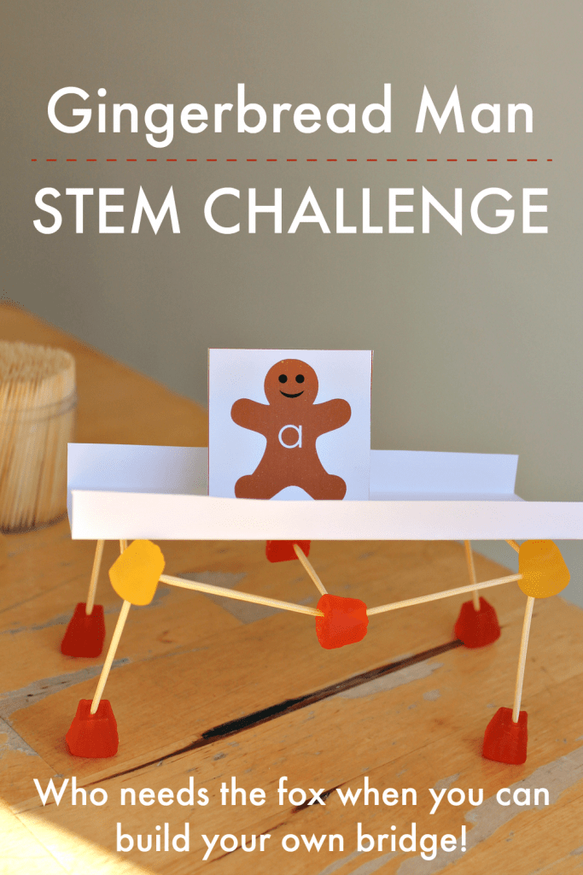  - Draw and decorate your own Gingerbread Man. Can you name all of his body parts? e.g. eyes, nose, arms etc.  - Use any construction you have in your house or household objects to create a bridge for the Gingerbread Man to use to cross the river (you could cut out a Gingerbread Man and use blue fabric to be the river)  