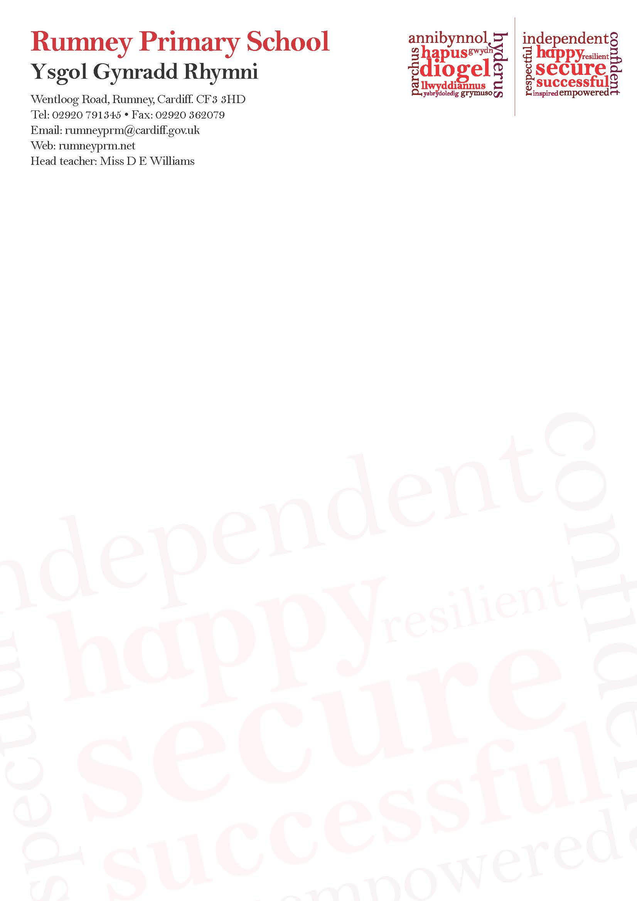

**Coronavirus (COVID-19) Update**

**Dear All in Rumney Primary School Community,**

During these ever changing times we want to share with you our plans so far in responding to the COVID-19 (Coronavirus) with regards to all our children, staff and other adults who may need to visit our school.

This is the most recent update from school. The school is remaining open and good hygiene procedures will be followed. All updates are in line with the information received from Cardiff Council and with Public Health Wales (PHW).

Currently Rumney Primary School and Breakfast Club remain open. Any changes will be communicated to all families via the school text messaging service, Schoop, Twitter, the school website and where possible and appropriate by letter. Please ensure any changes to your contact details have been shared with the office.

The plans are based on the most recent advice for schools and are not meant to alarm but they are preventative:

* ALL pupils and staff to wash hands as soon as they enter and leave the building
* Regular reminders about hand washing throughout the school day
* Increased cleaning procedures including regular wiping down of frequently touched surfaces in line with national recommendations
* Children must bring their own water bottles to school
* Children and staff who are unwell or show any signs will be sent home
* All after-school clubs including Judo will be cancelled until further notice
* Visitors to school are being contacted to reduce non-essential visits
* Any outstanding parents’ consultation meetings are postponed until further notice
* All Parents/Carers are asked to contact school via phone or email rather than visiting school wherever possible
* Y6 parents/carers can expect to receive updated information in relation to the Y6 forthcoming residential trip to Manor adventure later in the week

**In the event of unplanned school closure**

Staff are currently preparing provision for Home Learning in this event.

Full details for all year groups will be provided as and when appropriate.

If any parent or carer needs to discuss this prior to school closure please speak to the relevant class teacher.

The health and safety of all our pupils and staff remains our utmost priority.  Further communication as necessary will be via the school text messaging service, Twitter, Schoop and the school website.

Kind regards

D. E. Williams

Headteacher