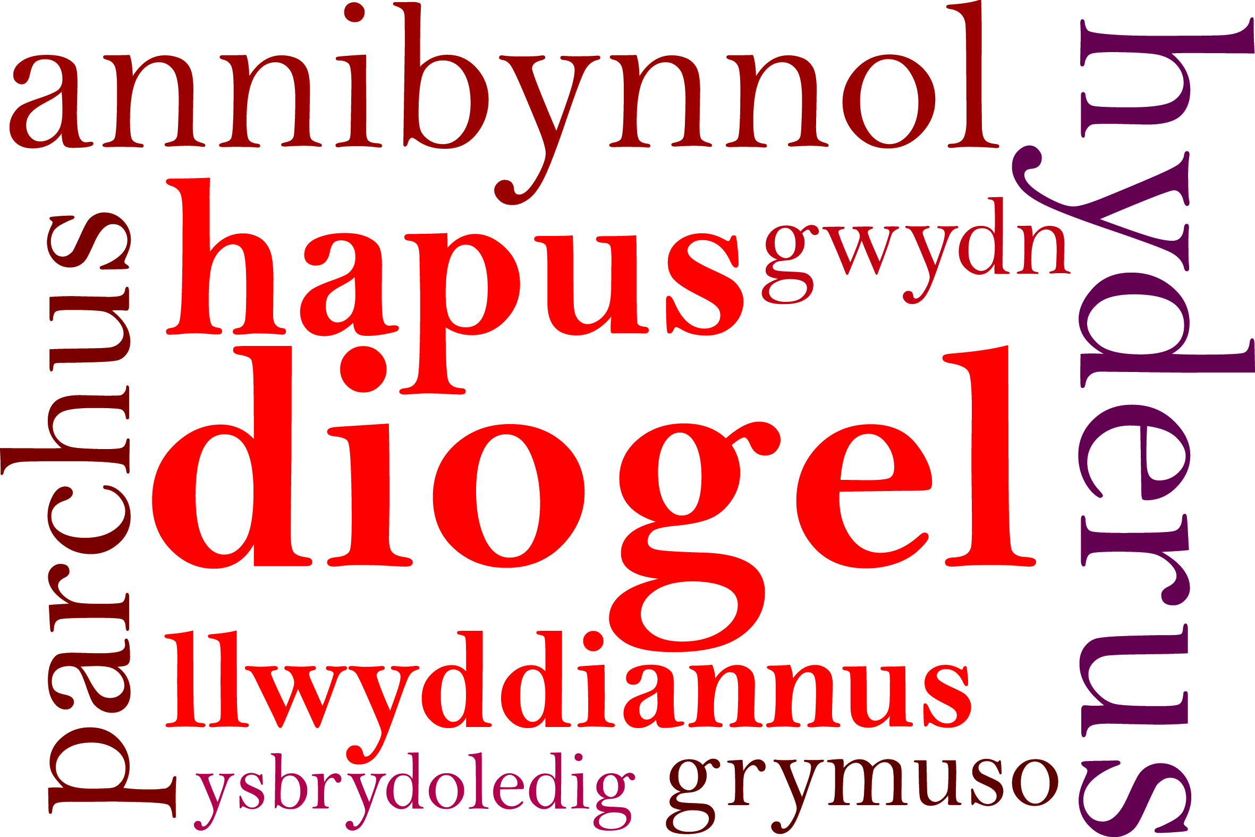
Professional Learning Plan April 2018 – March 2019 Rumney Primary School
No | National Mission Link | Planned Activity | Success Criteria | Funding Source | Type of Spend | Cost £
1 | Developing a high quality education profession |  |  | Welsh Government Professional Learning Funding | Training and development  Staff CPD  Resources

