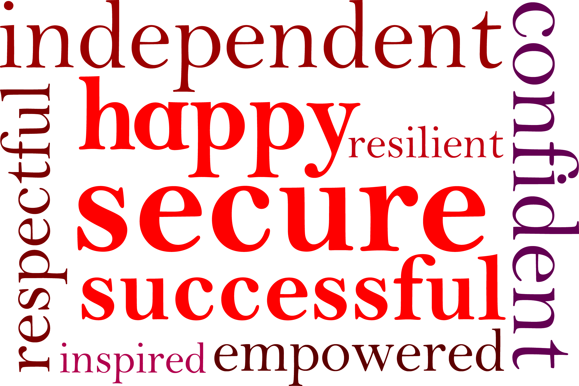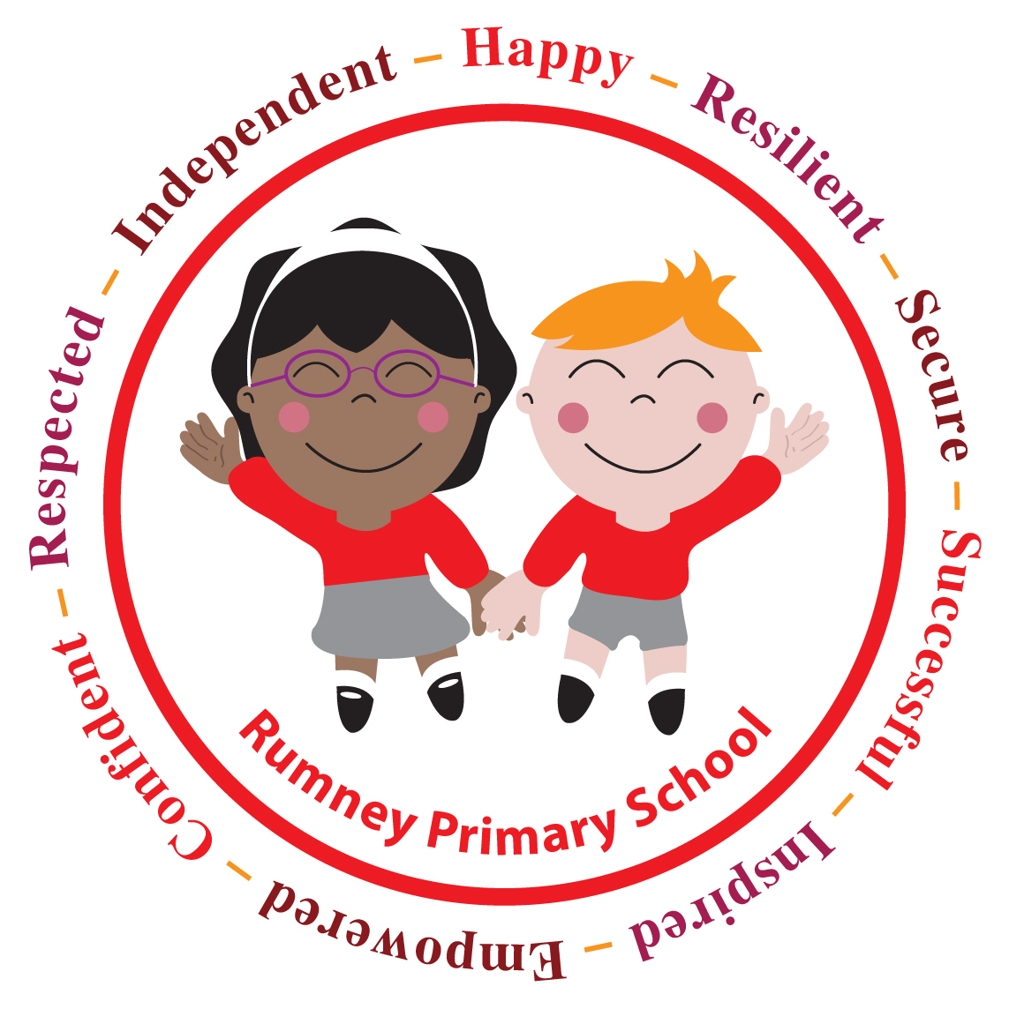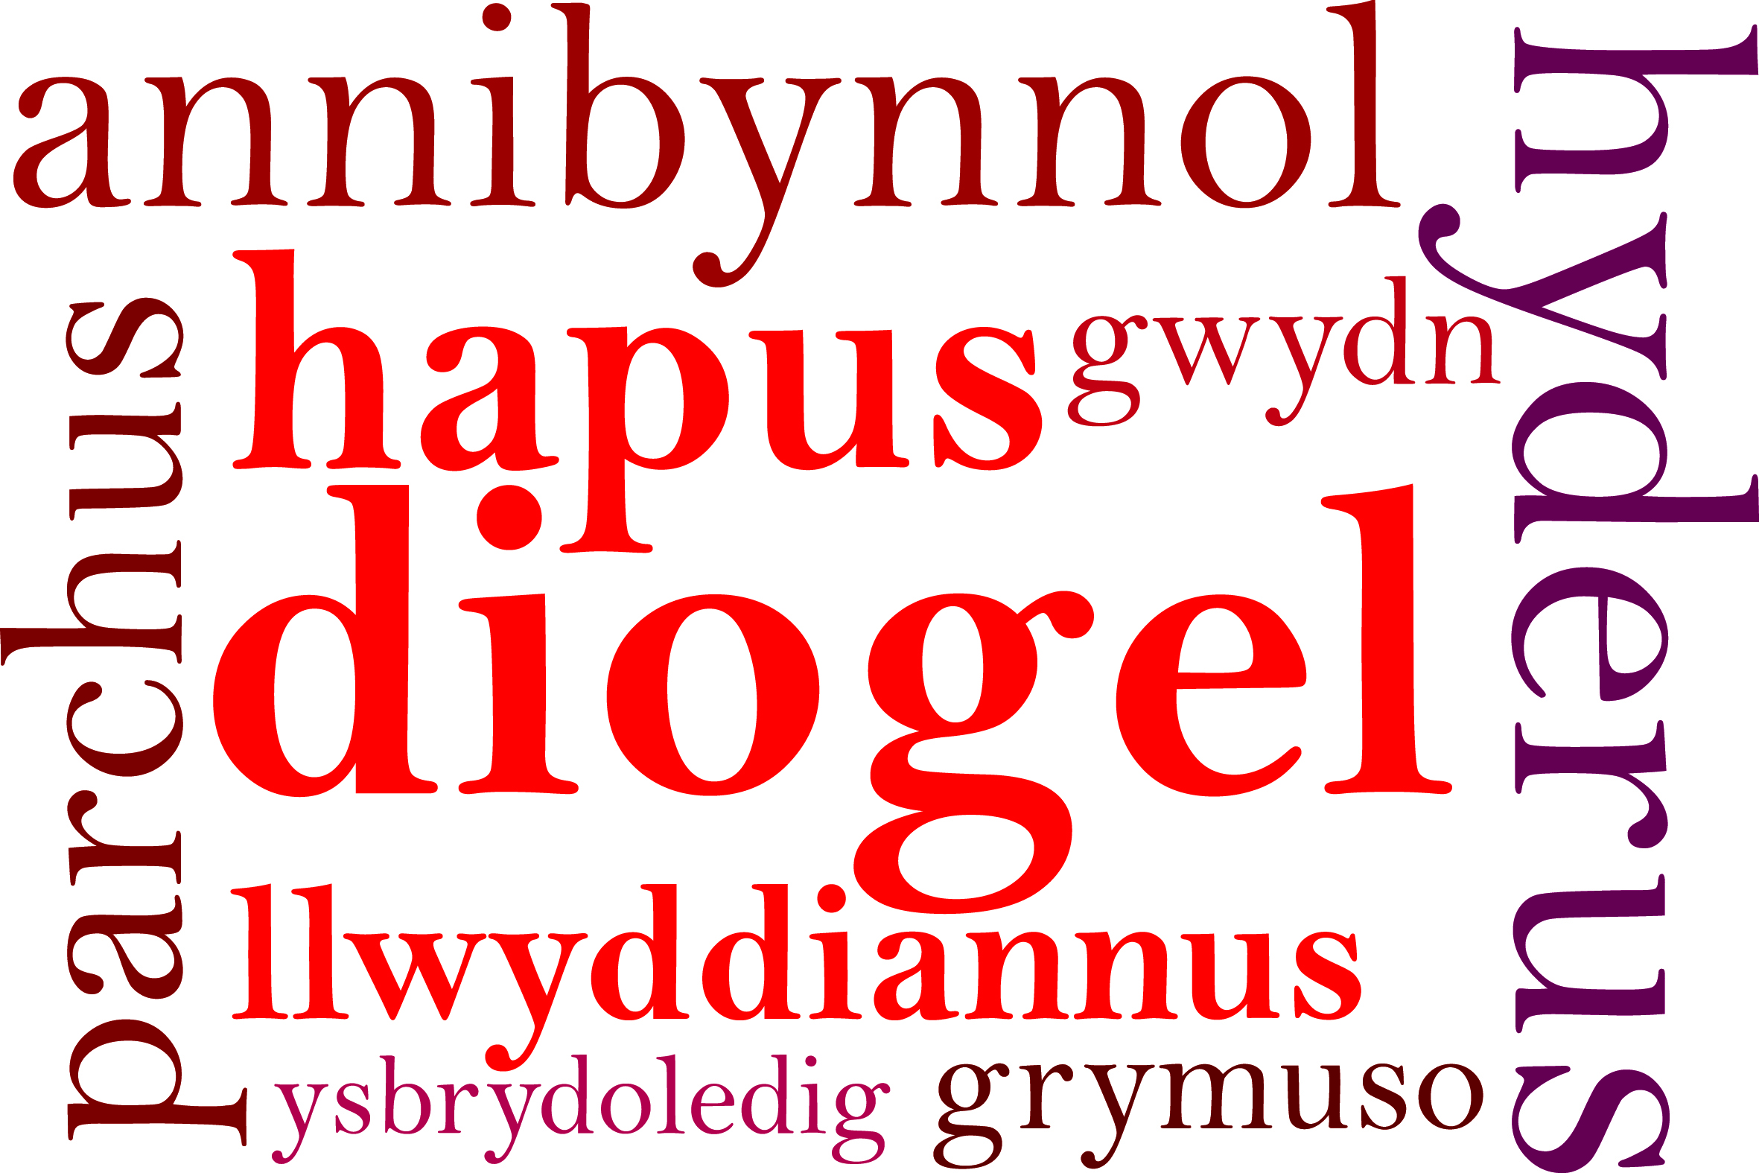

YEAR 2
CHRISTMAS PRODUCTION
29th November 2017.

Dear Parents/Carers,

The performance of the Year 2 Christmas Concert is on:

Thursday 14th December at 9:30 a.m. (for parents/carers in classes 5 & 6)

If you would like tickets at £1 per person, please complete the reply slip below and return it to school along
with the money. There is a limit of two tickets per family.

Please avoid bringing babies and toddlers to the performances as the children can become distracted.
This year the performance will not be recorded by school. You may take a photo of your child but please do not post any photos on social media sites as you do not have permission to do so. Please follow this important message to keep all of our children safe.

We look forward to seeing you at our Christmas production.

Yours sincerely,

Miss D.E Williams
Headteacher

YEAR 2
CHRISTMAS PRODUCTION

I would like to purchase 1 / 2 tickets (delete as appropriate) for the Year 2 Christmas Concert.

Thursday 14th December at 9:30 a.m. (for parents/carers in classes 5 & 6): ___________

Child’s Name: ____________________________ Class: _______________

