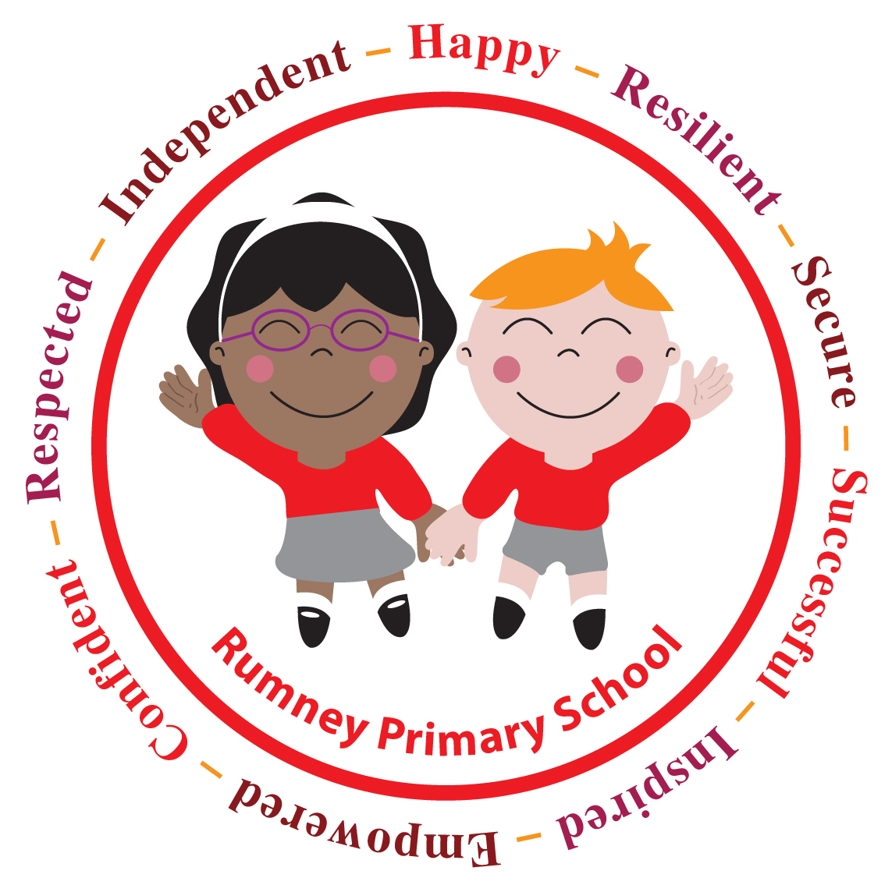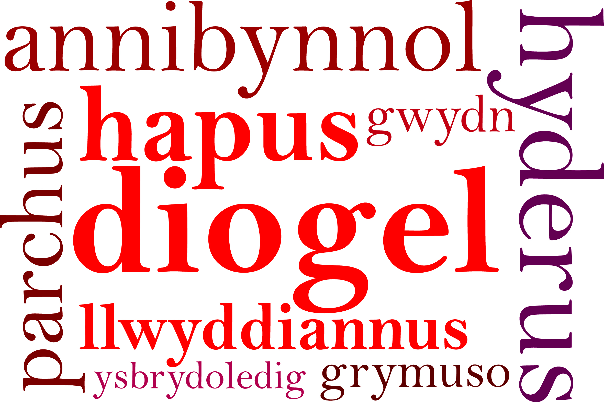

RECEPTION
CHRISTMAS PRODUCTION
29th November 2017.
Dear Parents/Carers,

There will be two performances of the Reception Christmas Concert:

Wednesday 13th December at 9:45 a.m. (dress rehearsal for grandparents in class 1 and 2)

Friday 15th December at 9:45 a.m. (for parents/carers in class 1 and class 2)

If you would like tickets at £1 per person, please complete the reply slip below and return it to school along
with the money. There is a limit of two tickets per family.

Please avoid bringing babies and toddlers to the performances as the children can become distracted.
This year the performance will not be recorded by school. You may take a photo of your child but please do not post any photos on social media sites as you do not have permission to do so. Please follow this important message to keep all of our children safe.

We look forward to seeing you at our Christmas production.

Yours sincerely,

Miss D.E Williams
Headteacher

RECEPTION
CHRISTMAS PRODUCTION

I would like to purchase 1 / 2 tickets (delete as appropriate) for the Reception Christmas Concert.

Wednesday 13th December at 9:45 a.m. (dress rehearsal for grandparents in class 1 and 2): __________

Friday 15th December at 9:45 a.m. (for parents/carers in class 1 and class 2): ___________

Child’s Name: ____________________________ Class: _______________

