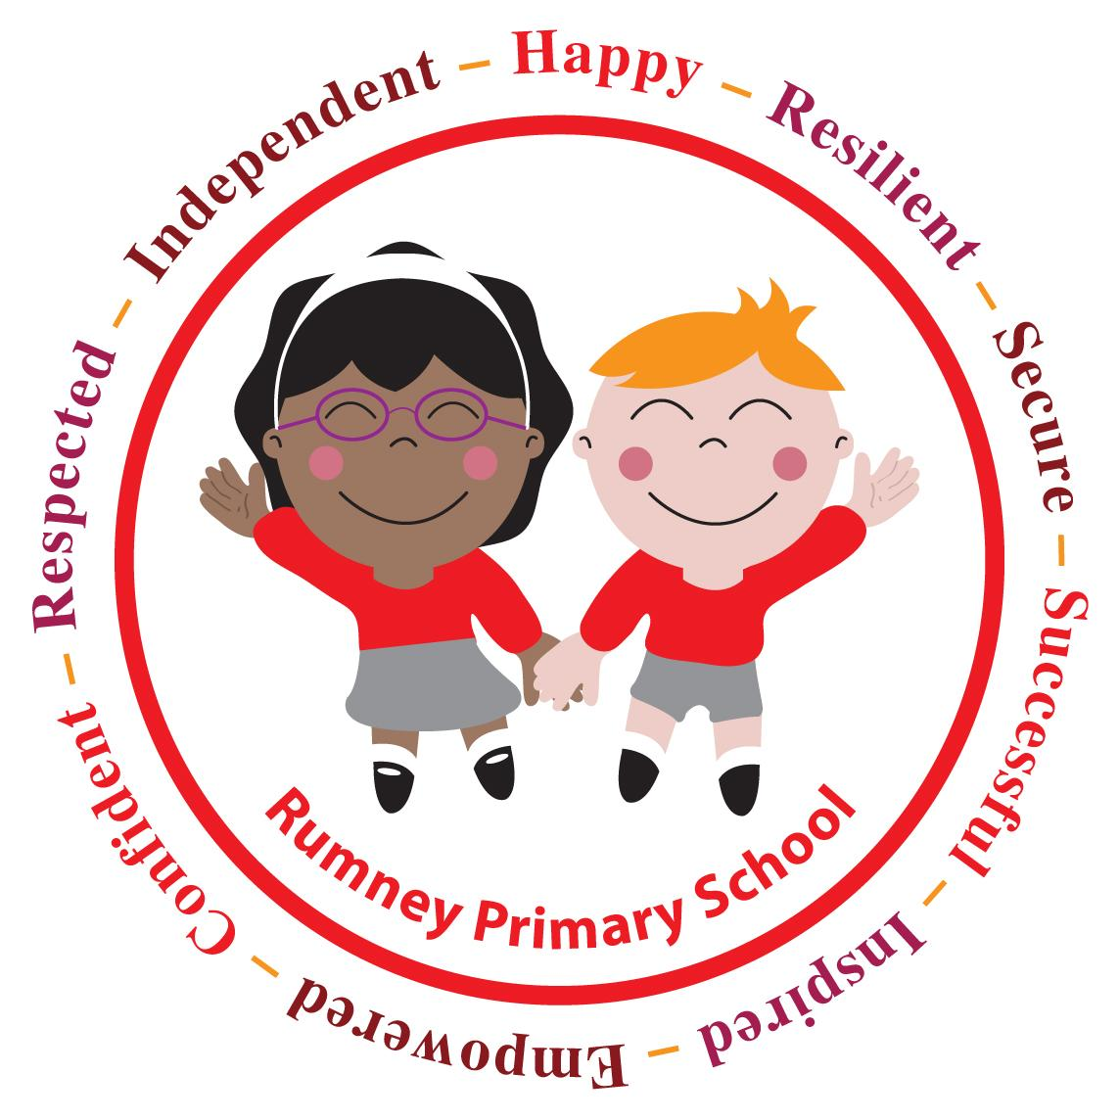
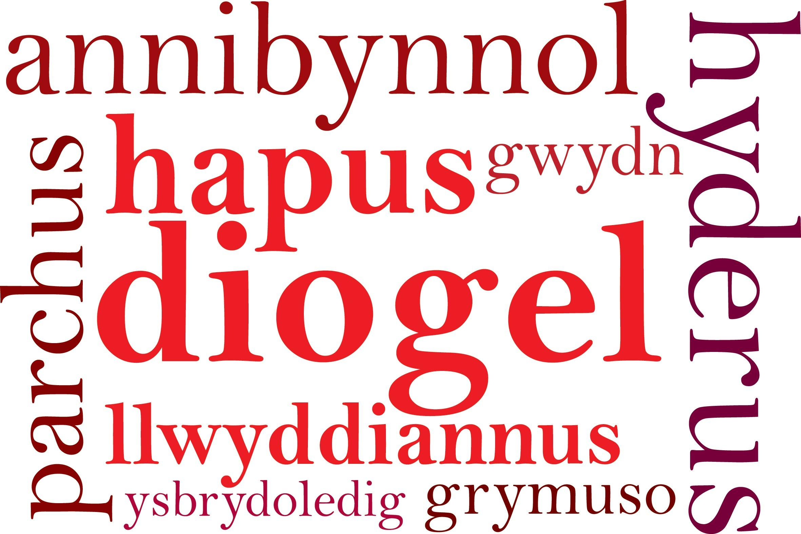

Headteacher's Spring Half Term 2022 Update
Dear Families,

As half term approaches we are able to share the organisation for school for the week beginning 28th February. Thankfully the data now allows us to return to how we were working at the beginning of the Autumn Term 2021. Throughout this half term we have met regularly with the LA and discussed the arrangements and mitigation measures in line with the advice from both the Welsh Government and Cardiff Council.
Whilst some restrictions are being lifted, it still remains important that children should not attend school if they have any of the COVID symptoms.

School Start and Finish Times from Tuesday 1st March
- Start Time - Nursery - 9 am
R - Y6 - 8.55 am door opens 9.15 am doors close

- Collection Time - Nursery - 3pm
R -Y2 - 3.10 pm
Y3-Y6 - 3.15 pm

Arrangements for Breakfast Club and lunchtime will remain the same.
We now have 92% of our families who have activated their ParentPay accounts. Please remember that should your child want school dinners your account needs to be activated. Going forward into the Spring term, should school trips return, all payment will need to be made using ParentPay. Please contact the office to ask for your activation letters and codes.

Punctuality / Attendance
Please can you make every effort to ensure your child arrives at school on time with everything they need for the school day. There are an increasing number of pupils being collected early from school especially at the end of the week. Should your child have a medical or dental appointment we ask you to make sure you inform us in advance with a copy of the appointment card or letter. It is also very important to let us know if your child is absent from school to avoid any unauthorised absences. You can ring using the automated voice mail service and leave us a message.

Uniform
It is our expectation that school uniform is worn to school everyday. All school uniform can be purchased from YC Sports on Crwys Road https://www.ycsports.com/

Important Dates
Monday 28th February is an INSET day
Tuesday 1st March is the first day back after half term and Dydd Gwyl Dewi (St Davids Day). The children can come dressed in Welsh costumes, Welsh sports kit or wear red clothes.
Thursday 4th March is World Book Day.
School will celebrate by encouraging everyone to wear their pyjamas and bring their favourite book to school to share during the day.
Monday 7th March will be our Eisteddfod St David's Day celebrations
The children can come dressed in Welsh costumes, Welsh sports kit or wear red clothes. Information has been shared on Schoop for Home School tasks linked to our Eisteddfod celebrations
Term / Inset Days
Friday 8th April 2022
Friday 27th May 2022 (platinum jubilee additional bank holiday)
Monday 6th June 2022

Term Starts | Half Term | Term Ends
 | Mon 21st Feb - Fri 25th Feb | Fri 8th Apr 2022
Mon 25th April | Mon 30th May - Fri 3rd Jun | Fri 22nd July

Parents’ Evening
We hope you have found the new parents’ evening booking system easy to use so far and hopefully the trial of this way of working will be successful. The links for the face to face video call will be sent 24 hrs prior to your appointment time. There is a time limit to each consultation of 10 minutes, as we have always had . Class teachers are looking forward to meeting with you. Please be in touch with the class teacher if you have any queries.
Y6 Residential
The trip is due to take place 3rd -5th May 2022. The payment facility is now live on ParentPay (we are unable to accept cash for this trip). You can pay in 3 installments or all in one go whatever suits you best. On Thursday 10th March at 4pm, there will be an online teams presentation by the course organiser, we will send you the link after half term.

SCHOOL CLOSURE
As you will have already seen on text, email, Schoop and Twitter, we are closed tomorrow due to adverse weather conditions and a RED weather warning.

We wish you all a very happy and safe half term. Thank you for your continued support

Best Wishes

Miss D E WIlliams

Headteacher

