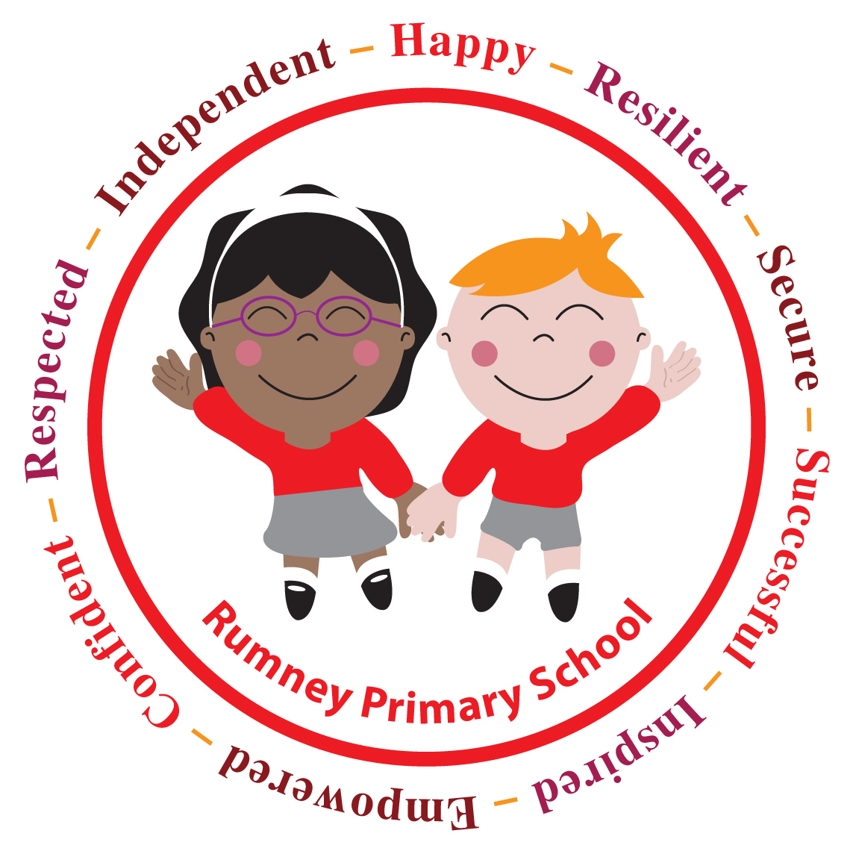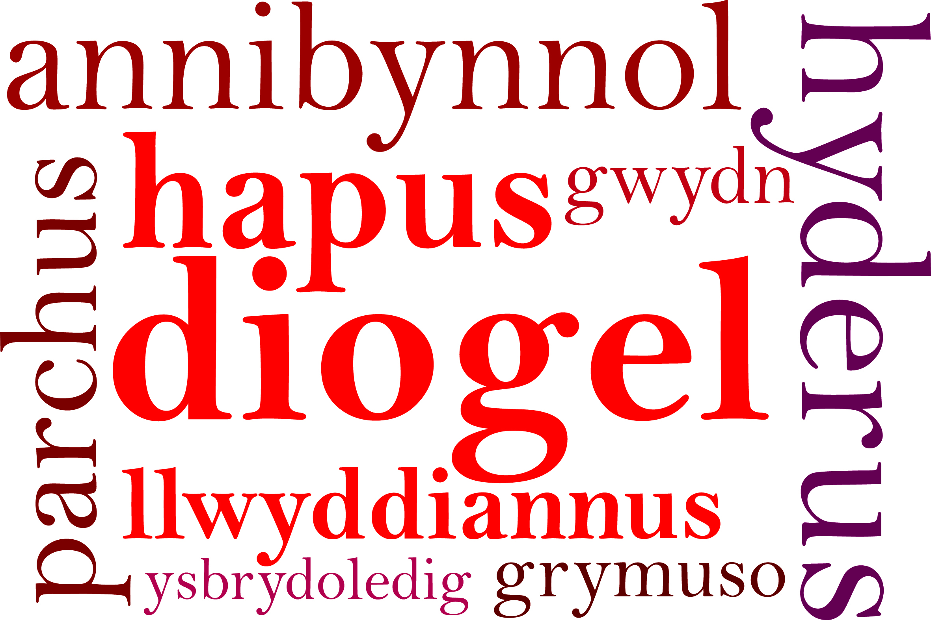

Year 5 & Year 6
CHRISTMAS SERVICE
29th November 2017.
Dear Parents/Carers,

Join us to celebrate Christmas by participating in a Christmas Service of readings and carols with your children, in Rumney Baptist Church, Ty’r y Sarn Road on;

Tuesday 19th December at 2.00 p.m.

Parents are requested to arrive at the church by 1:45 p.m. so that staff can meet and seat you with your child who will already be at the church. You will be able to take your child home at the end of the service, which will finish at 3:00 p.m. Donations will be collected in aid of Marie Curie Cancer Care.

For parents who are unable to attend your child will be walked back to school by a member of staff, where you will be able to collect them.

If you would like to attend please complete the reply slip below and return it to school by Friday 10th December. Due to health and safety regulations, places are strictly limited to
2 adults per family.

Unfortunately, parents cannot use cameras or video equipment during the services. We kindly request that you avoid bringing babies and toddlers to our Christmas Service.

We look forward to seeing you at our Christmas celebrations.

Yours sincerely,

Miss D.E Williams
Headteacher

__________________________________________________________________________

Year 5 & Year 6
CHRISTMAS SERVICE

I would like 1 / 2 seats (delete as appropriate) for the Christmas Service at Rumney Baptist Church on Tuesday 19th December at 2:00 p.m.

Child’s Name: _____________________ Class: _____________

